School:
Classes:
Dates: see content

Experiences & Outcomes
Movement skills, competencies and concepts |  |  | Cooperation and competition |  | Evaluating and appreciating
I am learning to move my body well, exploring how to manage and control it and finding out how to use and share space. HWB 0-21a | I am developing my movement skills through practice and energetic play. HWB 0-22a |  | I am aware of my own and others’ needs and feelings especially when taking turns and sharing resources. I recognise the need to follow rules. HWB 0-23a |  | By exploring and observing movement, I can describe what I have learned about it. HWB 0-24a
Significant Aspects of Learning  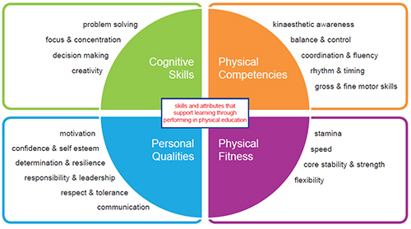  Cognitive Skills  Problem Solving  Focus & Concentration  Decision Making  Creativity  Personal Qualities  Motivation  Confidence & Self-esteem  Determination & Resilience  Responsibility & Leadership  Respect & Tolerance  Communication  Physical Competencies  Kinaesthetic Awareness  Balance & Control  Coordination & Fluency  Rhythm & Timing  Gross & Fine Motor Skills  Physical Fitness  Stamina  Speed  Core Stability & Strength  Flexibility |  | Benchmark statements |  | Content |  | IDL link (where appropriate)

