Experience & Outcome | Learning Intentions | Success Criteria | Learner Experience | Assessment  Say, write, make & do | Evaluation
Sharing learning intentions
Open Question
Thumbs up – no hands
Self-assessment
Peer assessment
2 stars & wish
Share the bigger picture
Next steps
Task observation
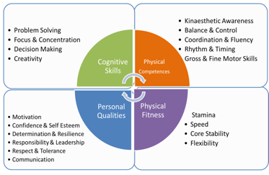
Record of improvement
 |  |  |  | Appropriate Benchmarks
SAL’s
Class: Teacher: Date:
Physical Education Planning Sheet

