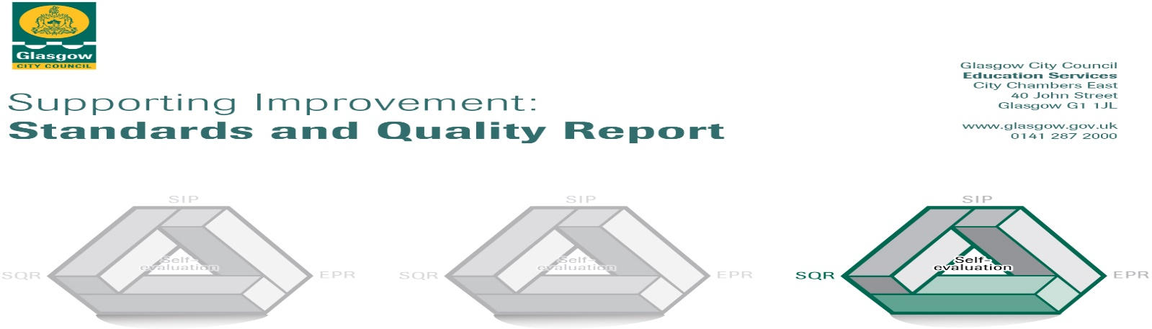

The summary report is provided for parents/careers and partners to outline our achievements in session 21-22 and outline our priorities for next session, 22-23. Throughout this session we have taken forward our priorities as detailed in our School Improvement Plan (SIP). Through our processes of self-evaluation, we have identified how we can improve outcomes for our children and young people.

Our achievements and improvements this year.
Our Lady of the Annunciation Primary

Standards and Quality Report - Session 21-22

We would like to highlight the following improvements/achievements this session:

Key developments: Leadership of Change

- All staff and our Pupil Council were involved in auditing and assessing how effective our classroom environments were. Changes were put in place to make classrooms more inviting and to increase pupils’ independence when working on tasks.
- Targeted intervention groups were introduced at Primary 2 and Primary 5 to support pupils to get on track with their learning. Our success in raising achievement for these pupils ranged from 75-85%.
- We undertook a whole school pledge to become a Laudato Si School following the message of Pope Franics to work tirelessly as Stewards of the Earth.
- All pupils and staff contributed to the renewal of our School Values of Love, Faith, Hope and Kindness. All of our parents were invited to take part in shaping our values through an online survey which resulted in overwhelming agreement of the core values for our school.
- Our Parent Council, Pupil Council and Staff were consulted on the use of our Pupil Equity Funding resulting in an additional teacher being recruited to the school for the academic year.
- All teaching staff undertook training in delivering effective Interdisciplinary Learning. The refresh of practice led to greater relevance in the study of topics and greater opportunities for our pupils to lead the learning.
- Staff professional learning continued to increase with three staff studying at Masters Level to develop play pedagogy and leadership within the school.
- We increased the use of digital technologies both at home and in school. Staff and pupil Digital Literacy competence continues to grow leading to a high level of proficiency across our school.

Developments in learning and teaching and assessment

- Mr Fisher was trained as our Challenge Leader of Learning in Literacy this session and worked with pupils and staff to embed Literacy for All strategies in Reading. Mr Fisher ran training for staff, undertook team teaching in our classes and worked directly with groups of pupils at P4 and P7. As a result, all pupils involved showed increased confidence in using more complex reading strategies to understand and interrogate texts.
- We refreshed our use of Kagan Collaborative Learning strategies across all classes this session giving pupils valuable opportunities to engage in their learning and develop their talking and listening skills still further.
- Staff worked in Focus Groups to develop planning pathways in Health and Wellbeing, Technologies and Learning for Sustainability. All children will benefit from greater breadth and depth of learning in these areas as a result.
- We increased the level of our partnership working to ensure our children received a greater breadth of experiences this session. We welcomed STEM students to Primary 5 and 6 who taught Biology and Chemistry to the children. We benefited from specialist PE students across all our classes and we worked again with the Clyde River Foundation on both their Salmon Schools and Clyde in the Classroom projects.
- As part of the Government initiative to increase language learning in schools and to develop our understanding and respect for world cultures our Primary 5 class were able to work in partnership with the Scottish National Centre for Languages at Strathclyde University to undertake the ‘Discovering the World: Arabic’ programme. Pupils were able to have recorded and live lessons looking at Arabic culture and language.

Progress in promoting wellbeing, equality and inclusion

- We embedded our daily wellbeing check-ins in all classes allowing pupils to talk about any worries or concerns they have. Some classes have incorporated their Modern Languages work into the framework with pupils talking about how they feel in French.
- All pupils undertook the Glasgow Motivational and Wellbeing Profile looking at how they thought and felt about a wide range of wellbeing issues. Class teachers used the results to support pupils who had concerns or worries and led to further support for these children being put in place.
- We continue to embed Pupil Rights into our school, following the non-accredited route. We were able to reinstate our core Pupil Voice Groups such as our Pupil Council, Eco Committee, Liturgy group, Librarians, and our Health and Wellbeing Committee.
- Our whole Primary 7 cohort were able to access comprehensive transition support for secondary school through our partnership with the charity, Bridging the Gap. All P7 pupils engaged with the charity looking at aspects of their own development. Eleven of our P7 pupils spent five weeks undertaking transition activities at our feeder Secondary School, Holyrood.

Progress in children’s learning: Raising attainment and recognising achievement

- This session we were delighted to be awarded First Place in our Learning Community debating competition, placing in the top two spots for the last three years in a row.
- We continued to embed targeted intervention to close the attainment gap for our pupils. We saw attainment levels in P1, P4 and P7 rise this session with an achievement range of 84% - 96% across Literacy and Numeracy.
- Teaching and support staff received training in the ‘Getting Started’ reading resource and individual programmes were embedded to support identified pupils’ learning across literacy and numeracy.
- This session we extended our Targeted Intervention Groups to include P2 and P5 pupils, as well as undertaking support groups in both literacy and numeracy to close attainment gaps.
- We audited our reading resources to ensure we had a breadth of suitable reading materials, which reflected both our children and the society they live in. New reading resources were purchased to develop specific reading skills such as prediction and analysis of texts.
- We refreshed our Monthly Merits this session to ensure there was recognition of wider achievement and equity of opportunity to gain an award. We introduced a new ‘Legendary Literacy’ Award to reflect the progress pupils were making in this area.

Here is what we plan to improve next year.
- Next session we will again look at raising attainment in Literacy, but with a particular focus on writing. Mr Fisher will continue as our Challenge Leader of Learning (CLOL) in Literacy and work with staff, pupils and families to raise attainment in this area.
- We will further develop of our approaches to Learning for Sustainability, Meeting Learners’ Needs and effective planning for teaching and learning.
- We will continue to progress the development of Play Pedagogy in Primary 1 and 2 to support developmental learning and raise attainment.
- We will work with all stakeholders to finalise our Curriculum Rationale, helping to embed a comprehensive and progressive curriculum offer from Primary 1 to Primary 7.
- We will finalise the refresh of our School Vision following further input from pupils and staff and in consultation with our Parent Council and the wider Parent/Carer Forum.
- We will re-introduce our full range of P4-7 Pupil Voice groups next session, along with our class assemblies, all school shows and our face-to-face family learning opportunities.

How can you find out more information about our school?
Please contact us directly if you require further information or if you wish to comment on the report.

Headteacher: Maureen A Douglas

The contact e-mail address is: headteacher@ourladyoftheannunciation-pri.glasgow.sch.uk

Our telephone number is: 0141-637-7457

Our school address is: 80 Friarton Road, Glasgow, G43 2PR

Further information is available in: our school newsletters, the school website, our Twitter feed and in our school handbook.

