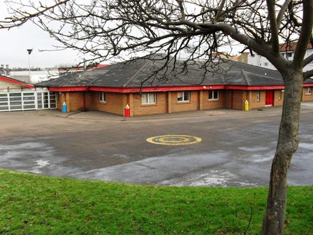

**Our Lady of the Annunciation Primary**

**Home - School**

**Agreement**

**2017-18**

Home School Partnership Agreement

**Parent/Guardian**

We/I will try to:

1. Support the school so that our/my child is able to enjoy learning in a caring and supportive environment.

2. Encourage our/my child to keep the Golden Rules by working in partnership with the school.

3. Ensure regular and punctual attendance and collection of our/my child.

4. Promote and encourage learning at home.

5. Attend meetings, read reports and newsletters, share with the school any problems or concerns that might affect our/my child’s progress.

Signed:

Date:

(Parent/Guardian)

Home School Partnership Agreement

**Child**





I will try to:

1. Treat others as I would want to be treated myself.

2. Keep the Golden Rules.

3. Arrive at school on time, in uniform and with the equipment I need.

4. Do my work when I take it home (reading, spelling and home learning).

5. Share my feelings with a grown up when I am happy or upset about anything.

 Signed:

Date:

Home School Partnership Agreement

**School**

At Our Lady of the Annunciation we will aim to:

1. Promote success for each individual child, through building good relationships, developing a sense of responsibility, confidence and self-esteem in a safe and secure environment.

2. Set high expectations of behaviour by encouraging children to develop an understanding of the needs of others and an awareness of the community and environment.

3. Recognise regular attendance and punctuality, keeping parents informed should problems arise.

4. Provide information and learning opportunities to help your child extend their development at home.

5. Offer opportunities to be involved in school life by providing information about the school and your child’s progress through regular meetings, reports and newsletters; promote and value communication from parents by being welcoming and responding to any concerns promptly.

Signed:

Date: