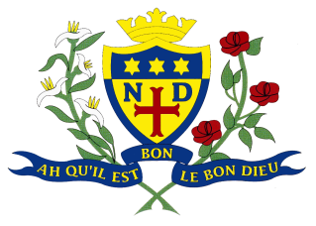
Notre Dame High School
Parent Council Meeting
Wednesday 29 November 2017

Present: K Brough, M Green, K Welsh, S Khokhar, E Henderson, R Bateman, A McClure
Apologies: A Miele, C Ewins, R Martin, P Pickett,

 | Minute | Action
1. | Minutes and Matters arising  Brief introductions  Previous minute was reviewed and approved
2. | Christmas Fayre update- Thursday December 7  L Dunn talked about the fayre’s progress with already 14 stalls which include home baking, jewellery, SCIAF, tombola. Christmas Fayre starts from 5:30-7pm on the night. Members to publicise as much as possible to attract lots of customers. | MW to get the pizzas.
3. | Notre Dame Primary Consultation Request- update  Email sent out from M McKenna regarding placing requests and ND associated schools. For a further meeting to discuss potential questions for a questionnaire to be sent to parents in supporting more girls to access the school. Questionnaire regarding enlarging the catchment area for primary schools to feed into NDHS.
4. | Parent Council Financial Support  Quote of £680 for rugby kit. £200 has been raised. Parent Council has been asked to support by providing the £300.
5. | Broad General Education- Reporting Consultation  New database created for S1-S3 BGE tracking report. E Henderson explained the structure of the report-performing above expected, on track and not on track. Suggestions made to add a foot note or comment explaining what is expected of the student to give parents a better idea of their child’s level. Suggestion of teachers comments to give more information on any areas of improvement and a target. Suggestion made to change the order of the three options so it’s more pleasing to the eye.
6. | Next Meeting: Monday January 15th 2018, 5:15pm

