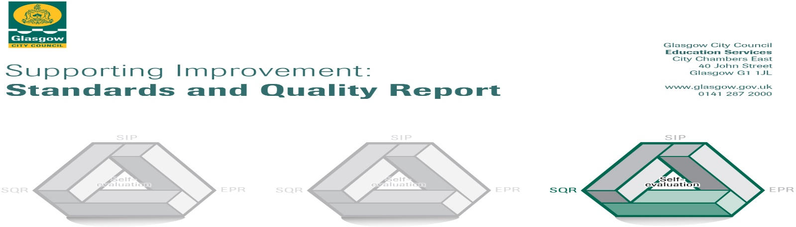

The summary report is provided for parents/careers and partners to outline our achievements this session and our priorities for next session. Throughout this session we have taken forward our priorities as detailed in our school improvement plan. Through our processes of self-evaluation, we have identified how we can improve outcomes for our children and young people.

Our achievements and improvements this year.
We would like to highlight the following improvements/achievements:
- During lockdown almost all staff felt supported by SLT and all staff found the staff team supportive of each other. Most staff say this has continued into the new session.
- SLT, along with staff, have begun to develop rationales for our policies and practices. Our rationales are guiding all of our practice. The school is developing our use of nurturing principles, the UNCRC and GIRFEC to ensure equality of opportunity for all pupils.
- All staff have been involved in moderation across the learning community. SLT work very closely with learning community colleagues and within a local improvement group. All staff are positive about moderation across the learning community.
- The ethos and culture in our school reflects a commitment to children’s rights and positive relationships. A calm, nurturing and purposeful ethos permeates the school.
- Through SLT observations it can be seen that all teacher are discussing and/or writing up learning intentions. Children have opportunities to work individually and collaboratively.
- All staff say they give regular feedback to pupils which helps them to progress.
- Glasgow Counts strategies are embedded across all classes with Number Talks also being used increasingly.
- The focus on reading last session is ensuring that staff have coherent and consistent approaches to teaching reading.
- Teachers say that new planners are supporting them to plan progressively to meet the needs of all children.
- All staff take the time to listen to children and parents and there are a range of supports available, resulting in improved relationships between all stakeholders. Staff are trained in All Behaviour is Communication and are building their awareness of ACES.
- We monitor attendance and take action as required. Our attendance rates are high.
- Most children make good progress from their prior levels of attainment in literacy and numeracy.
- Attainment over the last four years for reading, writing and numeracy has increased and remained consistent for listening and talking.
- Through PEF staffing we have initiated support groups for numeracy/literacy and some team teaching.

Here is what we plan to improve next year.
- We have a focus on recovery, reconnection and resilience through health and wellbeing.
- We will continue our work on reading and move onto writing.
- We are working on creativity and how to incorporate this throughout the curriculum.
- We will start to look at the consistency of learning and teaching approaches across the school.

How can you find out more information about our school?
Please contact us directly if you require further information or if you wish to comment on the report.

The contact e-mail address is: Headteacher@mountflorida-pri.glasgow.sch.uk

Our telephone number is: 0141 6324455

Our school address is: 1127 Carmunnock Road, Glasgow, G42 9HF

Further information is available in: newsletters, the school website, and the school handbook

