**Reading the Question**

[](http://www.google.co.uk/url?sa=i&rct=j&q=&esrc=s&source=images&cd=&cad=rja&uact=8&ved=0CAcQjRxqFQoTCNudiJXOiMkCFYfZGgodPC0Cig&url=http://www.dehumane.org/site/PageServer?pagename=adopter_resources&bvm=bv.106923889,d.d24&psig=AFQjCNHW-ZkKCzrza_K0-xgN2gZL6LMswA&ust=1447339559051260)

The Process

* Always read the question carefully, considering **both parts**.
* Underline **key words** from it that you will use from the **beginning** of your essay **right through to the end.**
* The starting point of your essay should **focus on the question**, not the text you have studied.
* Pay attention to **‘the magic box’**…

Answers to questions on Prose should refer to the text and to such relevant features as characterisation, setting, language, key incident(s), climax, turning point, plot, structure, narrative technique, theme, ideas, description . . .

narrative technique, theme, ideas, description . . .

Example

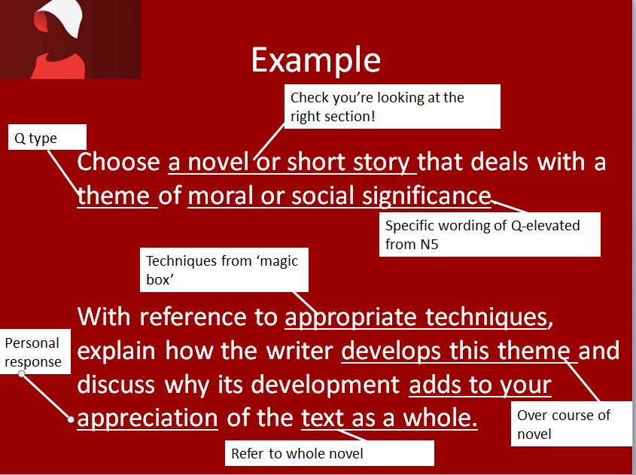

**Higher Prose Questions**

Answers to questions on prose fiction should refer to the text and to such relevant features as

characterisation, setting, language, key incident(s), climax, turning point, plot, structure,

narrative technique, theme, ideas, description…

1. Choose a novel or short story in which there is a character who could be considered responsible for their own suffering and/or fate.

By referring to appropriate techniques, explain the extent of the responsibility and discuss how this contributes to your appreciation of the text as a whole.

1. Choose a novel or short story which conveys a particularly pessimistic or inspiring message. By referring to appropriate techniques, explain the nature of the message and discuss how this contributes to your appreciation of the text as a whole.
2. Choose a novel or short story in which an incident is significant in relation to the central concerns of the text. By referring to appropriate techniques, explain why the incident is significant and discuss how it adds to your appreciation of the text as a whole.
3. Choose a novel or short story in which there is a complex character for whom the reader has some sympathy. With reference to appropriate techniques, explain the nature of the complexity and discuss how your response to this character adds to your appreciation of the text as a whole.
4. Choose a novel or short story in which important human values are explored. With reference to appropriate techniques, explain how these values are explored and discuss how this adds to your appreciation of the text as a whole.
5. Choose a novel or short story in which the setting in time and/or place is important to your understanding of the text. By referring to appropriate techniques, explain the nature of the setting and discuss how it is important to your understanding of the text as a whole.
6. Choose a novel or short story in which there is a character who experiences rejection or isolation. With reference to appropriate techniques, explain the rejection or isolation, and discuss how this aspect adds to your appreciation of the text as a whole.
7. Choose a novel or short story which has an effective opening or conclusion. With reference to appropriate techniques, explain why the opening or conclusion is effective and discuss how it adds to your appreciation of the text as a whole.
8. Choose a novel or short story which deals with the theme of love or loss or redemption. With reference to appropriate techniques, explain how the writer develops this theme, and discuss how it adds to your understanding of the text as a whole.
9. Choose a novel or short story in which there is a central character to whom you react with mixed feelings. With reference to appropriate techniques, briefly explain why you react to the character in this way and discuss how this reaction adds to your understanding of the text as a whole.
10. Choose a novel or short story that deals with a theme of moral or social significance.

With reference to appropriate techniques, explain how the writer develops this theme and discuss why its development adds to your appreciation of the text as a whole.

1. Choose a novel or short story in which the choice of setting is central to your appreciation of the text. Briefly explain how the writer effectively creates setting and, with reference to appropriate techniques, discuss how the writer’s presentation of the setting is central to your appreciation of the text as a whole.
2. Choose a novel or short story in which the method of narration is important. Outline briefly the writer’s method of narration and explain why you feel this method makes such a major contribution to your understanding of the text as a whole.
3. Choose a novel or short story in which there is a moment of significance for one of the characters. Explain briefly what the significant moment is and discuss, with reference to appropriate techniques, its significance to the text as a whole.
4. Choose a novel or short story which has a satisfying ending.

Discuss to what extent the ending provides a successful conclusion to the text as a whole.

**Planning Your Essay**

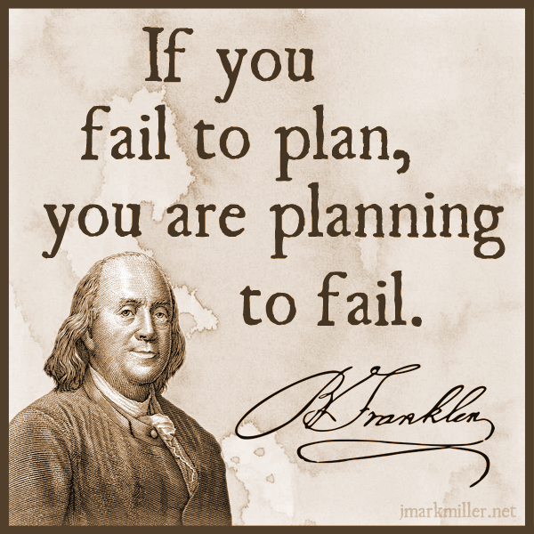

* In an exam, it doesn’t hurt to make a small plan of action for your essay, to give yourself focus and ensure you stay on task
* This could be a series of bullet points, a mind map or a few scribbles in a margin
* It will help you structure your essay well and adhere to what the question is asking

Planning Tips

* focus specifically on what is being asked-what type of Q, and what key aspects of the play you are looking at-e.g. theme, character, key scene, conflict, etc.
* think about the key moments in the play that relate to your Q-key scenes, climax, etc
* plan your essay chronologically-follow the order of the play in order to show how a theme is developed, a character changes, conflict grows, etc.

**Writing Your Introduction**

[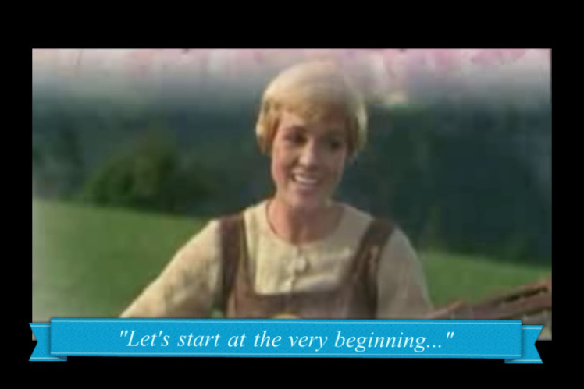](https://www.google.co.uk/url?sa=i&rct=j&q=&esrc=s&source=images&cd=&cad=rja&uact=8&ved=0CAcQjRxqFQoTCKfbq4POiMkCFYfWGgodDggAjg&url=https://lorijo.wordpress.com/2011/11/02/going-back-to-basics/&bvm=bv.106923889,d.d24&psig=AFQjCNH06lZNlNbNZjWZRbdIWLQA8_Itwg&ust=1447339510975493)

To write a good intro, you have to have **TASTE**

Title (name of text)

Author (who wrote text)

Summary (what happens, where, when)

Task (link to Q)

Explain techniques (how does writer do this?)

**EXAMPLE**

Question

Choose a novel or short story or work of non-fiction which theme of moral or social significance.

With reference to appropriate techniques, explain how the writer develops this theme and discuss why its development adds to your appreciation of the text as a whole.

Introduction

‘Of Mice and Men’ by John Steinbeck is a novella set in 1930s California, which focuses on the life of working farm hands struggling to get by during a time of great poverty. This novella deals with the important social issues of the time in America, as a result of The Great Depression, focusing primarily on disillusionment with The American Dream, and the inability for many struggling Americans to achieve this goal. Steinbeck develops this theme through careful use of characterisation, key incident and symbolism.

Set the tone

* Try to **avoid using ‘I’, ‘my’ etc**.
* Do not write in an informal tone = **no slang expressions**
* Do not use **shortened forms** (don’t, won’t, can’t = do not, will not, cannot)
* Do not use **abbreviations** (such as e.g. and etc. )
* Do not write out the number 1, always use ‘one’

What we can prep-TAS

We can very easily prepare for part of the introduction in advance, and use the same

* Title
* Author
* Summary

section for every essay we write, making it easy for you to write a quick intro and move on to the main focus on your essay.

We can also make this a very high quality opening, getting the marker on side early!

**Writing a Main Paragraph**

[](https://www.google.co.uk/url?sa=i&rct=j&q=&esrc=s&source=images&cd=&cad=rja&uact=8&ved=0CAcQjRxqFQoTCPfzsLrQiMkCFYnaGgodKhUJiA&url=https://breckynwood.wordpress.com/2013/09/23/the-unemployed-blues-and-cute-animals/&bvm=bv.106923889,d.d24&psig=AFQjCNGPuL8n7Z-rTPQawFBMSgwpMFHnxQ&ust=1447340151114821)

Use **PCQEL**

**Point**-(topic sentence-what are you writing about in this paragraph?)

**Context**- (when in the play does this take place? What’s going on at that point?)

**Quotation**-(appropriate evidence)

**Explanation**-(what does this quotation tell us? Explain key techniques used, why they are important)

**Link to Q**-(why is this important to your overall point? How does it relate to the wider ideas/themes?)

Making Your Point

* Topic sentences are really important as they signpost your essay and help you to structure your writing
* They remind you of what you are trying to say in the paragraph, and let the marker know what you intend to discuss
* A topic sentence should include:
  + A linking word/phrase
  + A reference to the technique you will be analysing
  + A reference to the Q

Example Topic Sentence

Initially, Atwood introduces the theme of women’s subjugation through her use of characterisation when describing the Handmaid’s clothing.

Using Linking Words

**Introducing an idea**

-firstly -to begin

-primarily -initially

**Adding to an idea/argument**

-additionally -furthermore -in addition

-also -moreover -in the same way

-as previously stated -similarly

**Contrasting an idea/argument**

-in contrast -on the other hand

-in comparison -instead

**Giving examples**

-for example -for instance

-such as -by way of illustration

**Concluding and summarising**

-in conclusion -to conclude -lastly

-all in all -in summary -to sum up

-ultimately

Context

Your context is where you **orientate** your reader and let them know what’s happening in the novel. Include brief details about:

-roughly **where** in the novel it takes place

-briefly **what is happening** at this point in the novel

**Example**

*At the beginning of the novel, Offred vividly describes the uniform prescribed for Handmaids:*

Quotation

Your quotation is your **evidence** to back up the point you are trying to make about the text. It must clearly **show something important** about the novel, and must be **relevant** to the question asked.

**Have you used quotations properly?**

* Use a colon : to introduce them
* If longer than a few words, take a new line
* No longer than one or two lines
* They should illustrate a point not simply repeat it

**Example:**

*It is clear she had no money: ‘Katie was heavy skint.’*

**MAKE SURE YOUR QUOTATIONS ARE WORTHWHILE!**

Explanation

Your explanation should be the longest section of your paragraph. Here you will explain in detail how your quotation backs up your point, by:

-analysing literary techniques used by the writer

-making a personal comment

-relating back to the question

**Example sentence starter**

*Here, Atwood emphasises _____through her use of ____. The ____ used illustrates…*

**Words for linking analysis to quotes**

* The following words and phrases describe **what the writer does**, or **what part of the text does**.
* They will help you to show that you are **analysing** the author’s work.

**This…**

reinforces emphasises highlights foreshadows exemplifies

explains demonstrates echoes has connotations of

suggests show creates mirrors establishes

underlines reveals hints illustrates

**Example Question**

Choose a novel or short story or work of non-fiction which theme of moral or social significance.

With reference to appropriate techniques, explain how the writer develops this theme and discuss why its development adds to your appreciation of the text as a whole.

**Example Explanation**

“Everything except the wings around my face is red: the colour of blood, which defines us….The white wings too are prescribed issue, they are to keep us from seeing, but also from being seen.” pg 18(C2)

Here, Atwood emphasises the theme of women’s subjugation through her use of characterisation. The vivid description used illustrates the strict dress code of the Handmaids, containing very symbolic elements. The colour red is significant as it symbolises their fertility, but also acts as a warning that they are untouchable. The contrasting white symbolises their ‘purity’, particularly teamed with the idea of ‘wings’, hinting at an angelic quality. However despite wings often symbolising freedom, these ‘wings’ block the Handmaids’ vision, meaning they are trapped and kept ignorant from their position. The heavy covering of the Handmaid’s bodies is symbolic of the control Gilead has over women, and suggests that women’s bodies are seen as dangerous and tempting.

Linking to the Q

In your final section of your main paragraph, you should:

* Evaluate why your chosen quotation is important
* Use wording from the question to make it clear your essay has a specific focus

**Words that indicate a personal response**

* The following words and phrases describe **how the reader feels**, or **how the text affects us** as we read.
* They will help you to show that you are **evaluating** the author’s work.

**This is…**

thought-provoking inspiring hard-hitting stimulating

fast-paced gripping profound important

skilfully done moving horrifying (a) pivotal moment

effective perceptive striking thoughtful

**Example link**

Atwood’s intriguing use of characterisation here demonstrates the complete control Gilead have over women in society in the novel, as symbolised in the enforced uniform of the Handmaids.

**Full Main Paragraph Example**

Initially, Atwood introduces the theme of women’s subjugation through her use of characterisation when describing the Handmaid’s clothing. At the beginning of the novel, Offred vividly describes the uniform prescribed for Handmaids:

“Everything except the wings around my face is red: the colour of blood, which defines us….The white wings too are prescribed issue, they are to keep us from seeing, but also from being seen.” pg 18(C2)

Here, Atwood emphasises the theme of women’s subjugation through her use of characterisation. The vivid description used illustrates the strict dress code of the Handmaids, containing very symbolic elements. The colour red is significant as it symbolises their fertility, but also acts as a warning that they are untouchable. The contrasting white symbolises their ‘purity’, particularly teamed with the idea of ‘wings’, hinting at an angelic quality. However despite wings often symbolising freedom, these ‘wings’ block the Handmaids’ vision, meaning they are trapped and kept ignorant from their position. The heavy covering of the Handmaid’s bodies is symbolic of the control Gilead has over women, and suggests that women’s bodies are seen as dangerous and tempting. Atwood’s intriguing use of characterisation here demonstrates the complete control Gilead have over women in society in the novel, as symbolised in the enforced uniform of the Handmaids.

**Writing Your Conclusion**

[](http://www.google.co.uk/url?sa=i&rct=j&q=&esrc=s&source=images&cd=&cad=rja&uact=8&ved=0CAcQjRxqFQoTCNbswrHIiskCFcfXFAodieIAbA&url=http://ted.coe.wayne.edu/sse/wq/Grant/Conclusion.html&bvm=bv.107406026,d.d24&psig=AFQjCNHvuqshZ6I-0OYSDR3o3VZIf0JdeQ&ust=1447406724079057)

Your conclusion-SERVE

In your conclusion you should:

Summarise the points you have made

Evaluate writer’s message (link to themes)

Refer back to the question

Vary your expression (don’t repeat yourself)

Express an opinion (appreciation of the text)

Example Question

Choose a novel or short story or work of non-fiction which theme of moral or social significance.

With reference to appropriate techniques, explain how the writer develops this theme and discuss why its development adds to your appreciation of the text as a whole.

Conclusion Example

Ultimately, The American Dream is seen as an unobtainable goal within Steinbeck’s novel, reflecting the difficulties of this time period and great despair felt by the working man. Through Steinbeck’s skilful use of characterisation, symbolism and key incident, this theme makes a powerful impact on the reader, allowing them to share the disillusionment felt by Lennie and George.

Concluding linking words

**Concluding and summarising**

-in conclusion -to conclude -lastly

-all in all -in summary -to sum up

-ultimately

**Reviewing Your Work**

Spelling

**Proofreading**

Spelling

[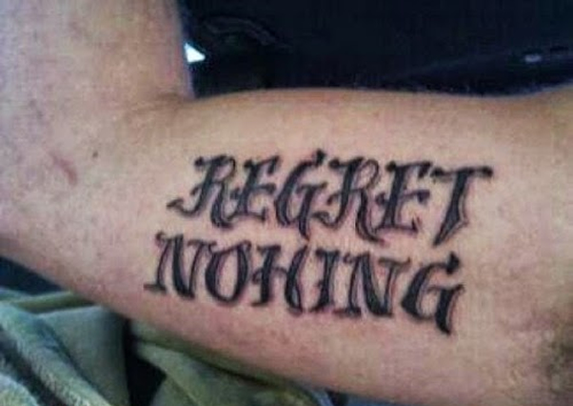](http://www.google.co.uk/url?sa=i&rct=j&q=&esrc=s&source=images&cd=&cad=rja&uact=8&ved=0CAcQjRxqFQoTCLLJno3KiskCFcVuFAodbzkCFQ&url=http://www.ultimatetop10s.com/top-10-of-the-worst-tattoo-spelling-fails/&bvm=bv.107406026,d.d24&psig=AFQjCNElIQr0POEfBxyHhYBsaCX1ex6cqg&ust=1447407165271419)

* Ensure all words are spelt correctly, to the best of your ability
* Check carefully for spellings of author names, key terminology and key words in the novel
* If you can’t spell it, don’t use it!

Punctuation and Grammar

[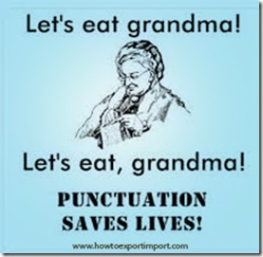](http://www.titanlists.com/wordpress/5-direct-mail-errors-avoid/)

* Ensure you are structuring your sentences properly using full stops and commas-don’t let them ramble on!
* Look back at advice for structuring quotations-ensure this is done properly
* Again, if you don’t know how to use it, don’t use it! E.g. don’t use a semi-colon if you don’t know why it’s used.
* PARAGRAPHING-follow the structure and you’ll do fine!

Presentation

[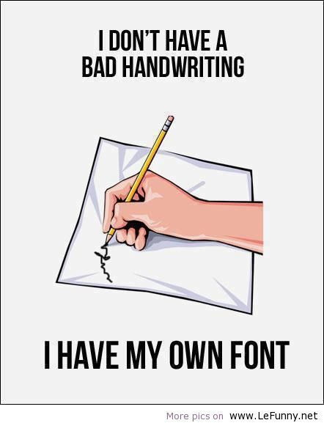](https://www.google.co.uk/url?sa=i&rct=j&q=&esrc=s&source=images&cd=&cad=rja&uact=8&ved=0CAcQjRxqFQoTCKio6pDLiskCFYlKFAodV60Juw&url=https://www.pinterest.com/arabhealth/doctors-handwriting-decoded/&bvm=bv.107406026,d.d24&psig=AFQjCNFfqLz3AKXRDzUO9NO1mcDYtImnVw&ust=1447407455792834)

* Take time to ensure your handwriting is legible-not just to you, but to others!
* Make sure spacing and size of lettering is appropriate
* To emphasise changes in paragraphs, miss a line before beginning a new one

Clarity of expression

