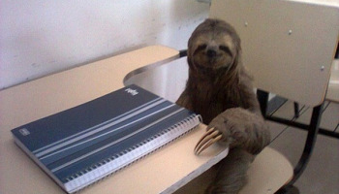
Higher Essay Writing 101

Contents
Reading the Question 1-3

Planning Your Essay 4

Writing Your Introduction 5-6

Writing Main Paragraphs 7-12

Writing Your Conclusion 13-14

Proofreading 15-16

