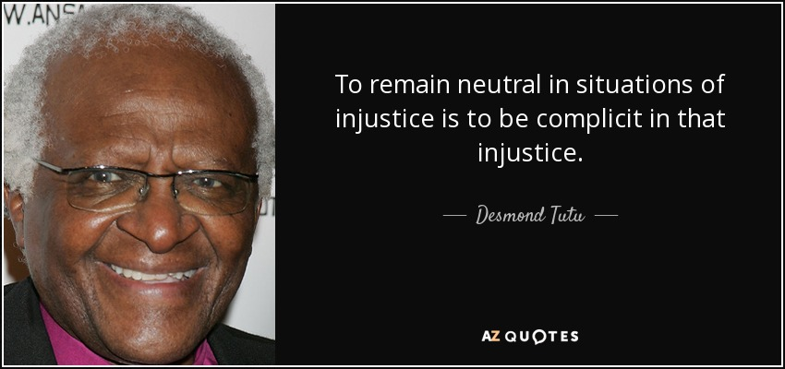

“…placed my hand on my heart to show my unity with the Salvagers and my consent, and my complicity in the death of this woman…I don’t want to see it any more. I look at the grass instead. I describe the rope.” (288, C42)

“Ofglen is giving up on me. She whispers less, talks more about the weather. I do not feel regret about this. I feel relief.” (283, C41)

“Dear God, I think, I will do anything you like. Now that you’ve let me off, I’ll obliterate myself, if that’s what you really want; I’ll empty myself, truly, become a chalice…I want to keep on living, in any form. I resign my body freely to the uses of others. They can do what they like with me. I am abject. I feel, for the first time, their true power.” (298, C45)

“…the red bodies tumble forward and I can no longer see, he’s obscured by arms, fists, feet. A high scream comes from somewhere, like a horse in terror…he has become an it.” (292, C43)