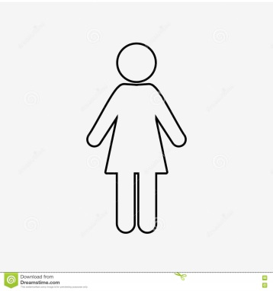

“Myself is a thing I must now compose, as one composes a speech. What I must present is a made thing, not something born.” (pg 76 C12)

“My nakedness is strange to me already. My body seems outdated. Did I really wear bathing suits, at the beach?...Shameful, immodest. I avoid looking down at my body, not so much because it is shameful or immodest but because I don’t want to see it. I don’t want to look at something that determines me so completely.” (pg72-73 C12)

It’s supposed to guarantee that I will never be able to fade, finally, into another landscape. I am too important, too scarce, for that. I am a national resource.” (pg 75 C12)

“I cannot avoid seeing, now, the small tattoo on my ankle. Four digits and an eye, a passport in reverse.

“It intersects me so that the doctor will never see my face. He deals with a torso only.” (pg 70 C11)

“The future is in your hands, she resumed. She held both her own hands out to us…But there was nothing in them. They were empty. It was our hands that were supposed to be full, of the future; which could be held but not seen.” (pg57 C8)