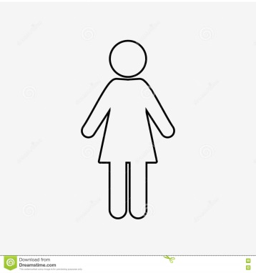

Tattoo=symbol of oppression and loss of identity. Links with animal branding/concentration camp victims. “passport in reverse”-prevents her from escaping, ever shaking off identity. “national resource”-owned by state, important for survival of nation.

Thoughts about body have shifted dramatically-sexualised image is shocking to her now, something she feels shame over-absorbing Gileadean beliefs-indoctrination. Body as symbol of purpose, lack of identity or control-“determines me so completely”

Handmaids offer hope for future of society (“future in hands”), but are offered nothing in return-they give everything-identity, bodies, children-and have no rights. Unfair exchange=oppression

Feels depersonalised-not truly herself, a utility to be used. “composes self”-has to change/modify her behaviour to suit societal expectations-not being her true self-fake. “made thing”=Gilead’s system is forced, unnatural.

Nudity/vulnerability is seen as negative-temptation for man. Hence barrier so doctor cannot see patient. No communication=no way out. Doctor hiding own identity when suggesting “assistance”. “Torso only”-fragmentation of body indicates dissociation felt by Offred-body no longer belongs to her; no longer part of her true identity

“Myself is a thing I must now compose, as one composes a speech. What I must present is a made thing, not something born.” (pg 76 C12)

“My nakedness is strange to me already. My body seems outdated. Did I really wear bathing suits, at the beach?...Shameful, immodest. I avoid looking down at my body, not so much because it is shameful or immodest but because I don’t want to see it. I don’t want to look at something that determines me so completely.” (pg72-73 C12)

It’s supposed to guarantee that I will never be able to fade, finally, into another landscape. I am too important, too scarce, for that. I am a national resource.” (pg 75 C12)

“I cannot avoid seeing, now, the small tattoo on my ankle. Four digits and an eye, a passport in reverse.

“It intersects me so that the doctor will never see my face. He deals with a torso only.” (pg 70 C11)

“The future is in your hands, she resumed. She held both her own hands out to us…But there was nothing in them. They were empty. It was our hands that were supposed to be full, of the future; which could be held but not seen.” (pg57 C8)