**Reading the Question**

[](http://www.google.co.uk/url?sa=i&rct=j&q=&esrc=s&source=images&cd=&cad=rja&uact=8&ved=0CAcQjRxqFQoTCNudiJXOiMkCFYfZGgodPC0Cig&url=http://www.dehumane.org/site/PageServer?pagename=adopter_resources&bvm=bv.106923889,d.d24&psig=AFQjCNHW-ZkKCzrza_K0-xgN2gZL6LMswA&ust=1447339559051260)

The Process

* Always read the question carefully, considering **both parts**.
* Underline **key words** from it that you will use from the **beginning** of your essay **right through to the end.**
* The starting point of your essay should **focus on the question**, not the text you have studied.
* Pay attention to **‘the magic box’**…

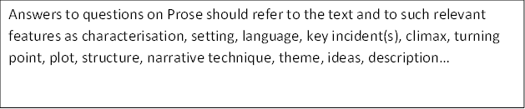

Answers to questions on Prose should refer to the text and to such relevant features as characterisation, setting, language, key incident(s), climax, turning point, plot, structure, narrative technique, theme, ideas, description…

Answers to questions on Prose should refer to the text and to such relevant features as characterisation, setting, language, key incident(s), climax, turning point, plot, structure, narrative technique, theme, ideas, description…

Answers to questions on Prose should refer to the text and to such relevant features as characterisation, setting, language, key incident(s), climax, turning point, plot, structure, narrative technique, theme, ideas, description…

Example

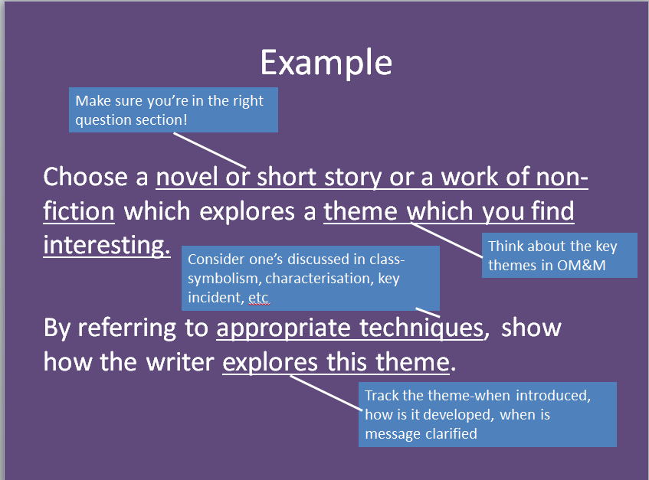

**N5 Prose Qs**

Answers to questions on Prose should refer to the text and to such relevant features as characterisation, setting, language, key incident(s), climax, turning point, plot, structure, narrative technique, theme, ideas, description…

1. Choose a novel or short story in which the writer creates a realistic or convincing character.

By referring to appropriate techniques, show how the writer creates this character, and say why you find him or her to be realistic or convincing.

1. Choose a novel or short story or a work of non-fiction which explores a theme which you find interesting.

By referring to appropriate techniques, show how the writer explores this theme.

1. Choose a novel or short story or work of non-fiction which has a key incident.

Give a brief account of the incident, and by referring to appropriate techniques, sow how this incident is important to the text as a whole.

1. Choose a novel or short story in which there is a character involved in some form of conflict.

By referring to appropriate techniques, show how the character comes to be involved in this conflict and how the conflict develops throughout the text.

1. Choose a novel or short story or work of non-fiction which explores an important theme.

By referring to appropriate techniques, show how the author has explored this theme.

1. Choose a novel or a short story in which the author creates a fascinating character.

By referring to appropriate techniques, show how the author has created this character and why you found him/her so fascinating.

1. Choose a novel or a short story where an important character clearly shows development or change.

By referring to appropriate techniques, show how the author has portrayed development and how influenced your response to the text.

1. Choose a novel or a short story or a work of non-fiction where you can identify a key moment, such as a turning point or climax.

By referring to appropriate techniques, describe the key moment and then go on to discuss its importance to the text as a whole.

1. Choose a novel or a short story or a work of non-fiction in which setting in time and/or place is an important feature.

By referring to appropriate techniques, show how the author has portrayed this setting and how this influenced your response to the text.

1. Choose a novel or short story which presents a theme that is relevant to you.

By referring to appropriate techniques, show how the author has explored this theme.

1. Choose a novel or short story that creates mood or atmosphere effectively.

By referring to appropriate techniques, show how the author has created this mood or atmosphere and how this influenced your response to the text.

1. Choose a novel or a short story or a work of non-fiction that made you consider an aspect of human nature or human society.

By referring to appropriate techniques, describe the aspect of human nature or human society and then go on to discuss its importance to the text as a whole.

**Planning Your Essay**

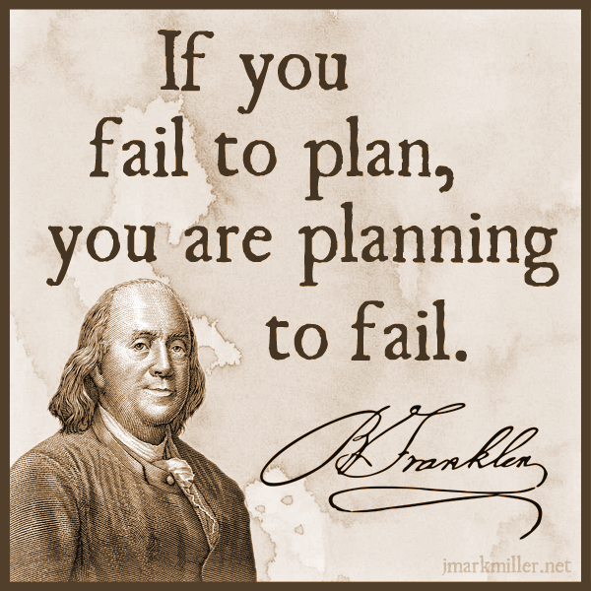

* In an exam, it doesn’t hurt to make a small plan of action for your essay, to give yourself focus and ensure you stay on task
* This could be a series of bullet points, a mind map or a few scribbles in a margin
* It will help you structure your essay well and adhere to what the question is asking

Planning Tips

* focus specifically on what is being asked-what type of Q, and what key aspects of the play you are looking at-e.g. theme, character, key scene, conflict, etc.
* think about the key moments in the play that relate to your Q-key scenes, climax, etc
* plan your essay chronologically-follow the order of the play in order to show how a theme is developed, a character changes, conflict grows, etc.

**Writing Your Introduction**

[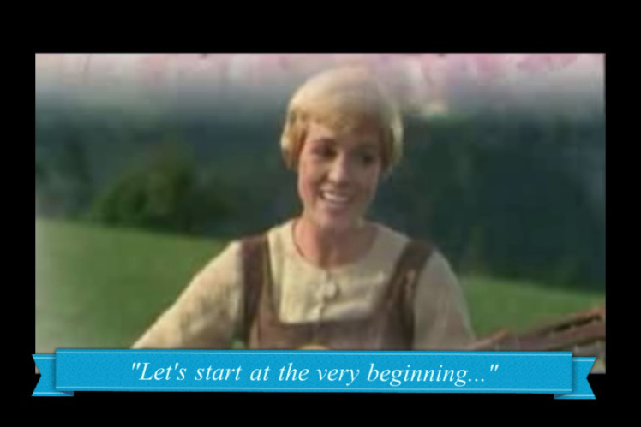](https://www.google.co.uk/url?sa=i&rct=j&q=&esrc=s&source=images&cd=&cad=rja&uact=8&ved=0CAcQjRxqFQoTCKfbq4POiMkCFYfWGgodDggAjg&url=https://lorijo.wordpress.com/2011/11/02/going-back-to-basics/&bvm=bv.106923889,d.d24&psig=AFQjCNH06lZNlNbNZjWZRbdIWLQA8_Itwg&ust=1447339510975493)

To write a good intro, you have to have **TASTE**

Title (name of text)

Author (who wrote text)

Summary (what happens, where, when)

Task (link to Q)

Explain techniques (how does writer do this?)

**EXAMPLE**

Question

Choose a novel or a short story in which the author creates a fascinating character.

By referring to appropriate techniques, show how the author has created this character and why you found him/her so fascinating.

Introduction

‘Of Mice and Men’ by John Steinbeck is a novella set in 1930s California, which focuses on the life of working farm hands, Lennie and George, struggling to get by during a time of great poverty. This novella focuses on the downfall of Lennie, a simplistic man who struggles to control his own strength, and acts as a representation of the difficulties for the working class man under capitalism. Steinbeck develops this character through careful use of characterisation, key incident and symbolism.

Set the tone

* Try to **avoid using ‘I’, ‘my’ etc**.
* Do not write in an informal tone = **no slang expressions**
* Do not use **shortened forms** (don’t, won’t, can’t = do not, will not, cannot)
* Do not use **abbreviations** (such as e.g. and etc. )
* Do not write out the number 1, always use ‘one’

What we can prep-TAS

We can very easily prepare for part of the introduction in advance, and use the same

* Title
* Author
* Summary

section for every essay we write, making it easy for you to write a quick intro and move on to the main focus on your essay.

We can also make this a very high quality opening, getting the marker on side early.

**Writing a Main Paragraph**

[](https://www.google.co.uk/url?sa=i&rct=j&q=&esrc=s&source=images&cd=&cad=rja&uact=8&ved=0CAcQjRxqFQoTCPfzsLrQiMkCFYnaGgodKhUJiA&url=https://breckynwood.wordpress.com/2013/09/23/the-unemployed-blues-and-cute-animals/&bvm=bv.106923889,d.d24&psig=AFQjCNGPuL8n7Z-rTPQawFBMSgwpMFHnxQ&ust=1447340151114821)

Use **PCQEL**

**Point**-(topic sentence-what are you writing about in this paragraph?)

**Context**- (when in the play does this take place? What’s going on at that point?)

**Quotation**-(appropriate evidence)

**Explanation**-(what does this quotation tell us? Explain key techniques used, why they are important)

**Link to Q**-(why is this important to your overall point? How does it relate to the wider ideas/themes?)

Making Your Point

* Topic sentences are really important as they signpost your essay and help you to structure your writing
* They remind you of what you are trying to say in the paragraph, and let the marker know what you intend to discuss
* A topic sentence should include:
  + A linking word/phrase
  + A reference to the technique you will be analysing
  + A reference to the Q

Example Topic Sentence

*Firstly, Steinbeck creates a sense of conflict between the characters of Lennie and Curley in their initial meeting, through characterisation.*

Using Linking Words

**Introducing an idea**

-firstly -to begin

-primarily -initially

**Adding to an idea/argument**

-additionally -furthermore -in addition

-also -moreover -in the same way

-as previously stated -similarly

**Contrasting an idea/argument**

-in contrast -on the other hand

-in comparison -instead

**Giving examples**

-for example -for instance

-such as -by way of illustration

**Concluding and summarising**

-in conclusion -to conclude -lastly

-all in all -in summary -to sum up

-ultimately

Context

Your context is where you **orientate** your reader and let them know what’s happening in the novel. Include brief details about:

-roughly **where** in the novel it takes place

-briefly **what is happening** at this point in the novel

**Example**

*At the beginning of the novel, Lennie and George arrive at the ranch and are introduced to the ranch-owner’s son, Curley, who takes an instant dislike to Lennie:*

Quotation

Your quotation is your **evidence** to back up the point you are trying to make about the text. It must clearly **show something important** about the novel, and must be **relevant** to the question asked.

**Have you used quotations properly?**

* Use a colon : to introduce them
* If longer than a few words, take a new line
* No longer than one or two lines
* They should illustrate a point not simply repeat it

**Example:**

*It is clear she had no money: ‘Katie was heavy skint.’*

**MAKE SURE YOUR QUOTATIONS ARE WORTHWHILE!**

Explanation

Your explanation should be the longest section of your paragraph. Here you will explain in detail how your quotation backs up your point, by:

-analysing literary techniques used by the writer

-making a personal comment

-relating back to the question

**Example sentence starter**

*Here, Steinbeck emphasises _____through his use of ____. The ____ used illustrates…*

**Words for linking analysis to quotes**

* The following words and phrases describe **what the writer does**, or **what part of the text does**.
* They will help you to show that you are **analysing** the author’s work.

**This…**

reinforces emphasises highlights foreshadows

exemplifies explains demonstrates echoes

has connotations of suggests show creates mirrors establishes underlines reveals hints illustrates

Example

**Question**

Choose a novel or short story in which there is a character involved in some form of conflict.

By referring to appropriate techniques, show how the character comes to be involved in this conflict and how the conflict develops throughout the text.

**Example explanation**

“He glanced coldly at George and then at Lennie. His arms gradually bent at the elbows and his hands closed into fists.” Here, Steinbeck emphasises the Curley’s immediate dislike and resentment towards Lennie through his characterisation. The description of Curley’s reaction demonstrates an instant dislike and feeling of threat, as Steinbeck indicates that he makes himself appear larger by bending his elbows, and uses his fists to create a threatening stance. In previous descriptions of each character, Steinbeck has created contrast in terms of their appearances: Lennie is very tall and large, Curley is small and stocky. potentially causing Curley to feel inferior to Lennie, despite the fact he is in a position of power on the ranch.

Linking to the Q

In your final section of your main paragraph, you should:

* Evaluate why your chosen quotation is important
* Use wording from the question to make it clear your essay has a specific focus

**Words that indicate a personal response**

* The following words and phrases describe **how the reader feels**, or **how the text affects us** as we read.
* They will help you to show that you are **evaluating** the author’s work.

**This is…**

thought-provoking inspiring hard-hitting stimulating

fast-paced gripping profound important

skilfully done moving horrifying (a) pivotal moment

effective perceptive striking thoughtful

**Example link**

These opposing descriptions, combined with Curley’s aggressive reaction towards Lennie indicate from the beginning of the text that these are very different characters, and are used by Steinbeck to demonstrate the inequality between the struggling working man and the privileged few in trying to achieve the American Dream.

**Full Main Paragraph Example**

“He glanced coldly at George and then at Lennie. His arms gradually bent at the elbows and his hands closed into fists.” Here, Steinbeck emphasises the Curley’s immediate dislike and resentment towards Lennie through his characterisation. The description of Curley’s reaction demonstrates an instant dislike and feeling of threat, as Steinbeck indicates that he makes himself appear larger by bending his elbows, and uses his fists to create a threatening stance. In previous descriptions of each character, Steinbeck has created contrast in terms of their appearances: Lennie is very tall and large, Curley is small and stocky. potentially causing Curley to feel inferior to Lennie, despite the fact he is in a position of power on the ranch. These opposing descriptions, combined with Curley’s aggressive reaction towards Lennie indicate from the beginning of the text that these are very different characters, and are used by Steinbeck to demonstrate the inequality between the struggling working man and the privileged few in trying to achieve the American Dream.

**Writing Your Conclusion**

[](http://www.google.co.uk/url?sa=i&rct=j&q=&esrc=s&source=images&cd=&cad=rja&uact=8&ved=0CAcQjRxqFQoTCNbswrHIiskCFcfXFAodieIAbA&url=http://ted.coe.wayne.edu/sse/wq/Grant/Conclusion.html&bvm=bv.107406026,d.d24&psig=AFQjCNHvuqshZ6I-0OYSDR3o3VZIf0JdeQ&ust=1447406724079057)

Your conclusion-SERVE

In your conclusion you should:

Summarise the points you have made

Evaluate writer’s message (link to themes)

Refer back to the question

Vary your expression (don’t repeat yourself)

Express an opinion (appreciation of the text)

Example Question

Choose a novel or short story or work of non-fiction which theme of moral or social significance.

With reference to appropriate techniques, explain how the writer develops this theme and discuss why its development adds to your appreciation of the text as a whole.

Example Conclusion

Ultimately, The American Dream is seen as an unobtainable goal within Steinbeck’s novel, reflecting the difficulties of this time period and great despair felt by the working man. Through Steinbeck’s skilful use of characterisation, symbolism and key incident, this theme makes a powerful impact on the reader, allowing them to share the disillusionment felt by Lennie and George.

Concluding linking words

**Concluding and summarising**

-in conclusion -to conclude -lastly

-all in all -in summary -to sum up

-ultimately

**Reviewing Your Work**

Spelling

**Proofreading**

Spelling

[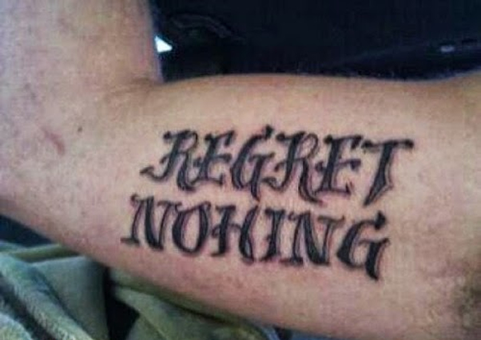](http://www.google.co.uk/url?sa=i&rct=j&q=&esrc=s&source=images&cd=&cad=rja&uact=8&ved=0CAcQjRxqFQoTCLLJno3KiskCFcVuFAodbzkCFQ&url=http://www.ultimatetop10s.com/top-10-of-the-worst-tattoo-spelling-fails/&bvm=bv.107406026,d.d24&psig=AFQjCNElIQr0POEfBxyHhYBsaCX1ex6cqg&ust=1447407165271419)

* Ensure all words are spelt correctly, to the best of your ability
* Check carefully for spellings of author names, key terminology and key words in the novel
* If you can’t spell it, don’t use it!

Punctuation and Grammar

[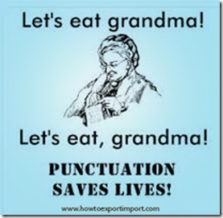](http://www.titanlists.com/wordpress/5-direct-mail-errors-avoid/)

* Ensure you are structuring your sentences properly using full stops and commas-don’t let them ramble on!
* Look back at advice for structuring quotations-ensure this is done properly
* Again, if you don’t know how to use it, don’t use it! E.g. don’t use a semi-colon if you don’t know why it’s used.
* PARAGRAPHING-follow the structure and you’ll do fine!

Presentation

[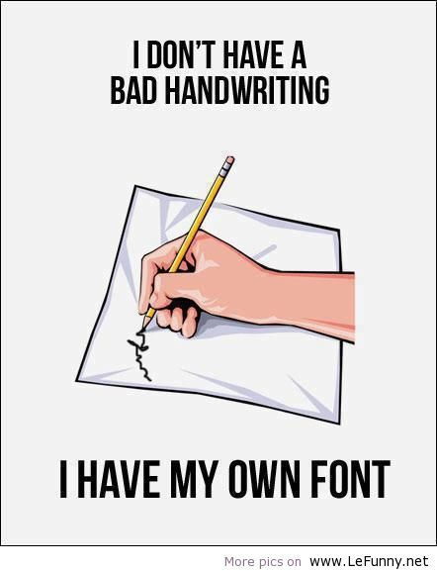](https://www.google.co.uk/url?sa=i&rct=j&q=&esrc=s&source=images&cd=&cad=rja&uact=8&ved=0CAcQjRxqFQoTCKio6pDLiskCFYlKFAodV60Juw&url=https://www.pinterest.com/arabhealth/doctors-handwriting-decoded/&bvm=bv.107406026,d.d24&psig=AFQjCNFfqLz3AKXRDzUO9NO1mcDYtImnVw&ust=1447407455792834)

* Take time to ensure your handwriting is legible-not just to you, but to others!
* Make sure spacing and size of lettering is appropriate
* To emphasise changes in paragraphs, miss a line before beginning a new one

Clarity of expression

