Background to Poem
Your Favourite Season
What is your favourite season? Give three reasons why this season is your favourite.
____________________________________

Different Seasons, Different Feelings
Spring | Summer
Autumn | Winter

Seasons and Symbolism
Spring:
________________________________________________________________________________________________________________________________________________________________________________________________
Summer:
________________________________________________________________________________________________________________________________________________________________________________________________
Autumn:
________________________________________________________________________________________________________________________________________________________________________________________________
Winter:
________________________________________________________________________________________________________________________________________________________________________________________________

What winter represents
Consider the films/TV shows set in winter. Why have they been set at this time of year? Choose one of the examples and explain why.
Chosen film/TV programme:
_______________________________________________________________
Why winter?
________________________________________________________________________________________________________________________________________________________________________________________________________________________________________________________________
Winter Symbolism
In literature, film and popular culture, winter is often used to represent:

Learning Review
Do you agree with this slightly negative view of winter? Why/why not?
________________________________________________________________________________________________________________________________________________________________________________________________________________________________________________________________

‘Winter’-Edwin Morgan
The year goes, the woods decay, and after,
many a summer dies. The swan
on Bingham’s pond, a ghost, comes and goes.
It goes, and ice appears, it holds,
bears gulls that stand around surprised,
blinking in the heavy light, bears boys
when skates take over swan-tracks gone.
After many summer dyes, the swan-white ice
glints only crystal beyond white. Even
dearest blue’s not there, though poets would find it.
I find one stark scene
cut by evening cries, by warring air.
The muffled hiss of blades escapes into breath,
hangs with it a moment, fades off.
Fades off, goes, the scene, the voices fade,
the line of trees, the woods that fall, decay
and break, the dark comes down, the shouts
run off into it and disappear.
At last the lamps go too, when fog
drives monstrous down the dual carriageway
out to the west, and even in my room
and on this paper I do not know
about that grey dead pane
of ice that sees nothing and that nothing sees.

Understanding the Poem
Morgan’s Winter
Morgan’s overall view of winter is that it is a _____________ season.
Create a Wordle based on the words in the poem representing the kind of season it is.
In a Wordle, the most frequently used/most important words are larger.

Example-Frozen ‘In Summer’
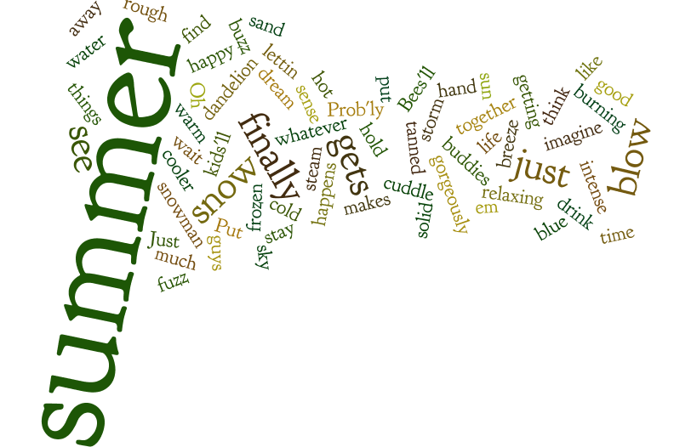
Winter Wordle
Winter

Understanding the Poem
- What common symbolic meaning of winter is introduced within the first lines of the poem? What words help you understand this?
____________________________________________________________________________________________________________________________________________________________________________________________________________________________________________
- What kind of mood is suggested in the image of the swan in lines 2-3? What technique is this?
____________________________________________________________________________________________________________________________________________________________________________________________________________________________________________
- How does Morgan create a contrasting joyful image in lines 6-7?
____________________________________________________________________________________________________________________________________________________________________________________________________________________________________________

- In lines 8-10, Morgan writes about the changing colours of the ice and states “. Even/dearest blue’s not there, though poets would find it.” What does he mean by this? Consider the symbolism behind the colour blue.
____________________________________________________________________________________________________________________________________________________________________________________________________________________________________________

- In lines 11-13, how does Morgan create a harsh image of winter? Pick out key words used.
____________________________________________________________________________________________________________________________________________________________________________________________________________________________________________

- How does Morgan create an eerie scene in lines 15-18?
____________________________________________________________________________________________________________________________________________________________________________________________________________________________________________

- How does Morgan demonstrate the power of nature in the final section of the poem? Identify a technique used here.
____________________________________________________________________________________________________________________________________________________________________________________________________________________________________________

- The final image in the poem is quite haunting. What technique is used here, and what does it suggest about winter?
____________________________________________________________________________________________________________________________________________________________________________________________________________________________________________

- What is the speaker doing in this poem? How do you know this?
____________________________________________________________________________________________________________________________________________________________________________________________________________________________________________

Learning Review
_____________________: when a writer looks back on key events for deeper meaning.

Annotating the Poem
Paired Annotation
With your partner, carefully reread the poem, annotating where you see important words/techniques being used.
- Highlight important words used
- Underline poetic techniques used
- Add comments explaining important features
You should have a good understand of the annotating process now, after our group discussions.
Use your poetic techniques cheat sheet to help you spot key techniques.

Reminder-Annotation Example
Suggests slow process of death; rotting
Idea of time passing, winter as a time of old age
The year goes, the woods decay, and after,
Personification-seasons dying adds drama; idea of winter as a symbol of death
many a summer dies.

Creating Setting

Creating a Vivid Setting
We already know that Morgan creates very interesting and vivid characters in his poems.
He also creates very vivid impressions of settings and scenes in his poetry
Poets often use sensory description to create vivid settings
What do we mean by sensory description?
________________________________________________________________________________________________________________________________________________________________________________________________
Sensory description explores:

Creating Setting in ‘Winter’
Briefly scan the poem again. What three senses does Morgan use most frequently to create a vivid impression of setting?

Sense | Evidence | Analysis
Sight
Sound
Touch

Themes in ‘Winter’
What’s the message?
What do you think Morgan is trying to say about winter in this poem?
________________________________________________________________________________________________________________________________________________________________________________________________________________________________________________________________
What is the mood in this poem?
________________________________________________________________________________________________________________________________________________________________________________________________________________________________________________________________

Exploring theme-creating PowerPoints
In your groups, you will create a PowerPoint based on one of the themes in ‘Winter’
In your PowerPoint, you will include:
- A definition of what the theme means
- 2-3 key quotations which demonstrate this theme
- Analysis of each quotation, explaining:
  - Techniques used
  - Links to theme
- A conclusion about the poet’s overall message

Notes on Themes in ‘Winter’
Theme:

Theme definition:

Key Quotations:
Quotation 1

Analysis

Quotation 2

Analysis

Overall message:

Theme:

Theme definition:

Key Quotations:
Quotation 1

Analysis

Quotation 2

Analysis

Overall message:

Theme:

Theme definition:

Key Quotations:
Quotation 1

Analysis

Quotation 2

Analysis

Overall message:

