Background to Poem
Valentine Association
What words/ideas spring to mind when you think of the word ‘valentine’?

Valentine

‘Valentine’-The Title
Denotation
________________________________________________________________________________________________________________________________
Connotations (negative)

Connotations (positive)

An Onion
What ideas are associated with onions?

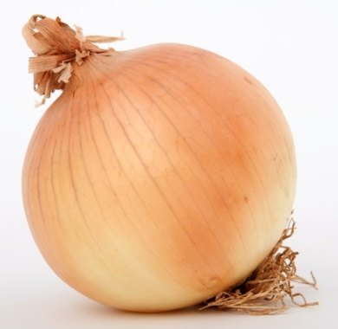

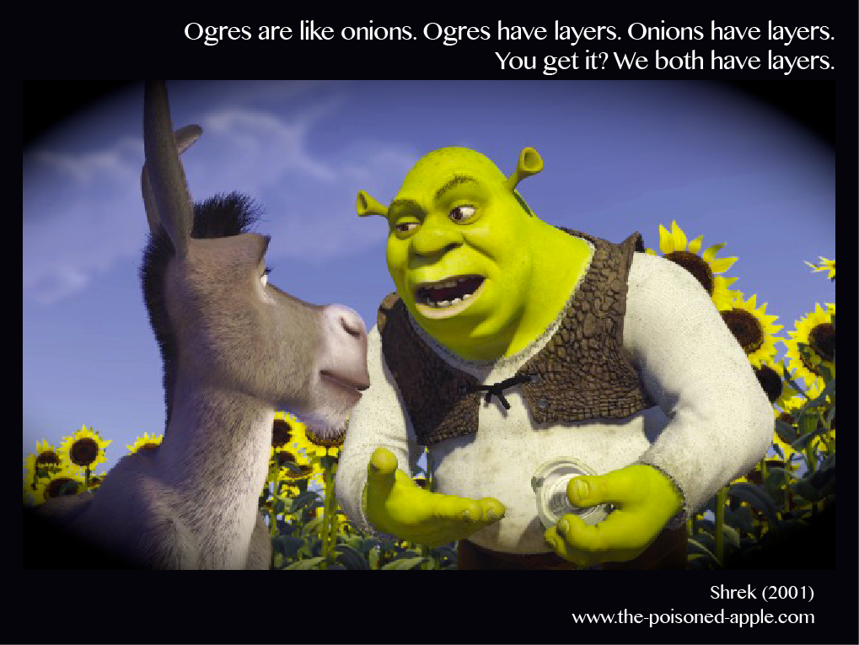
What does Shrek mean by this?
________________________________________________________________________________________________________________________________________________________________________________________________________________________________________________________________

‘Valentine’-Carol Ann Duffy

Not a red rose or a satin heart.

I give you an onion.
It is a moon wrapped in brown paper.
It promises light
like the careful undressing of love.

Here.
It will blind you with tears
like a lover.
It will make your reflection
a wobbling photo of grief.

I am trying to be truthful.

Not a cute card or a kissogram.

I give you an onion.
Its fierce kiss will stay on your lips,
possessive and faithful
as we are,
for as long as we are.

Take it.
Its platinum loops shrink to a wedding ring,
if you like.
Lethal.
Its scent will cling to your fingers,
cling to your knife.

Understanding the Poem
- From lines 1 and 12, what does the speaker think about St Valentine’s Day and the gifts that people give?
____________________________________________________________________________________________________________________________________________________________________________________________________________________________________________

- What is interesting about the way the onion is described in the third stanza of the poem? What is the speaker trying to say about love?
____________________________________________________________________________________________________________________________________________________________________________________________________________________________________________

- What does the writer compare to a ‘fierce kiss’ in stanza 6? What does she mean by this?
____________________________________________________________________________________________________________________________________________________________________________________________________________________________________________

- How is an onion described as being similar to a wedding ring in stanza 7? What are the similarities?
____________________________________________________________________________________________________________________________________________________________________________________________________________________________________________

- How is the ending of the poem slightly sinister/uncomfortable?
____________________________________________________________________________________________________________________________________________________________________________________________________________________________________________

- Who is the speaker and do you think they are addressing a specific person? If so, who?
____________________________________________________________________________________________________________________________________________________________________________________________________________________________________________

- Do you think the speaker is feeling a specific emotion throughout this poem? If so what is it/are they?
____________________________________________________________________________________________________________________________________________________________________________________________________________________________________________

Learning Review
What are the speaker’s overall thoughts on Valentine’s day?
________________________________________________________________________________________________________________________________________________________________________________________________

What are the speaker’s overall thoughts on love?
________________________________________________________________________________________________________________________________________________________________________________________________

Creating Comparisons
Extended Metaphor
________________________________________________________________________________________________________________________________________________________________________________________________
Love is like an onion…
Quotation | Shared Quality | Onion | Love

Themes
Theme:

Theme definition:

Key Quotations:
Quotation 1

Analysis

Quotation 2

Analysis

Overall message:

Theme:

Theme definition:

Key Quotations:
Quotation 1

Analysis

Quotation 2

Analysis

Overall message:

10 Mark Question-Comparing ‘Valentine’ and ‘Havisham’
What is the 10 mark question?
The final question in your textual analysis paper will be worth 10 marks.
It will ask you to compare at least two of the poems you have studied, based on aspects they have in common.
These aspects could be:
- Common themes
- Similar characters
- Poetic techniques commonly used
- Similar settings-time/place
- Similarities in structure
- Persona/speaker’s voice

Identifying Commonalities
As we study each poem, we will try to identify how it is similar to other poems we have studied.We will practise making comparisons between poems to ensure we are well-prepared for this
These poems have very different topics and plots. How are they similar? Identify two things they have in common:

Example Question
By referring to this poem and to at least one other poem by Duffy, discuss how the poet explores emotional conflict within an individual. (10 marks)
Structure of the 10 mark Q
- Your answer to this question will use headings and bullet points
- You will use this structure for all 10 mark questions
- Deal with each poem at a time
Commonality (2 marks)

Given poem in exam (2 marks)

Chosen poem (6 marks/4 marks/2 marks)

(chosen poem) (4 marks/2 marks)
10 Mark Question-Commonality
Commonality
- Explain how poem given links to Q (1)
- explain how chosen poem links to Q (1)
WHO is the individual in the poem, WHAT is their emotional conflict?
Commonality-Example
- In ‘Valentine’, Duffy explores emotional conflict within an individual by presenting a character who is struggling to express their love in an effective way
- In ‘Havisham’, Duffy explores emotional conflict within an individual by…___________________________________________________________________________________________________________________
10 Mark Q-Given Poem
‘Valentine’/given poem
- Quotation from extract
- Thorough analysis of quotation (1)
- Link to 10 mark Q (1)

‘Valentine’/given poem-Example
- “it’s fierce kiss will stay on your lips/possessive and faithful”
- Throughout poem, compares love to an onion-here emphasising lasting impression of love, like taste of onion
- ________________________________________________________________________________________________________________________________________________________________________________________________________________________________
10 Mark Q-Chosen Poem
‘Havisham’/chosen poem
- Quotation from extract
- Thorough analysis of quotation (1)
- Link to 10 mark Q (1)
- X 3
‘Havisham’/chosen poem-Example
- “beloved sweetheart bastard”
- Use of juxtaposition in word choice-”beloved” suggests tenderness, affection, love; whereas “bastard” suggests hatred, bitterness, rejection (1)
- Indicates the conflicting emotions Havisham feels towards her former love-she clings onto her loving feelings, but has been twisted by the rejection (1)

- ______________________________________________________________________________________________________________________

- _________________________________________________________________________________________________________________________________________________________________________________

- ____________________________________________________________________________________________________________________________________________________________________________________________________________________________________________

- ______________________________________________________________________________________________________________________

- _________________________________________________________________________________________________________________________________________________________________________________

- ____________________________________________________________________________________________________________________________________________________________________________________________________________________________________________

