Background to Text
Myth of Midas
In Greek mythology, King Midas performed a service for the god Bacchus and in return was granted a wish; Midas wished for everything he touched to be turned to gold.
Though Midas initially enjoyed this ability, when he discovered that his food and drink also turned to gold he realised his mistake in wishing for riches above all things.
Starving and deranged, Midas was forced to wander alone, searching for a cure.
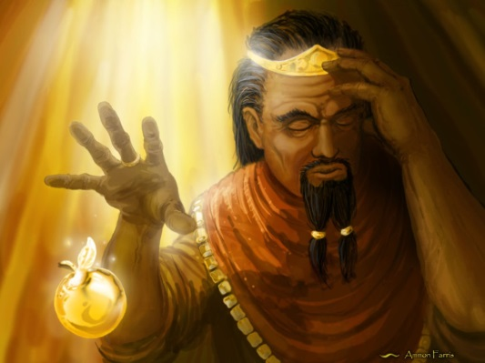

The ‘Midas Touch’
In modern times, the phrase 'Midas touch' is often applied within the media to entrepreneurs who seem to have the ability to make unprofitable companies or a range of companies, yield significant profits.

The World’s Wife
- A collection of poems written by Carol Ann Duffy
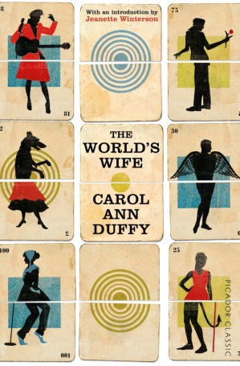
- All written from the point of view of a famous person’s partner

‘Mrs Darwin’
7 April 1852.

Went to the Zoo.
I said to Him –
Something about that Chimpanzee over there reminds me
of you.

Mrs Midas
What do you think her attitude will be towards her husband?
________________________________________________________________________________________________________________________________________________________________________________________________
What would she think was good about his choice?
________________________________________________________________________________________________________________________________________________________________________________________________
What would she think was bad about his choice?
________________________________________________________________________________________________________________________________________________________________________________________________

‘Mrs Midas’
It was late September. I’d just poured a glass of wine, begun
to unwind, while the vegetables cooked. The kitchen
filled with the smell of itself, relaxed, its steamy breath
gently blanching the windows. So I opened one,
then with my fingers wiped the other’s glass like a brow.
He was standing under the pear tree snapping a twig.

Now the garden was long and the visibility poor, the way
the dark of the ground seems to drink the light of the sky,
but that twig in his hand was gold. And then he plucked
a pear from a branch. – we grew Fondante d’Automne –
and it sat in his palm, like a lightbulb. On.
I thought to myself, Is he putting fairy lights in the tree?

He came into the house. The doorknobs gleamed.
He drew the blinds. You know the mind; I thought of
the Field of the Cloth of Gold and of Miss Macready.
He sat in that chair like a king on a burnished throne.
The look on his face was strange, wild, vain. I said,
What in the name of God is going on? He started to laugh.

I served up the meal. For starters, corn on the cob.
Within seconds he was spitting out the teeth of the rich.
He toyed with his spoon, then mine, then with the knives, the forks.
He asked where was the wine. I poured with a shaking hand,
a fragrant, bone-dry white from Italy, then watched
as he picked up the glass, goblet, golden chalice, drank.

It was then that I started to scream. He sank to his knees.
After we’d both calmed down, I finished the wine
on my own, hearing him out. I made him sit
on the other side of the room and keep his hands to himself.
I locked the cat in the cellar. I moved the phone.
The toilet I didn’t mind. I couldn’t believe my ears:

how he’d had a wish. Look, we all have wishes; granted.
But who has wishes granted? Him. Do you know about gold?
It feeds no one; aurum, soft, untarnishable; slakes
no thirst. He tried to light a cigarette; I gazed, entranced,
as the blue flame played on its luteous stem. At least,
I said, you’ll be able to give up smoking for good.

Separate beds. in fact, I put a chair against my door,
near petrified. He was below, turning the spare room
into the tomb of Tutankhamun. You see, we were passionate then,
in those halcyon days; unwrapping each other, rapidly,
like presents, fast food. But now I feared his honeyed embrace,
the kiss that would turn my lips to a work of art.

And who, when it comes to the crunch, can live
with a heart of gold? That night, I dreamt I bore
his child, its perfect ore limbs, its little tongue
like a precious latch, its amber eyes
holding their pupils like flies. My dream milk
burned in my breasts. I woke to the streaming sun.

So he had to move out. We’d a caravan
in the wilds, in a glade of its own. I drove him up
under the cover of dark. He sat in the back.
And then I came home, the woman who married the fool
who wished for gold. At first, I visited, odd times,
parking the car a good way off, then walking.

You knew you were getting close. Golden trout
on the grass. One day, a hare hung from a larch,
a beautiful lemon mistake. And then his footprints,
glistening next to the river’s path. He was thin,
delirious; hearing, he said, the music of Pan
from the woods. Listen. That was the last straw.

What gets me now is not the idiocy or greed
but lack of thought for me. Pure selfishness. I sold
the contents of the house and came down here.
I think of him in certain lights, dawn, late afternoon,
and once a bowl of apples stopped me dead. I miss most,
even now, his hands, his warm hands on my skin, his touch.
Understanding the Poem
- What kind of environment in created in the first stanza of the poem? What role do we think Mrs Midas plays in the relationship?

- “he plucked/a pear from a branch…it sat in his palm, like a lightbulb. On.” (stanza 2) What does the writer’s comparison suggest about this moment?

- How does the writer make Midas (man) seem childish in stanzas 4 and 5? Pick out a quotation and explain.

- “Look, we all have wishes; granted./But who has wishes granted? Him. Do you know about gold?/It feeds no one…; slakes/no thirst.” (stanza 6) what are the speaker’s feelings about her husband’s wish?

- Look at stanza 7. Describe how the speaker feels at this point in the poem.

- Look at stanza 9. What do you think the speaker’s final feelings are towards her husband? Pick a quotation and explain.

- How would you describe the tone of this poem? How does it change throughout the poem? Use examples in your answer.

Creating Character
Mrs Midas
Aspect of Characterisation | Evidence | Explanation
Appearance | “And then I came home, the woman who married the fool/  who wished for gold.” Stanza 9
Actions | Stanza 7
Speech | Stanza 6
Thoughts | Stanza 8/11

Midas
Aspect of Characterisation | Evidence | Explanation
Appearance | “The look on his face was strange, wild, vain” (stanza 3)
Actions | Stanza 4/5
Speech | Stanza 10
Thoughts | Stanza 6

Themes
Theme:

Theme definition:

Key Quotations:
Quotation 1

Analysis

Quotation 2

Analysis

Overall message:

Theme:

Theme definition:

Key Quotations:
Quotation 1

Analysis

Quotation 2

Analysis

Overall message:

Theme:

Theme definition:

Key Quotations:
Quotation 1

Analysis

Quotation 2

Analysis

Overall message:

Theme:

Theme definition:

Key Quotations:
Quotation 1

Analysis

Quotation 2

Analysis

Overall message:

