In The Snack Bar-Background to Poem

Considering Setting

Setting is an important aspect in poetry. It can give us:

Vs.
Restaurant
Snack bar

What does the snack bar setting tell us about the poem?
- information on a character’s circumstances

_________________________________________________________________________________________________________________________________________________________________________________
- mood within the poem

_________________________________________________________________________________________________________________________________________________________________________________

- cultural context for the poem

_________________________________________________________________________________________________________________________________________________________________________________

Exploring Character

Morgan’s poetry is often about people, places or animals.

In this poem, there is a character study of the experience of a disadvantaged man, with Morgan acting as the speaker within the poem.

Morgan reflects on this man’s experience of life, and how it differs from his own, as an able-bodied person.

Defining Disability

How would you define the word ‘disability’? What does this word mean to you?

Disability is…

________________________________________________________________________________________________________________________________________________________________________________________________

Disability-Differing Stances

There is actually more than one way of defining disability, and different groups in society see disability differently.

Medical Model

Social Model

Disability-Why A Taboo?

Disability can often be a subject that people feel uncomfortable discussing, or confronting in person.
- Why might that be?

- How can we tackle this issue?

- Have you ever felt uncomfortable encountering someone with a disability?

- Has a family member or friend ever been treated badly because of a disability?

Disability is sometimes seen as taboo, because…

________________________________________________________________________________________________________________________________________________________________________________________________________________________________________________________________________________________________________________________________

From what we know about Morgan, Why might he sympathise with a character who experiences stigma?

_______________________________________________________________________________________________________________________________________________________________________________________________

In the Snack Bar
A cup capsizes along the formica,
slithering with a dull clatter.
A few heads turn in the crowded evening snack-bar.
An old man is trying to get to his feet
from the low round stool fixed to the floor.
Slowly he levers himself up, his hands have no power.
He is up as far as he can get. The dismal hump
looming over him forces his head down.
He stands in his stained beltless garberdine
like a monstrous animal caught in a tent
in some story. He sways slightly,
the face not seen, bent down
in shadow under his cap.
Even on his feet he is staring at the floor
or would be, if he could see.
I notice now his stick, once painted white
but scuffed and muddy, hanging from his right arm.
Long blind, hunchback born, half paralysed
he stands
fumbling with the stick
and speaks:
‘I want –to go to the-toilet.’

It is down two flights of stairs, but we go.
I take his arm. ‘Give me-your arm-it’s better,’ he says.
Inch by inch we drift towards the stairs.
A few yards of floor are like a landscape
to be negotiated, in the slow setting out
time has almost stopped. I concentrate
my life to his: crunch of spilt sugar,
slidy puddle from the night’s umbrellas,
table edges, people’s feet,
hiss of the coffee-machine, voices and laughter,
smell of a cigar, hamburgers, wet coats steaming,
and the slow dangerous inches to the stairs.
I put his right hand on the rail
and take his stick. He clings to me. The stick
is in his left hand, probing the treads
I guide his arm and tell him the steps.
And slowly we go down. And slowly we go down.
White tiles and mirrors at last. He shambles
uncouth into the clinical gleam.
I set him in position, stand behind him
and wait with his stick.
His brooding reflection darkens the mirror
but the trickle of his water is thin and slow,
an old man’s apology for living.
Painful ages to close his trousers and coat –
I do up the last buttons for him.
He asks doubtfully, ‘Can I- wash my hands?’
I fill the basin, clasp his soft fingers round the soap.
He washes, feebly, patiently. There is no towel.
I press the pedal of the drier, draw his hands
gently into the roar of the hot air.
But he cannot rub them together,
drags out a handkerchief to finish.
He is glad to leave the contraption, and face the stairs.
He climbs, and steadily enough.
He climbs, we climb. He climbs
with many pauses but with that one
persisting patience of the undefeated
which is the nature of man when all is said.
And slowly we go up. And slowly we go up.
The faltering, unfaltering steps
take him at last to the door
across that endless, yet not endless waste of floor.
I watch him helped on a bus. It shudders off in the rain.
The conductor bends to hear where he wants to go.

Wherever he could go it would be dark
and yet he must trust men.
Without embarrassment or shame
he must announce his most pitiful needs
in a public place. No one sees his face.
Does he know how frightening he is in his strangeness
under his mountainous coat, his hands like wet leaves
stuck to the half-white stick?
His life depends on many who would evade him.
But he cannot reckon up the chances,
having one thing to do,
to haul his blind hump through these rains of August.
Dear Christ, to be born for this!
Understanding the Poem
Summary of poem
Write an eight line rap, summarizing the poem:
________________________________________________________________________________________________________________________________________________________________________________________________________________________________________________________________________________________________________________________________________________________________________________________________________________________________________________________________________________________________________________________________

Understanding the Poem
- Who do you think the speaker is in the poem?
_________________________________________________________________________________________________________________________________________________________________________________
- How does the poet subtly suggest the man has a disability in stanza 1? Give two quotations that show this.
_________________________________________________________________________________________________________________________________________________________________________________
_________________________________________________________________________________________________________________________________________________________________________________

- How does the poet demonstrate the difficulties of the journey to the toilet in stanza 2 (first half)? Give two quotations to support this.
_________________________________________________________________________________________________________________________________________________________________________________
_________________________________________________________________________________________________________________________________________________________________________________

- How do you think the old man feels about himself? Look at the second half of stanza 2.
_________________________________________________________________________________________________________________________________________________________________________________
_________________________________________________________________________________________________________________________________________________________________________________

- How does the poet demonstrate the man’s weakness in stanza 2 (second half)? Give two quotations to support this.
_________________________________________________________________________________________________________________________________________________________________________________
_________________________________________________________________________________________________________________________________________________________________________________

- Who do you think the poet is speaking to in stanza 3? Why?
_________________________________________________________________________________________________________________________________________________________________________________
___________________________________________________________
- What is the poet’s attitude towards society in stanza 3? Write down a quotation that supports this.
____________________________________________________________________________________________________________________________________________________________________________________________________________________________________________

- What mood is created at the end of the poem? Explain your answer.
____________________________________________________________________________________________________________________________________________________________________________________________________________________________________________

Learning Review
What attitude is the reader supposed to have towards:
The speaker:
________________________________________________________________________________________________________________________________________________________________________________________________________________________________________________________________
The man:
________________________________________________________________________________________________________________________________________________________________________________________________________________________________________________________________

Annotating the Poem
Annotating
What do you think this word means?
________________________________________________________________________________________________________________________________________________________________________________________________
What word do you recognise inside this word?
________________________________________________________________
Annotating is…
________________________________________________________________________________________________________________________________________________________________________________________________

Poetic Techniques Bingo
You will be given a bingo sheet with a number of poetic techniques on it.
I will read aloud examples of some of these poetic techniques.
You will write the example underneath the technique when you hear it.
When you complete a line, shout BINGO!
If you complete your whole sheet, shout HOUSE!

Annotation Example
Hyperbole-little moments given great importance
Formica-laminate used for worktops; cheap
Alliteration-C sound is harsh, like smash of cup
A cup capsizes along the formica,
slithering with a dull clatter.
A few heads turn in the crowded evening snack-bar.
An old man is trying to get to his feet
from the low round stool fixed to the floor.
Slowly he levers himself up, his hands have no power.
He is up as far as he can get. The dismal hump
looming over him forces his head down.
Suggests bleakness, unpleasantness
Personification-hump/disabilities overpowering him
Personification-man reduced to disabilities rather than whole person
Suggests difficulty/ struggle
Suggests difficulty
Contrast-clatter seems sharp and loud, dull makes it sound every day and ordinary-emphasises his clumsiness
Personification-cup hiding out of embarrassment

‘In The Snack Bar-Creating Character
Key Characters
In this poem, we have two key characters-the man and the speaker.
Why is each character important?
The man:
________________________________________________________________________________________________________________________________________________________________________________________________

The speaker:
________________________________________________________________________________________________________________________________________________________________________________________________
Creating Characters
Characters are created in a number of ways, through:

Creating Characters-‘In The Snack Bar’
In your pair, you will consider how ONE of the characters is created in the poem. You will complete the table, explaining the different aspects of their character, and give evidence for this from the poem.
Some aspects may be easier to spot than others!

The man
Aspect of Characterisation | Evidence | Description
Appearance
Actions
Speech
Thoughts

The speaker
Aspect of Characterisation | Evidence | Description
Appearance
Actions
Speech
Thoughts

In The Snack Bar-Themes
A theme is…
________________________________________________________________________________________________________________________________________________________________________________________________

Themes in Disney
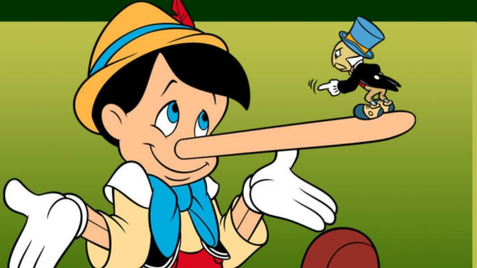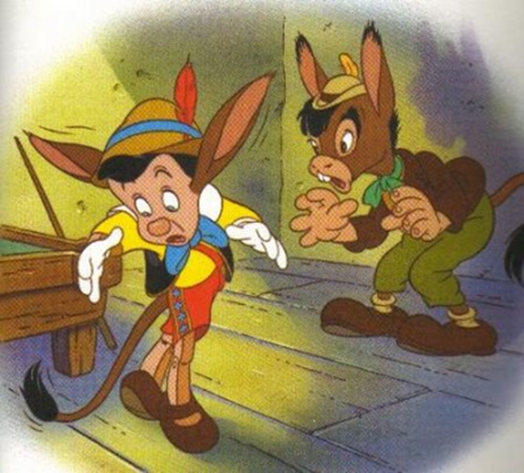
In Disney’s ‘Pinocchio’, Pinocchio runs away from his father, disobeying his rules. He then faces consequences for making bad decisions, for example-when he lies, his nose grows longer. When he drinks alcohol, he turns into a donkey.
What are the main messages/themes in this story?

Can you identify the main theme in the following Disney films?
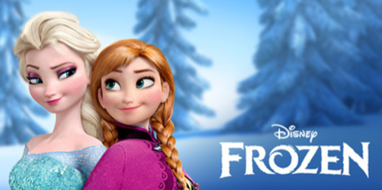
______________________________________ ____________________________________________________________________________

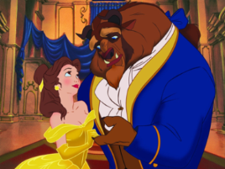
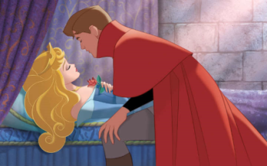
_____________________________________ ____________________________________________________________________________
_____________________________________ ____________________________________________________________________________

Identifying Theme
In poetry, themes are often based on feelings and opinions, created by character, setting, plot.
- Think about the characters-how do we feel about them?
- How does the writer feel about his topic?
- How do they feel about their actions?
Identifying Themes in ‘In The Snack Bar’
What do you think the themes might be in ‘In The Snack Bar’?
What is the big idea or message?
Identify two.

Themes in ‘In The Snack Bar’

Theme Group Work Task-Success Criteria
Your poster should include:
- An explanation of what your theme is e.g. what is guilt/abuse/isolation/etc…?
- At least TWO quotations from the poem that show this theme
- At least TWO explanations of how the quotations show the theme
- What you think the poet’s overall message is about this theme
- TWO pictures to demonstrate your theme-drawings/online images (to be printed at home)
Group Roles
Highlight your role
- Resource Manager-collect materials, ensure everyone is on task, assist with researching/drawing
- Researcher-identify quotations in poem
- Scribe-Note down information on poster
- Artist-draw/create/source images, assist with researching
Peer Assessment-Contribution
Assessor: _________________________
Comment: _________________________________________________________________________________________________________________________________________________________________________________________________________________________________
Making Effective Notes
Effective notes are…
Structure

Content

Notes on Themes in ‘In The Snack Bar’
Theme:

Theme definition:

Key Quotations:
Quotation 1

Analysis

Quotation 2

Analysis

Overall message:

Theme:

Theme definition:

Key Quotations:
Quotation 1

Analysis

Quotation 2

Analysis

Overall message:

Theme:

Theme definition:

Key Quotations:
Quotation 1

Analysis

Quotation 2

Analysis

Overall message:

Theme:

Theme definition:

Key Quotations:
Quotation 1

Analysis

Quotation 2

Analysis

Overall message:

Learning Review-Morgan and Religion
- Is there a biblical story that you are reminded of in this poem?
- What biblical figure might the speaker in the poem represent?
- Explain your reasoning
________________________________________________________________________________________________________________________________________________________________________________________________________________________________________________________________

