Background to Poem
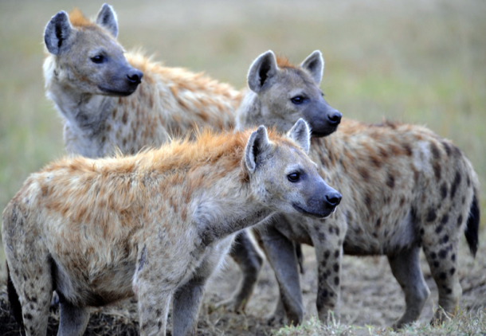
Thoughts on Hyenas
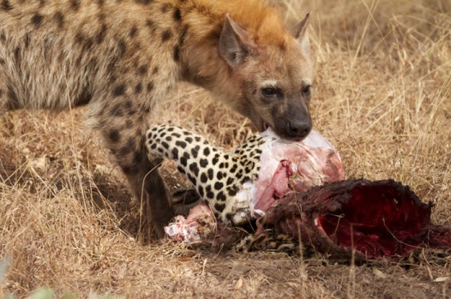
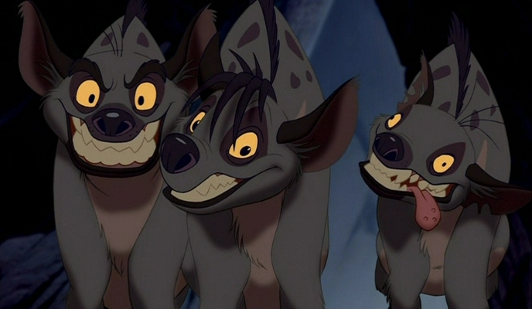
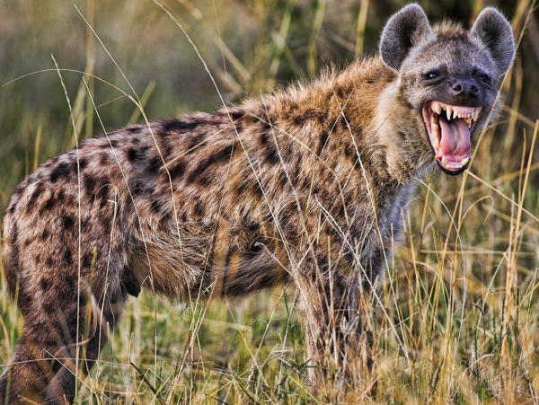

Based on your prior knowledge/the photos presented/representations you know, what do you think hyenas are like?
Write three bullet points about your views/knowledge on hyenas

Hyenas-Finding Out More
- Watch the video clips on hyenas
- Note down five key pieces of information you discover about hyenas

Hyena Information

Hyenas in Culture
Consider the Disney depiction of hyenas. What are they like? What qualities do they possess? What attitude do we have towards them?

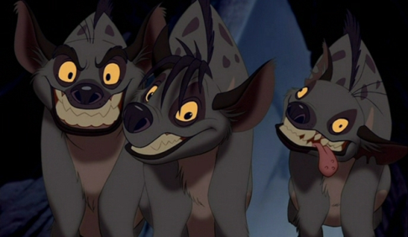

Hyenas: Positive or Negative?
Positive qualities

Negative qualities

‘Hyena’-Edwin Morgan

I am waiting for you.
I have been travelling all morning through the bush
and not eaten.
I am lying at the edge of the bush
on a dusty path that leads from the burnt-out kraal.
I am panting, it is midday, I found no water-hole.
I am very fierce without food and although my eyes
are screwed to slits against the sun
you must believe I am prepared to spring.

What do you think of me?
I have a rough coat like Africa.
I am crafty with dark spots
like the bush-tufted plains of Africa.
I sprawl as a shaggy bundle of gathered energy
like Africa sprawling in its waters.
I trot, I lope, I slaver, I am a ranger.
I hunch my shoulders. I eat the dead.

Do you like my song?
When the moon pours hard and cold on the veldt
I sing, and I am the slave of darkness.
Over the stone walls and the mud walls and the ruined places
and the owls, the moonlight falls.
I sniff a broken drum. I bristle. My pelt is silver.
I howl my song to the moon – up it goes.
Would you meet me there in the waste places?

It is said I am a good match
for a dead lion. I put my muzzle
at his golden flanks, and tear. He
is my golden supper, but my tastes are easy.
I have a crowd of fangs, and I use them.
Oh and my tongue – do you like me
when it comes lolling out over my jaw
very long, and I am laughing?
I am not laughing.
But I am not snarling either, only
panting in the sun, showing you
what I grip
carrion with.

I am waiting
for the foot to slide,
for the heart to seize,
for the leaping sinews to go slack,
for the fight to the death to be fought to the death,
for a glazing eye and the rumour of blood.
I am crouching in my dry shadows
till you are ready for me.
My place is to pick you clean
and leave your bones to the wind.

Understanding the Poem
Identifying Narrative Style
Identify the narrative style used in the sentence-is it written in first, second or third person narration?

- Today, Sally will go to Tesco.
______________________
- I don’t know if I can pass my National 5 Maths this year.
______________________
- We know that Edwin Morgan is a Scottish poet.
______________________
- You went to David’s party.
______________________
- Miss Innes gave the class sweeties on their last day.
______________________
- My favourite Edwin Morgan poem is ‘In The Snack Bar’.
______________________
- You didn’t listen to the teacher.
______________________
- The class decided to buy the teacher a bottle of wine.
______________________

Narrative Perspective
First person:
________________________________________________________________________________________________________________________________
Second person:
________________________________________________________________________________________________________________________________
Third person:
________________________________________________________________________________________________________________________________
Narrative Perspective-Pros and Cons
First person
Pros

Cons

Third Person

Pros

Cons

Dramatic Monologue
Dramatic monologue is…
________________________________________________________________________________________________________________________________________________________________________________________________

Understanding the Poem
- Why is it perhaps unusual that Morgan has used dramatic monologue as the form of this poem?
____________________________________________________________________________________________________________________________________________________________________________________________________________________________________________
- What sort of persona is created in stanza 1? Give evidence to support your answer.
____________________________________________________________________________________________________________________________________________________________________________________________________________________________________________

- “I have a rough coat like Africa” (stanza 2). What technique is used here? What comparison is being made?
____________________________________________________________________________________________________________________________________________________________________________________________________________________________________________

- How does the poet create a dark, mysterious image of the hyena in stanza 3? Give evidence.
____________________________________________________________________________________________________________________________________________________________________________________________________________________________________________

- “It is said I am a good match/for a dead lion” (stanza 4). What does this suggest about the hyena?
____________________________________________________________________________________________________________________________________________________________________________________________________________________________________________

- How does the hyena demonstrate its power in stanza 4?
____________________________________________________________________________________________________________________________________________________________________________________________________________________________________________

- How is the hyena shown to be quite sinister in the final stanza? Give evidence in your answer.
____________________________________________________________________________________________________________________________________________________________________________________________________________________________________________

- What is your overall opinion/impression of the hyena? Explain in detail.
____________________________________________________________________________________________________________________________________________________________________________________________________________________________________________

Learning Review
This poem is designed to make the reader feel uncomfortable.
How does Morgan do this? Consider our discussion of narrative perspective earlier.
____________________________________________________________________________________________________________________________________________________________________________________________________________________________________________

Annotating The Poem

Quick-fire Annotation!
- We will split the poem into sections

- Each group will be given a different pen colour

- Each group will be given 2 minutes with the poem

- Each group will be asked to contribute something different to the section during their round

‘Hyena’-Creating Character
Why the Hyena?
Why do you think Morgan has chosen to write from the point of view of this animal?
________________________________________________________________________________________________________________________________________________________________________________________________________________________________________________________________
Do you think humans and hyenas share any similar qualities?
________________________________________________________________________________________________________________________________________________________________________________________________________________________________________________________________
Comparing Humans and Hyenas
Quality | Hyenas | Humans
Easily irritable | “I am very fierce without food and although my eyes/  are screwed to slits against the sun/  you must believe I am prepared to spring.” | Miss Innes if she doesn’t eat regularly!
Hunter
Creating Character
As with ‘In the Snack Bar’, Morgan builds character in a number of ways:
- Appearance-what they look like, wear
- Actions-what they do, how they do it
- Speech-what they say, how they say it
- Thoughts-what they think

Creating Character-‘Hyena’
- In your pair, you will consider how the character of the hyena is created in the poem. You will complete the table, explaining the different aspects of their character, and give evidence for this from the poem.
- Some aspects may be easier to spot than others!
Aspect of Characterisation | Evidence | Description
Appearance
Actions
Speech
Thoughts

Themes in ‘Hyena’
What’s the message?
In this dramatic monologue, the hyena makes many bold statements about itself
What do you think Morgan is trying to say about:
- Our attitude towards hyenas?
________________________________________________________________________________________________________________________________________________________________________________________________________________________________________________________________
- The main priority of hyenas?
________________________________________________________________________________________________________________________________________________________________________________________________________________________________________________________________
Key themes in ‘Hyena’

________________________________________________________________________________________________________________________________________________________________________________________________

________________________________________________________________________________________________________________________________________________________________________________________________

__________________________________________________________________________________________________________________________________________________________________________________________
Poet’s overall message
Explanation of theme

Changed perceptions

Key Quotation 2

Analysis
Key Quotation 1

Analysis

Poet’s overall message
Explanation of theme

Key Quotation 2

Analysis
Key Quotation 1

Analysis
Survival

Poet’s overall message
Explanation of theme

Key Quotation 1

Analysis

Life and death

Key Quotation 2

Analysis

8 Mark Question-‘Hyena’ and ‘In The Snack Bar’

Identifying Commonalities-‘Hyena’ and ‘In the Snack Bar’
These poems have very different topics and plots
How are they similar? Identify two things they have in common

Example Question
________________________________________________________________________________________________________________________________________________________________________________________________________________________________________________________________

Structure of 8 mark question
- Deal with each poem separately
- Use headings for each poem
- Use bullet points to check you have written enough

Basic Structure
Given poem (e.g. ‘Hyena’)
- State link between poem and question-how is theme/character/technique shown in poem?
- Relevant quotation
- Explain what quotation shows-techniques used

Chosen Poem (e.g. ‘In The Snack Bar’)
- State link between poem and question-how is theme/character/technique shown in poem?
- Relevant quotation
- Explain what quotation shows-techniques used
- State further link between poem and question-how is theme/character/technique shown in poem?
- Relevant quotation
- Explain what quotation shows-techniques used

