What is Scottish Text Study?
In class
- Part of your critical reading study

- You will study a series of poems by a Scottish poet (six poems in total), analysing key language features and ensuring you have a good understanding of the common themes in their work

In exam
- Part of critical reading paper, alongside critical essay (1hr 30mins)

- You are given one of the poems you have studied in class

- You will answer questions based on that poem (textual analysis), looking at the language, themes, characters etc.

- You will then compare the extract to another poem you have studied, in an 8 mark essay-style question

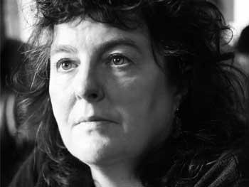
Who is Carol Ann Duffy?
- Born in Glasgow 1955, moved to Stafford aged 6.
- Critically acclaimed as well as popular with readers.
- One of the best known and most celebrated of living poets, Duffy was appointed Poet Laureate in 2009-the first female, and first LGBT poet to hold the position.
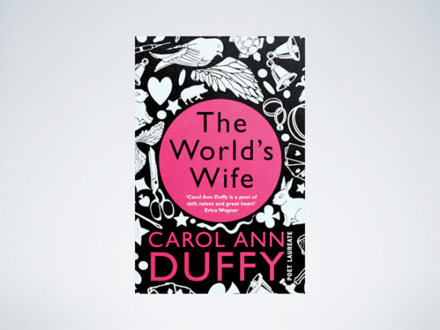
- As well as being Poet Laureate, Duffy is currently the Director of the Writing School at Manchester Metropolitan University.
Duffy's Work
- She says she uses “simple words in a complicated way.”
- Duffy’s poems often explore political, philosophical and social issues, especially issues centring on gender, identity and inequality.
- Duffy is particularly known for her exploration of feminine archetypes, the subversion of gender stereotypes and her dramatic monologues.
- These monologues are often written in the voices of characters marginalised or demonised by mainstream society.
- A lapsed Catholic for whom poetry is very close to prayer, for Duffy, in each of her poems she is “trying to reveal a truth”.
Major Themes in Duffy's writing
- Memory-childhood, lost love, preserving memories
- Time-past-pleasant and haunting; inability to return to past; decay; losing time
- Love and relationships-passion and desire; heartbreak
- Isolation-socially, emotionally
- Female voice-characters and female myths
- Truth-honesty, bluntness
Havisham-Background to Text
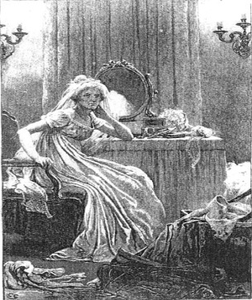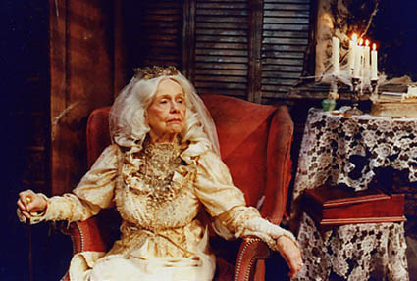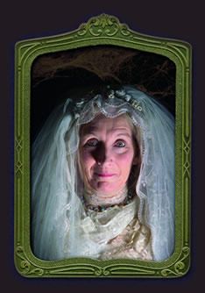
What do you think has happened to this old lady? What might be her story?
________________________________________________________________________________________________________________________________________________________________________________________________
Miss Havisham

Describing Miss Havisham
What words would you use to describe Miss Havisham? Think about appearance and looks

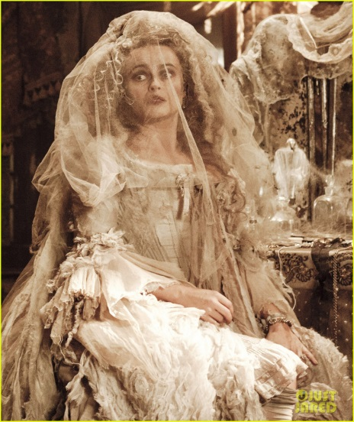
Duffy's Stance
Considering Duffy is a firm feminist, what do you think she would think of Miss Havisham as a representation of someone who has been rejected at the altar?
________________________________________________________________________________________________________________________________________________________________________________________________________________________________________________________
Why do you think Duffy chose to drop the ‘Miss’?
________________________________________________________________________________________________________________________________________________________________________________________________________________________________________________________

Havisham
Beloved sweetheart bastard. Not a day since then
I haven’t wished him dead. Prayed for it
so hard I’ve dark green pebbles for eyes,
ropes on the back of my hands I could strangle with.

Spinster. I stink and remember. Whole days
in bed cawing Nooooo at the wall; the dress
yellowing, trembling if I open the wardrobe;
the slewed mirror, full-length, her, myself, who did this

to me? Puce curses that are sounds not words.
Some nights better, the lost body over me,
my fluent tongue in its mouth in its ear
then down till I suddenly bite awake. Love’s

hate behind a white veil; a red balloon bursting
in my face. Bang. I stabbed at a wedding cake.
Give me a male corpse for a long slow honeymoon.
Don’t think it’s only the heart that b-b-b-breaks.

Understanding The Poem
- How does Duffy create contrast in the opening line of the poem? Do you know what this technique is called?
____________________________________________________________________________________________________________________________________________________________________________________________________________________________________________
- What is the significance of the colour green in line 3? What does green symbolise?
____________________________________________________________________________________________________________________________________________________________________________________________________________________________________________
- How does Duffy create a bluntness in the first line of stanza 2?
____________________________________________________________________________________________________________________________________________________________________________________________________________________________________________
- How does the poet make Havisham seem animalistic in stanza 2?
____________________________________________________________________________________________________________________________________________________________________________________________________________________________________________
- How is stanza 3 different from stanza 1 and 2? What is Havisham doing in this stanza?
____________________________________________________________________________________________________________________________________________________________________________________________________________________________________________
- How does Duffy use wedding imagery to show Havisham’s distress in stanza 4?
____________________________________________________________________________________________________________________________________________________________________________________________________________________________________________
- What does the final line suggest about Havisham’s emotions and mental state?
____________________________________________________________________________________________________________________________________________________________________________________________________________________________________________
Learning Review
- How is the reader supposed to feel towards Havisham?
- Do we have conflicting feelings towards her?
____________________________________________________________________________________________________________________________________________________________________________________________________________________________________________

Annotating the Poem
Annotating
What do you think this word means?
________________________________________________________________________________________________________________________________________________________________________________________________
What word do you recognise inside this word?
________________________________________________________________
Annotating is…
________________________________________________________________________________________________________________________________________________________________________________________________

Poetic Techniques Bingo
You will be given a bingo sheet with a number of poetic techniques on it.
I will read aloud examples of some of these poetic techniques.
You will write the example underneath the technique when you hear it.
When you complete a line, shout BINGO!
If you complete your whole sheet, shout HOUSE!

Creating Character
Creating Characters
Characters are created in a number of ways, through:

Creating Character-‘Havisham
Look back at the poem, and find evidence of how Duffy creates a full character in the form of Havisham

Find evidence describing
  - Appearance
  - Actions
  - Speech
  - thoughts

Aspect of Characterisation | Evidence | Description
Appearance
Actions
Speech
Thoughts

How does Duffy create a sinister character?
Pick one quotation that describes an aspect of Havisham that makes her seem sinister.
Put a star next to your chosen quotation.
________________________________________________________________________________________________________________________________________________________________________________________________________________________________________________________________________________________________________________________________________________________________________________________________________________________________________________________________________________________________________________________________________________________________________________________________________________________________________________________________________________________________________________________________________________________________________________________________________________________________________________________________________________________________________________________________________________________________________________________________________________________________________________________________________________________________________________________________________________________________________________________________________________________________________________________________________________________________________________________________

Themes
Themes in Duffy's Work
Look back at the list of themes in Duffy’s work, discussed at the beginning of the course.
Which themes are present in ‘Havisham’?
- Memory-childhood, lost love, preserving memories
- Time-past-pleasant and haunting; inability to return to past; decay; losing time
- Love and relationships-passion and desire; heartbreak
- Isolation-socially, emotionally
- Female voice-characters and female myths
- Truth-honesty, bluntness
Themes in 'Havisham'
- _________________________________________________________________________________________________________________________________________________________________________________
- _________________________________________________________________________________________________________________________________________________________________________________
- _________________________________________________________________________________________________________________________________________________________________________________
- _________________________________________________________________________________________________________________________________________________________________________________
- _________________________________________________________________________________________________________________________________________________________________________________

Theme Group Work Task-Success Criteria
Your poster should include:
- An explanation of what your theme is e.g. what is guilt/abuse/isolation/etc…?
- At least TWO quotations from the poem that show this theme
- At least TWO explanations of how the quotations show the theme
- What you think the poet’s overall message is about this theme
- TWO pictures to demonstrate your theme-drawings/online images (to be printed at home)

Notes on Themes in ‘Havisham'
Theme:

Theme definition:

Key Quotations:
Quotation 1

Analysis

Quotation 2

Analysis

Overall message:

Theme:

Theme definition:

Key Quotations:
Quotation 1

Analysis

Quotation 2

Analysis

Overall message:

Theme:

Theme definition:

Key Quotations:
Quotation 1

Analysis

Quotation 2

Analysis

Overall message:

Theme:

Theme definition:

Key Quotations:
Quotation 1

Analysis

Quotation 2

Analysis

Overall message:

Theme:

Theme definition:

Key Quotations:
Quotation 1

Analysis

Quotation 2

Analysis

Overall message:

