**Reading the Question**

[](http://www.google.co.uk/url?sa=i&rct=j&q=&esrc=s&source=images&cd=&cad=rja&uact=8&ved=0CAcQjRxqFQoTCNudiJXOiMkCFYfZGgodPC0Cig&url=http://www.dehumane.org/site/PageServer?pagename=adopter_resources&bvm=bv.106923889,d.d24&psig=AFQjCNHW-ZkKCzrza_K0-xgN2gZL6LMswA&ust=1447339559051260)

The Process

* Always read the question carefully, considering **both parts**.
* Underline **key words** from it that you will use from the **beginning** of your essay **right through to the end.**
* The starting point of your essay should **focus on the question**, not the text you have studied.
* Pay attention to **‘the magic box’**…

Answers to questions on Drama should refer to the text and to such relevant features as characterisation, key scene(s), structure, climax, theme, plot, conflict, setting...

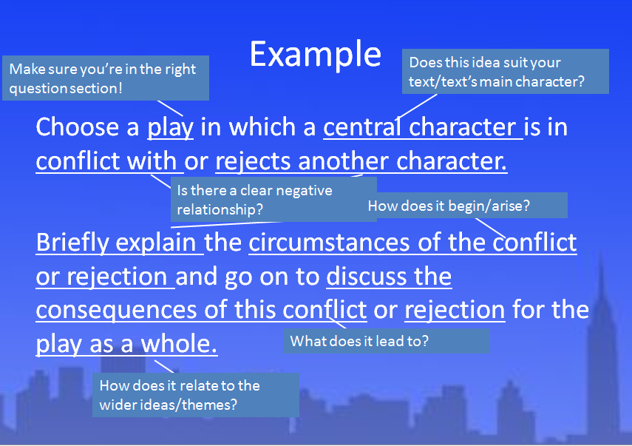Example

**Higher Drama Qs**

Answers to questions on Drama should refer to the text and to such relevant features as characterisation, key scene(s), structure, climax, theme, plot, conflict, setting...

1. Choose a play in which a central character is in conflict with or rejects another character.

Briefly explain the circumstances of the conflict or rejection and go on to discuss the consequences of this conflict or rejection for the play as a whole.

2. Choose a play in which the historical and/or geographical and/or social setting is important to your understanding of the play.

Explain how the dramatist presents the setting and discuss why it is important to your understanding of the play as a whole.

3. Choose a play which has an effective opening or concluding scene.

By briefly referring to details of the scene, explain how the dramatist made it effective and discuss how it contributes to your appreciation of the text as a whole.

4. Choose a play in which a major character's actions influence the emotions of others.

Briefly explain how the dramatist presents these emotions and actions and discuss how this contributes to your understanding of the play as a whole.

5. Choose a play in which there is a scene involving a moment of conflict or of resolution to conflict.

By referring to details of the scene, explain how the dramatist presents this moment and discuss how this contributes to your appreciation of the play as a whole.

6. Choose a play which explores an important issue or issues within society.

Briefly explain the nature of the issue(s) and discuss how the dramatist's presentation of the issue(s) contributed to your appreciation of the play as a whole.

7. Choose a play in which a central character struggles to cope with social convention or financial difficulties or family duties.

Briefly explain the reasons for the character's struggle and discuss how the dramatist's presentation of this struggle enhances your understanding of character and/or theme in the play as a whole.

8. Choose a play in which the concluding scene provides effective clarification of the central concerns.

By referring in detail to the concluding scene, discuss in what ways it is important for your understanding of the play as a whole.

9. Choose a play in which the conflict between two characters in as important feature.

Briefly explain the nature of this conflict and discuss how the dramatist's presentation of this feature enhances your understanding of the play as a whole.

**Planning Your Essay**

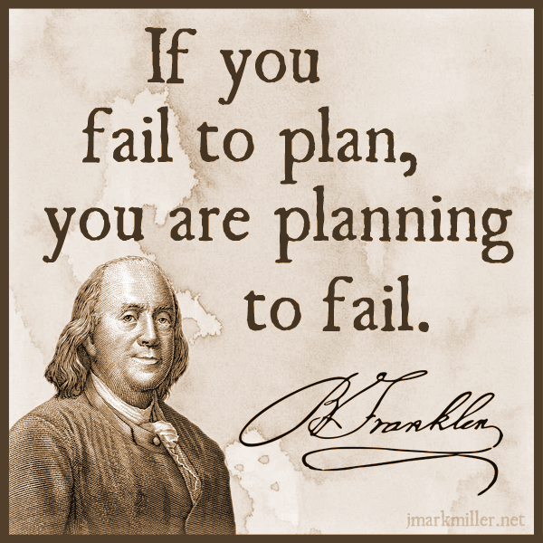

* In an exam, it doesn’t hurt to make a small plan of action for your essay, to give yourself focus and ensure you stay on task
* This could be a series of bullet points, a mind map or a few scribbles in a margin
* It will help you structure your essay well and adhere to what the question is asking

Planning Tips

* focus specifically on what is being asked-what type of Q, and what key aspects of the play you are looking at-e.g. theme, character, key scene, conflict, etc.
* think about the key moments in the play that relate to your Q-key scenes, climax, etc
* plan your essay chronologically-follow the order of the play in order to show how a theme is developed, a character changes, conflict grows, etc.

**Writing Your Introduction**

[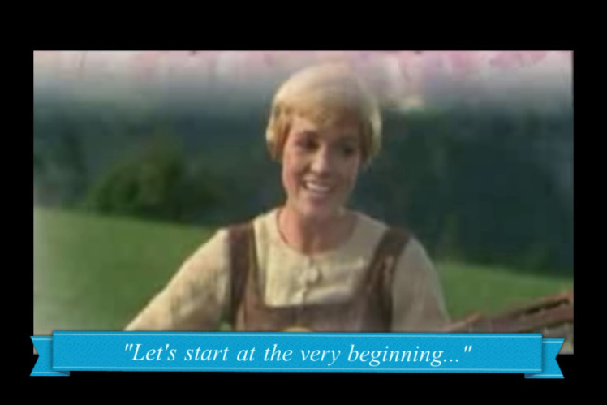](https://www.google.co.uk/url?sa=i&rct=j&q=&esrc=s&source=images&cd=&cad=rja&uact=8&ved=0CAcQjRxqFQoTCKfbq4POiMkCFYfWGgodDggAjg&url=https://lorijo.wordpress.com/2011/11/02/going-back-to-basics/&bvm=bv.106923889,d.d24&psig=AFQjCNH06lZNlNbNZjWZRbdIWLQA8_Itwg&ust=1447339510975493)

To write a good intro, you have to have **TASTE**

Title (name of text)

Author (who wrote text)

Summary (what happens, where, when)

Task (link to Q)

Explain techniques (how does writer do this?)

**EXAMPLE**

Question

Choose a novel or short story or work of non-fiction which theme of moral or social significance.

With reference to appropriate techniques, explain how the writer develops this theme and discuss why its development adds to your appreciation of the text as a whole.

Introduction

‘Of Mice and Men’ by John Steinbeck is a novella set in 1930s California, which focuses on the life of working farm hands struggling to get by during a time of great poverty. This novella deals with the important social issues of the time in America, as a result of The Great Depression, focusing primarily on disillusionment with The American Dream, and the inability for many struggling Americans to achieve this goal. Steinbeck develops this theme through careful use of characterisation, key incident and symbolism.

Set the tone

* Try to **avoid using ‘I’, ‘my’ etc**.
* Do not write in an informal tone = **no slang expressions**
* Do not use **shortened forms** (don’t, won’t, can’t = do not, will not, cannot)
* Do not use **abbreviations** (such as e.g. and etc. )
* Do not write out the number 1, always use ‘one’

What we can prep-TAS

We can very easily prepare for part of the introduction in advance, and use the same

* Title
* Author
* Summary

section for every essay we write, making it easy for you to write a quick intro and move on to the main focus on your essay.

We can also make this a very high quality opening, getting the marker on side early!

**Writing a Main Paragraph**

[](https://www.google.co.uk/url?sa=i&rct=j&q=&esrc=s&source=images&cd=&cad=rja&uact=8&ved=0CAcQjRxqFQoTCPfzsLrQiMkCFYnaGgodKhUJiA&url=https://breckynwood.wordpress.com/2013/09/23/the-unemployed-blues-and-cute-animals/&bvm=bv.106923889,d.d24&psig=AFQjCNGPuL8n7Z-rTPQawFBMSgwpMFHnxQ&ust=1447340151114821)

Use **PCQEL**

**Point**-(topic sentence-what are you writing about in this paragraph?)

**Context**- (when in the play does this take place? What’s going on at that point?)

**Quotation**-(appropriate evidence)

**Explanation**-(what does this quotation tell us? Explain key techniques used, why they are important)

**Link to Q**-(why is this important to your overall point? How does it relate to the wider ideas/themes?)

Making Your Point

* Topic sentences are really important as they signpost your essay and help you to structure your writing
* They remind you of what you are trying to say in the paragraph, and let the marker know what you intend to discuss
* A topic sentence should include:
  + A linking word/phrase
  + A reference to the technique you will be analysing
  + A reference to the Q

Example Topic Sentence

Initially, Miller introduces the idea of conflict between Eddie and Rodolpho through his use of stage directions in their first meeting.

Using Linking Words

**Introducing an idea**

-firstly -to begin

-primarily -initially

**Adding to an idea/argument**

-additionally -furthermore -in addition

-also -moreover -in the same way

-as previously stated -similarly

**Contrasting an idea/argument**

-in contrast -on the other hand

-in comparison -instead

**Giving examples**

-for example -for instance

-such as -by way of illustration

**Concluding and summarising**

-in conclusion -to conclude -lastly

-all in all -in summary -to sum up

-ultimately

Context

Your context is where you **orientate** your reader and let them know what’s happening in the novel. Include brief details about:

-roughly **where** in the novel it takes place

-briefly **what is happening** at this point in the novel

**Example**

*At the beginning of the play, Eddie closely watches Rodolpho’s interactions with Catherine, and his jealousy is apparent:*

Quotation

Your quotation is your **evidence** to back up the point you are trying to make about the text. It must clearly **show something important** about the novel, and must be **relevant** to the question asked.

**Have you used quotations properly?**

* Use a colon : to introduce them
* If longer than a few words, take a new line
* No longer than one or two lines
* They should illustrate a point not simply repeat it

**Example:**

*It is clear she had no money: ‘Katie was heavy skint.’*

**MAKE SURE YOUR QUOTATIONS ARE WORTHWHILE!**

Explanation

Your explanation should be the longest section of your paragraph. Here you will explain in detail how your quotation backs up your point, by:

-analysing literary techniques used by the writer

-making a personal comment

-relating back to the question

**Example sentence starter**

*Here, Miller emphasises _____through his use of ____. The ____ used illustrates…*

**Words for linking analysis to quotes**

* The following words and phrases describe **what the writer does**, or **what part of the text does**.
* They will help you to show that you are **analysing** the author’s work.

**This…**

reinforces emphasises highlights foreshadows

exemplifies explains demonstrates echoes

has connotations of suggests show creates mirrors establishes underlines reveals hints illustrates

Example

**Question**

Choose a play in which a central character is in conflict with or rejects another character.

Briefly explain the circumstances of the conflict or rejection and go on to discuss the consequences of this conflict or rejection for the play as a whole.

**Example explanation**

“*he is sizing up Rodolpho, and there is a concealed suspicion.*” Here, Miller emphasises Eddie’s discomfort through his use of stage directions. Eddie’s desire for dominance and control over Catherine and the household is indicated in his ‘sizing up’ of Rodolpho, as he assesses Rodolpho’s attributes carefully. At this stage in the play, Eddie is furtive about his dislike for Rodolpho-he is aware he must present as a welcoming figure, yet his fatal flaw of his secret desire for his niece clouds his ability to see Rodolpho as an equal.

Linking to the Q

In your final section of your main paragraph, you should:

* Evaluate why your chosen quotation is important
* Use wording from the question to make it clear your essay has a specific focus

**Words that indicate a personal response**

* The following words and phrases describe **how the reader feels**, or **how the text affects us** as we read.
* They will help you to show that you are **evaluating** the author’s work.

**This is…**

thought-provoking inspiring hard-hitting stimulating

fast-paced gripping profound important

skilfully done moving horrifying (a) pivotal moment

effective perceptive striking thoughtful

**Example link**

Miller’s careful use of stage directions at the beginning of the play foreshadows Eddie’s prolonged vendetta against Rodolpho, and reveals the spark of jealousy that will ignite the conflict which motivates this tragic play.

**Full Main Paragraph Example**

Initially, Miller introduces the idea of conflict between Eddie and Rodolpho through his use of stage directions in their first meeting. At the beginning of the play, Eddie closely watches Rodolpho’s interactions with Catherine, and his jealousy is apparent: “*he is sizing up Rodolpho, and there is a concealed suspicion.*” Here, Miller emphasises Eddie’s discomfort through his use of stage directions. Eddie’s desire for dominance and control over Catherine and the household is indicated in his ‘sizing up’ of Rodolpho, as he assesses Rodolpho’s attributes carefully. At this stage in the play, Eddie is furtive about his dislike for Rodolpho-he is aware he must present as a welcoming figure, yet his fatal flaw of his secret desire for his niece clouds his ability to see Rodolpho as an equal. Miller’s careful use of stage directions at the beginning of the play foreshadows Eddie’s prolonged vendetta against Rodolpho, and reveals the spark of jealousy that will ignite the conflict which motivates this tragic play.

**Writing Your Conclusion**

[](http://www.google.co.uk/url?sa=i&rct=j&q=&esrc=s&source=images&cd=&cad=rja&uact=8&ved=0CAcQjRxqFQoTCNbswrHIiskCFcfXFAodieIAbA&url=http://ted.coe.wayne.edu/sse/wq/Grant/Conclusion.html&bvm=bv.107406026,d.d24&psig=AFQjCNHvuqshZ6I-0OYSDR3o3VZIf0JdeQ&ust=1447406724079057)

Your conclusion-SERVE

In your conclusion you should:

Summarise the points you have made

Evaluate writer’s message (link to themes)

Refer back to the question

Vary your expression (don’t repeat yourself)

Express an opinion (appreciation of the text)

Example Question

Choose a novel or short story or work of non-fiction which theme of moral or social significance.

With reference to appropriate techniques, explain how the writer develops this theme and discuss why its development adds to your appreciation of the text as a whole.

Conclusion Example

Ultimately, The American Dream is seen as an unobtainable goal within Steinbeck’s novel, reflecting the difficulties of this time period and great despair felt by the working man. Through Steinbeck’s skilful use of characterisation, symbolism and key incident, this theme makes a powerful impact on the reader, allowing them to share the disillusionment felt by Lennie and George.

Concluding linking words

**Concluding and summarising**

-in conclusion -to conclude -lastly

-all in all -in summary -to sum up

-ultimately

**Reviewing Your Work**

Spelling

**Proofreading**

Spelling

[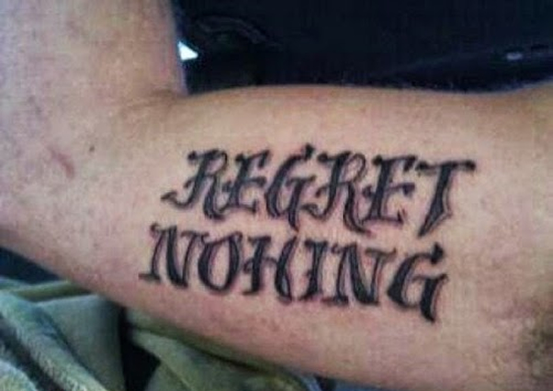](http://www.google.co.uk/url?sa=i&rct=j&q=&esrc=s&source=images&cd=&cad=rja&uact=8&ved=0CAcQjRxqFQoTCLLJno3KiskCFcVuFAodbzkCFQ&url=http://www.ultimatetop10s.com/top-10-of-the-worst-tattoo-spelling-fails/&bvm=bv.107406026,d.d24&psig=AFQjCNElIQr0POEfBxyHhYBsaCX1ex6cqg&ust=1447407165271419)

* Ensure all words are spelt correctly, to the best of your ability
* Check carefully for spellings of author names, key terminology and key words in the novel
* If you can’t spell it, don’t use it!

Punctuation and Grammar

[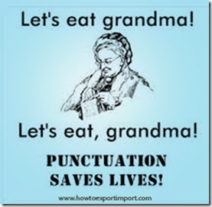](http://www.titanlists.com/wordpress/5-direct-mail-errors-avoid/)

* Ensure you are structuring your sentences properly using full stops and commas-don’t let them ramble on!
* Look back at advice for structuring quotations-ensure this is done properly
* Again, if you don’t know how to use it, don’t use it! E.g. don’t use a semi-colon if you don’t know why it’s used.
* PARAGRAPHING-follow the structure and you’ll do fine!

Presentation

[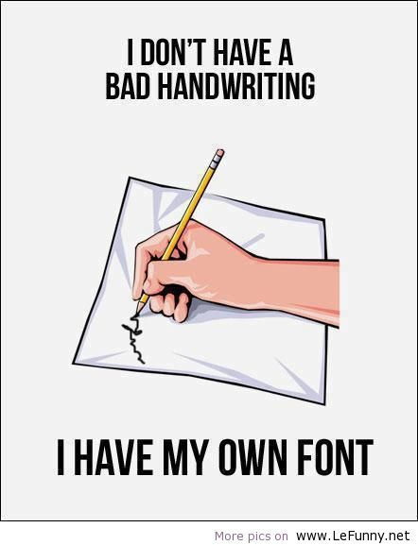](https://www.google.co.uk/url?sa=i&rct=j&q=&esrc=s&source=images&cd=&cad=rja&uact=8&ved=0CAcQjRxqFQoTCKio6pDLiskCFYlKFAodV60Juw&url=https://www.pinterest.com/arabhealth/doctors-handwriting-decoded/&bvm=bv.107406026,d.d24&psig=AFQjCNFfqLz3AKXRDzUO9NO1mcDYtImnVw&ust=1447407455792834)

* Take time to ensure your handwriting is legible-not just to you, but to others!
* Make sure spacing and size of lettering is appropriate
* To emphasise changes in paragraphs, miss a line before beginning a new one

Clarity of expression

