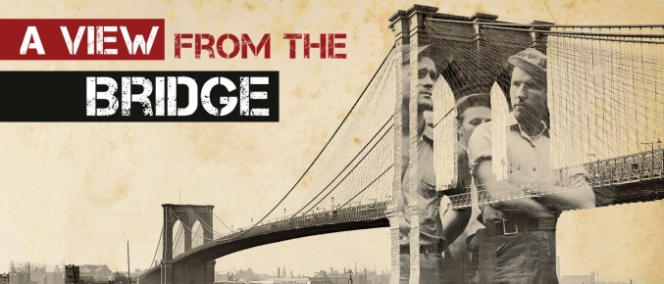
Key Quotations for Essay Qs-AVFTB

Key Scene Q (ending)
Context | Quotation | Explanation
 | “Now we settle for half, and I like it better.”
 | “a guy do a thing like that? How’s he gonna show his face?”
 | “When the law is wrong it’s because it’s unnatural, but in this case it is natural and a river will drown you if you buck it now.”
“Marco…dashes into the room and faces Eddie…spits into Eddie’s face.”

“Lipari and wife exit…Louis barely turns, then walks off.”
 | “Eddie lunges with the knife. Marco grabs his arm, turning the blade inward and pressing it home…Eddie, the knife still in his hand, falls to his knees before Marco.”

Character Q (fatal flaw) (Eddie)
Context | Quotation | Explanation
“a guy do a thing like that? How’s he gonna show his face?”

“Now don’t aggravate me, Katie, you are walkin’ wavy!....You ain’t ‘all the girls’.”
 | “he is sizing up Rodolpho, and there is a concealed suspicion”
 | “sometimes…there’s too much…there’s too much love for the daughter, there is too much love for the niece.”(pg 42)
 | “Marco is face to face with Eddie, a strained tension gripping his eyes and jaw, his neck stiff, the chair raised like a weapon” pg 52
 | “Eddie lunges with the knife. Marco grabs his arm, turning the blade inward and pressing it home…Eddie, the knife still in his hand, falls to his knees before Marco.”
 | “not purely good, but himself purely, for he allowed himself to be wholly known”

Conflict Q-E vs R/M
Context | Quotation | Explanation
 | “he is sizing up Rodolpho, and there is a concealed suspicion”
“watch out, here I come, Danish! (he feints with his left hand and lands with his right. It mildly staggers Rodolpho. Marco rises.”

“Marco is face to face with Eddie, a strained tension gripping his eyes and jaw, his neck stiff, the chair raised like a weapon”
 | “Marco…dashes into the room and faces Eddie…spits into Eddie’s face.”
 | “Eddie lunges with the knife. Marco grabs his arm, turning the blade inward and pressing it home…Eddie, the knife still in his hand, falls to his knees before Marco.”

Theme-Value of Moral Justice
Context | Quotation | Explanation
 | “Now we settle for half, and I like it better.”
 | “a guy do a thing like that? How’s he gonna show his face?”
 | “When the law is wrong it’s because it’s unnatural, but in this case it is natural and a river will drown you if you buck it now.”
 | “Marco…dashes into the room and faces Eddie…spits into Eddie’s face.”
 | “Lipari and wife exit…Louis barely turns, then walks off.”
 | “Eddie lunges with the knife. Marco grabs his arm, turning the blade inward and pressing it home…Eddie, the knife still in his hand, falls to his knees before Marco.”

Theme-Masculinity
Context | Quotation | Explanation
 | “Now don’t aggravate me, Katie, you are walkin’ wavy!....You ain’t ‘all the girls’.”
“Paper Doll they’re callin’ him. Canary. He’s like a weird...with that wacky hair, he’s like a chorus girl or sump’m.”

“Marco goes around like a man; nobody kids Marco.”
“watch out, here I come, Danish! (he feints with his left hand and lands with his right. It mildly staggers Rodolpho. Marco rises.” pg 51

“Marco is face to face with Eddie, a strained tension gripping his eyes and jaw, his neck stiff, the chair raised like a weapon over Eddie’s head” pg 52
 | “Rodolpho flies at him in attack. Eddie pins his arms, laughing, and suddenly kisses him.”Pg 58
 | “Marco…dashes into the room and faces Eddie…spits into Eddie’s face.”
 | “Eddie lunges with the knife. Marco grabs his arm, turning the blade inward and pressing it home…Eddie, the knife still in his hand, falls to his knees before Marco.”

Theme-Fate
Context | Quotation | Explanation
 | “a guy do a thing like that? How’s he gonna show his face?”
 | “I could see every step coming, step after step, like a dark figure walking down a hall toward a certain door. I knew where he was heading for, I knew where he was going to end.”
“Marco is face to face with Eddie, a strained tension gripping his eyes and jaw, his neck stiff, the chair raised like a weapon over Eddie’s head”

“he transforms what might appear like a glare of warning into a smile of triumph, and Eddie’s grin vanishes as he absorbs his look.”
 | When the law is wrong it is unnatural, but in this case it is natural and a river will drown you if you buck it now.”
“Marco…dashes into the room and faces Eddie…spits into Eddie’s face.”

“Lipari and wife exit…Louis barely turns, then walks off.”
 | “not purely good, but himself purely, for he allowed himself to be wholly known”

