Background to Poem

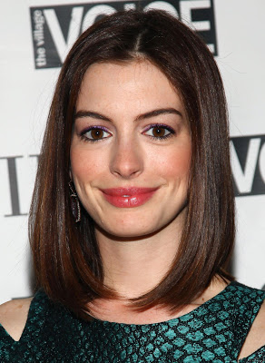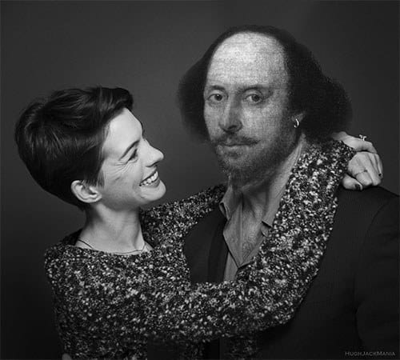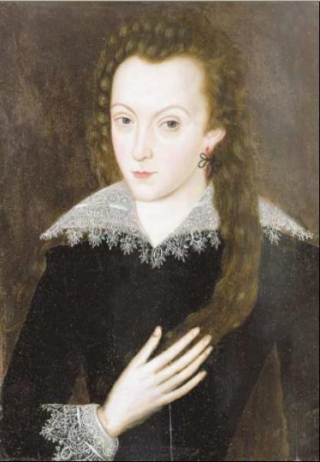
- Shakespeare’s wife
- Born in 1556, died aged 66
- Lived in Stratford Upon Avon
- Had three children with Shakespeare
- Actress
- Born in 1982 (34)
- Lives in New York
- Starred in ‘The Devil Wears Prada’, ‘Les Mis’, ‘Interstellar’

Who is Anne Hathaway?
- Shakespeare’s wife
- Seven years older than him (married at 26 and 18)
- Speculated that it was a ‘shotgun wedding’
- Some have speculated Shakespeare was unwilling to marry and did not like her that much
- Others suggest he chased her and was desperately in love with her
- From a well-respected and wealthy family
- Separated often as his career took off-worked in London while she stayed in Stratford
- In his will, he left her one item-his ‘second best bed’…

The World’s Wife
- Part of same collection of poems as ‘Mrs Midas’
- All written from the point of view of a famous person’s partner
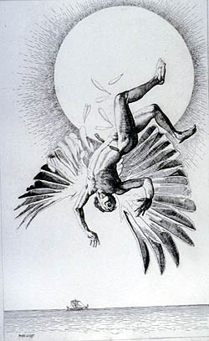
Mrs Icarus
By Carol Ann Duffy
I’m not the first or the last
to stand on a hillock,
watching the man she married
prove to the world
he’s a total, utter, absolute, Grade A pillock.

Style
- Shakespeare’s most famous poems about love were written in sonnet form (154 of them!)
- Duffy’s choice here suggests that this poem is both a homage to Shakespeare’s romantic sonnet and at the same time a re-examining of the poet and playwright from a different angle.

Shakespearean Sonnet Structure
- 14 lines long
- 3 stanzas of 4 lines (a quatrain) and a rhyming couplet (2 lines)
- Rhyme scheme: abab, cdcd, efef, gg

Sonnet 18
Shall I compare thee to a summer's day?
Thou art more lovely and more temperate.
Rough winds do shake the darling buds of May,
And summer's lease hath all too short a date.
Sometime too hot the eye of heaven shines,
And often is his gold complexion dimmed;
And every fair from fair sometime declines,
By chance, or nature's changing course untrimmed.
But thy eternal summer shall not fade
Nor lose possession of that fair thou ow'st;
Nor shall death brag thou wand'rest in his shade,
When in eternal lines to time thou grow'st,
So long as men can breathe or eyes can see,
So long lives this, and this gives life to thee.
Duffy’s Sonnet
- Whilst she keeps the rough outline of the sonnet, Duffy does not use the traditional rhyme scheme that all Shakespearian sonnets follow; ABAB CDCD EFEF GG.
- She keeps the rhyming couplet at the end, but otherwise her lines are only loosely joined together through assonance (vowel rhyme), for example “world” and “words”.
- The lines are softly and subtly joined together, as if to echo the physical relationship between Anne and Shakespeare
- Duffy’s choice to subvert the form of the sonnet emphasises that these are the words of his wife and represent her own insight into her husband, an insight that cannot be shared or replicated by anyone else.
Predictions
From our reading of ‘Mrs Midas’ and what we have learned about Anne Hathaway…
What emotions do you think will be expressed by Anne in this poem?

Anne Hathaway
‘Item I gyve unto my wife my second best bed …’
(from Shakespeare’s will)

The bed we loved in was a spinning world
of forests, castles, torchlight, clifftops, seas
where we would dive for pearls. My lover’s words
were shooting stars which fell to earth as kisses
on these lips; my body now a softer rhyme
to his, now echo, assonance; his touch
a verb dancing in the centre of a noun.
Some nights, I dreamed he’d written me, the bed
a page beneath his writer’s hands. Romance
and drama played by touch, by scent, by taste.
In the other bed, the best, our guests dozed on,
dribbling their prose. My living laughing love –
I hold him in the casket of my widow’s head
as he held me upon that next best bed.

Understanding the Poem
- Why do you think the poem begins with a quotation from Shakespeare’s will?
____________________________________________________________________________________________________________________________________________________________________________________________________________________________________________

- In the first lines of the poem, Anne Hathaway compares their bed to a “spinning world”. What technique is this, and what does she mean by this?
____________________________________________________________________________________________________________________________________________________________________________________________________________________________________________
- How does the writer show Hathaway’s admiration for her husband in lines 3-7? Give evidence and explain.
____________________________________________________________________________________________________________________________________________________________________________________________________________________________________________
- Throughout the poem, Hathaway compares herself to poetry. Pick out an example of this from lines 3-9, and explain why she uses this comparison.
____________________________________________________________________________________________________________________________________________________________________________________________________________________________________________
- Look at line 11. What idea do we now have about the difference between the ‘best bed’ and the second bed?
____________________________________________________________________________________________________________________________________________________________________________________________________________________________________________
- How does the writer’s use of imagery in lines 13 and 14 indicate a change in tone in the rhyming couplet?
____________________________________________________________________________________________________________________________________________________________________________________________________________________________________________
Analysing Imagery
Quotation | Shared Quality | Poetry | Anne
“my body now a softer rhyme/to his, now echo, assonance”  (lines 5-6) | Both complementary, go together well | Lines in a poem fit together through rhyme, flow nicely | Feels she and Shakespeare are well-suited , complement each other well
Lines 6-7
Lines 8-9
Lines 11-12

Anne Hathaway-Links

