The summary report is provided for parents/careers and partners to outline our achievements this session and our priorities for next session. Throughout this session we have taken forward our priorities as detailed in our nursery improvement plan. Through our processes of self-evaluation, we have identified how we can improve outcomes for our children and young people.

Our achievements and improvements this year.
We would like to highlight the following improvements/achievements:

This year we became one of Glasgow’s first Gender Friendly Nurseries at a ceremony in the City Chambers.
We have always strived to give boys and girls the same opportunities in nursery. In practice this means not buying gender specific Christmas presents, not separating boys from girls for activities, ensuring that children understand that both sexes can excel in traditional male and female jobs etc. fire fighters, nurses, soldiers. We ensure that when buying books and puzzles, they depict male and female roles equally and are not sexist e.g. female refuse collector, dad caring for the baby. However there is always more to learn and training for staff was provided by personal from NHS Health Improvement team. We looked more closely at how the media: TV commercials and magazines, use provocative images of women and girls to sell their goods, how boys and girls are portrayed in children’s programmes, and how toy manufacturers and the clothing industry re-enforce gender stereo types. To gain the award we were challenged to, examine our practice, and the language we use when talking with boys and girls: do we make differences?
We decided to leave Take Home Ted gender neutral and the children can make that decision when they take Ted home. One of our partners Caledonian University, give the children a pencil case after their visit but they wanted to give specific colours to boys and girls so we asked them to give us a variety of colours. Girls are encouraged to use tools and design and build, boys are encouraged to take on care roles in the house corner.
A newsletter on our progress was emailed to all families using the nursery and comments were requested. One parent said that boys who play with prams and dolls would grow up to be good dads and another thought that equality of opportunity for boys and girls was worth promoting.
So what do the children have to say? “Can boys wear pink clothes?” “Yes” Would you wear a pink t-shirt?” “No”. However they are aware that there are female bus drivers, fire fighters, male nurses etc.
We finished off our challenge by creating a Gender Friendly policy.
We want our children to be happy, healthy, with a ‘can do’ attitude and reach their full potential regardless of them being a boy or a girl. We want girls to be self–assured and boys to talk about their feelings and resolve problems through dialogue.

We have made a difference in children’s learning by buying 2 ipads from the nursery fund. We know that many of our children are using tablets at home and we have used them to respond to children’s desire for information and to support individual learning. A very practical use was recording the children singing the ‘tooth brushing’ song. Not only was it fun to make but the recording measured the length of time accurately for tooth brushing. The children have downloaded music and apps and used the many tools available on the I pad. We also use the stopwatch to time activities giving children a visual indicator; children don’t really understand when an adult say ‘in two minutes.’
Staff have also developed technology skills with further training that will give them more tools to find resources to enhance their learning and the children’s.
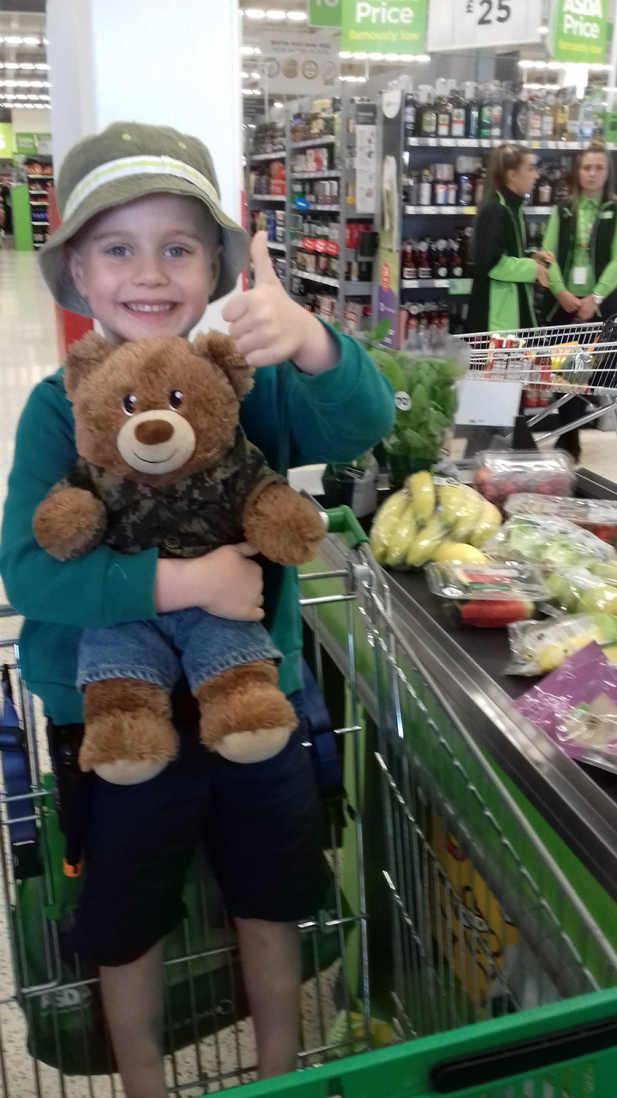
Shona created a Glow blog which is very similar to a web page. It is full of information about the nursery and it will continue to be developed and updated.

We continue to make improvements in how we can link learning between home and nursery.
Take Home Ted continues to be a popular resource in Jura room. Having Ted going home gives the children some responsibilities about taking care of Ted, parent and child reading a bed time story and brushing Ted’s teeth. It’s lovely to read about what Ted was doing on the sleepover however it also helps us to observe what your child likes to do at home allowing us to use this interest for building on learning and celebrate achievement e.g. success at dancing class, swimming, boxing…

Your involvement in individual learning has had many advantages e.g. helped develop relationships with keyworkers and parents and giving the activity much more depth, linking the learning between home and nursery. An example of this was when Jai wanted to learn about castles. His keyworker asked mum if he could visit a castle and come back and tell her about it. They didn’t need to go too far as there is a castle in Springburn! Some children wanted to learn to cook for individual learning so they went with some money and their family member and bought and paid for the ingredients.

Parents of children moving to primary in August 2018 were invited to attend a workshop in the library organised jointly by the Catriona and the literacy coordinator. The workshop was about the children’s transition from nursery to school and to respond to parents questions.

Other achievements included:
- Children growing their own food: potatoes, onions and carrots.
- Re-cycling used clothes with half of the proceeds being spent on food for the food bank.
- More of our children buying fruit from the Fruit Barra on a Wednesday learning about a healthy lifestyle and the value of money.
- Children learning outdoors all through the year.
- Children’s progress with nurture support.
- A successful transition programme to school and within the nursery.
- A joint eco-committee meeting (children) with St Monica’s primary school.
- Creation of a Glow blog (just Google: Milton Community Nursery)

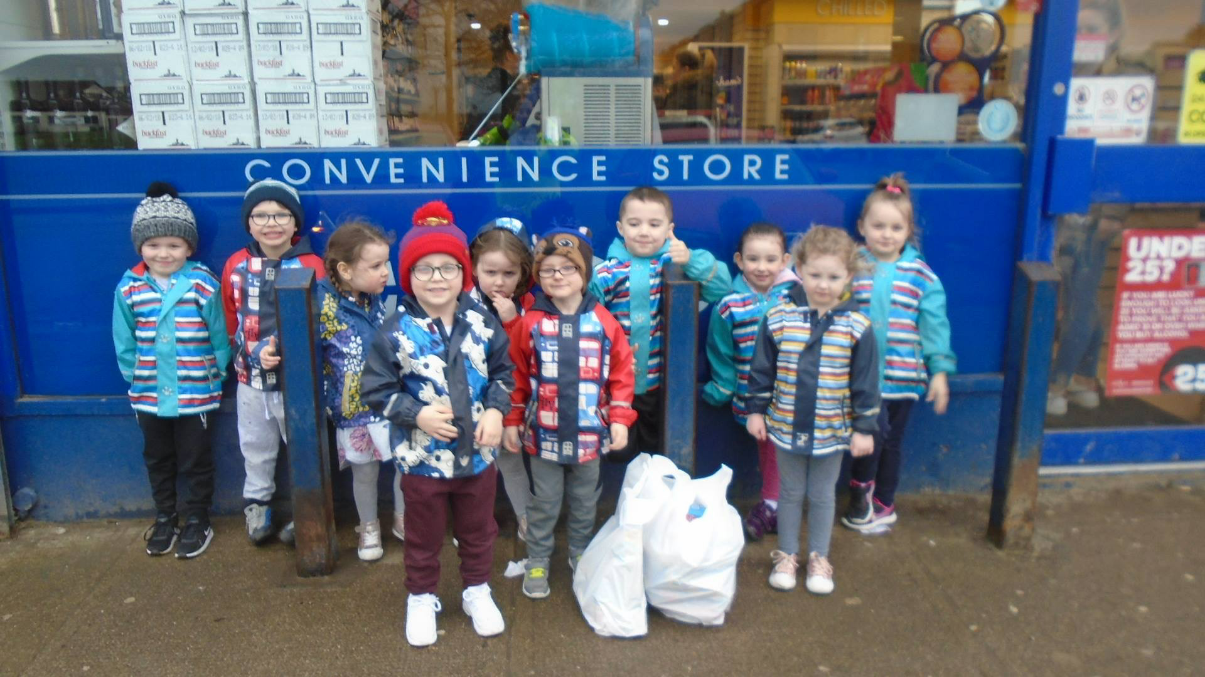

Your responses to our questionnaire (email) told us that many of you follow us on Facebook but most of you do not use Twitter. You find the newsletter beneficial and most answered that they may look at the Glow blog.
An exit poll to parents of children leaving for school this year asked if we could consider cards for Mother’s Day and wondered why we didn’t have an end of term outing.

We take your responses seriously and make changes to our practice in line with council and nursery policies.

Here is what we plan to improve next year.
- We want to improve our capacity to develop the language and communication skills of all children.

- To improve our provision and quality of outdoor play experiences

- We want to review and improve our STEM (Science, Technology, Engineering and Mathematics) activities.

How can you find out more information about our nursery?
Please contact us directly if you require further information or if you wish to comment on the report.

The contact e-mail address is: headteacher@milton-nursery.glasgow.sch.uk

Our telephone number is: 0141 772 6319

Our nursery address is:200 Liddesdale Rd, Milton, G22 7QR

Further information is available in: newsletters, Facebook and the nursery Glow Blog.

Deirdre Kilmurry
Head of Centre
10.08.18

