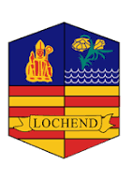
Lochend Community High School ASL Update June 2026
School Updates-
Mr Bonini will be retiring at the end of this term (early retirement of course). The pupils and staff will miss him so much- he has been an essential member of the team and built strong positive relationships across the school and provided the pupils with quality support. Good luck Mr Bonini.
School finishes at 2.30 on Thursday 25th June and the pupils return on Wednesday 12th August (staff return the 10th).


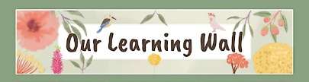

Have a wonderful summer holiday and we will be back in touch in August 2026- the aim will be to continue the parent/ carer support group on the last Friday of the month. We have taken the information and thoughts from you all and shared this with the Senior Leadership Team. Working together with you ensures we can plan and provide the best support for the pupils at Lochend.
https://enquire.org.uk/
https://www.gov.scot/publications/supporting-childrens-learning-statutory-guidance-education-additional-support-learning-scotland/



Legislation Supports

Key Questions when planning Supports

Tele: 0141 582 0170

Aims
Next Meeting:
TBC in the new term- the school will be in touch to arrange the first meeting.
Tel: 0141 582 0170





