My
Inside Out

Booklet

Name:

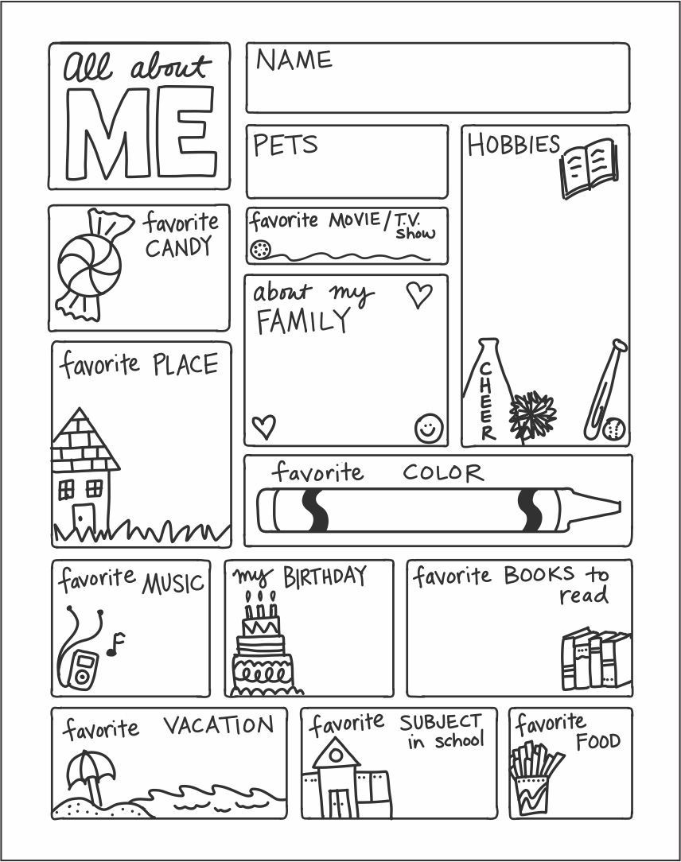

Changes and Me
Change is a part of life
We often look at change as a bad thing, but during big transitions especially ones that are out of our control, it may help to remember that change is a natural part of life.

Change can look like:
- Transitioning from primary school to secondary school
- Transitioning from S1 to S2
- Moving house
- A sibling moving out
Take this time to write down some changes you have been through

Change can be a good thing
When a plant grows from a seed, we see that change can be beautiful.
When the seasons change throughout the year, we can look forward to new things, like swimming in warm weather or warm drinks in cold weather.
When the colour on traffic lights change, traffic runs smoothly... change can be helpful!

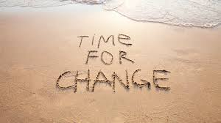
Change definition:
Make or become different
The act or instance of making or becoming different
My own definition:
(what I can remind myself of when I feel anxious or nervous about a new change)
(why change is a good thing)
(how it makes me feel)
(how it makes me act)
CHANGE IS:

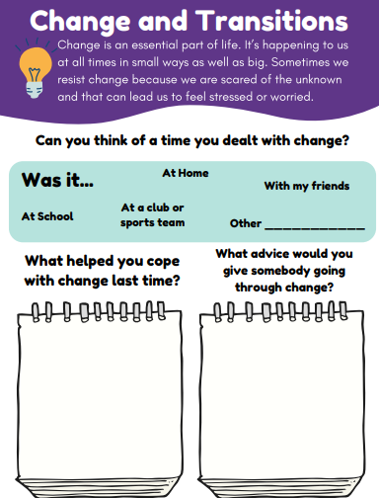

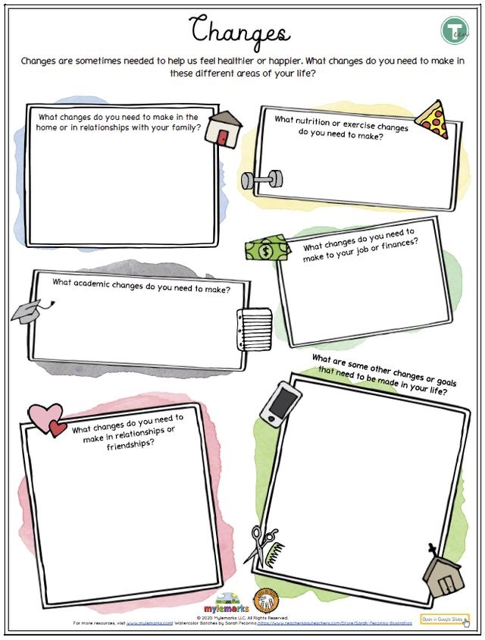

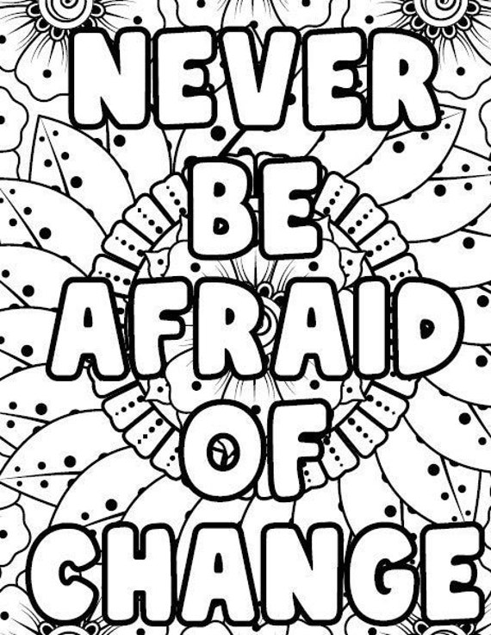

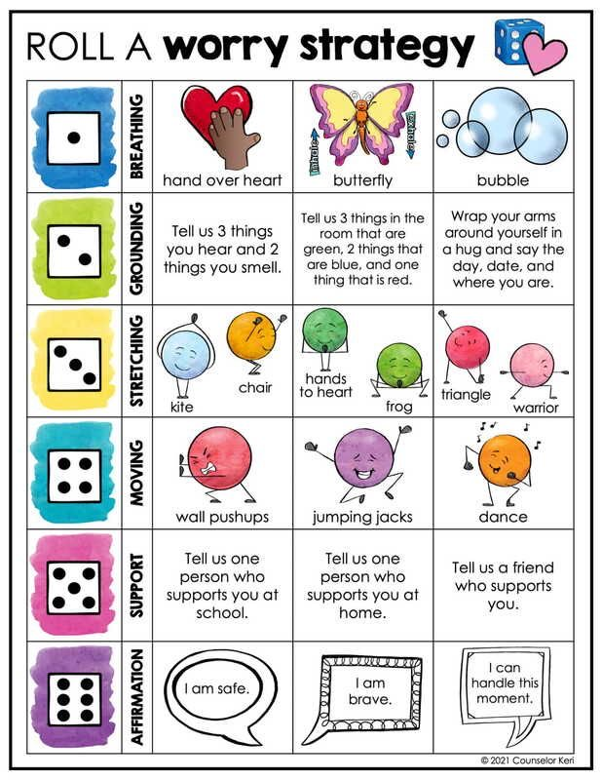

Self esteem
What is self esteem?
Self esteem is about your self-worth and how you feel about yourself. If you have low self-esteem, it means you are probably low on confidence, more likely to see things in a negative light. If your self-esteem is high then you’re better at self-love and more positive about life in general.

How can I improve my self esteem?
- Choose your heroes carefully: Don’t let the media tell you who your hero should be. Think about what you stand for and who really inspires you and why
- Self appreciation break: Set a reminder every day to appreciate three things about yourself. This only takes two minutes but can have a powerful influence on self-esteem.
- Talk to someone you trust: It’s important to speak to someone you trust about how you are feeling. Bottling up your feelings can sometimes make things worse.
- Choose your relationships carefully: Are the people that you choose to spend time with good for your self-esteem? Are they honest, kind, compassionate and non-judgemental? If they are, they are likely to have a positive influence on how you think!

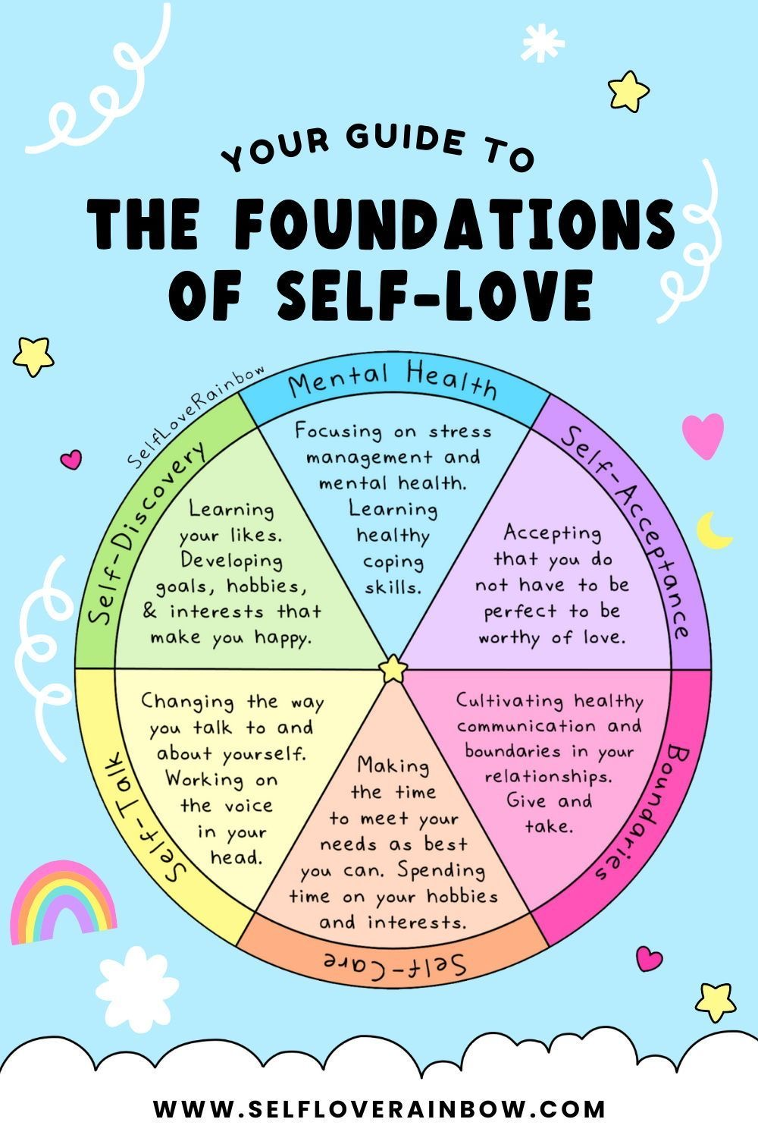

Note down 4 things you can tell yourself when your feeling like your self-esteem is low?

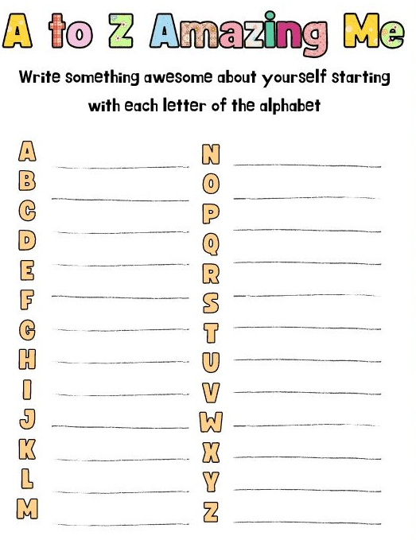

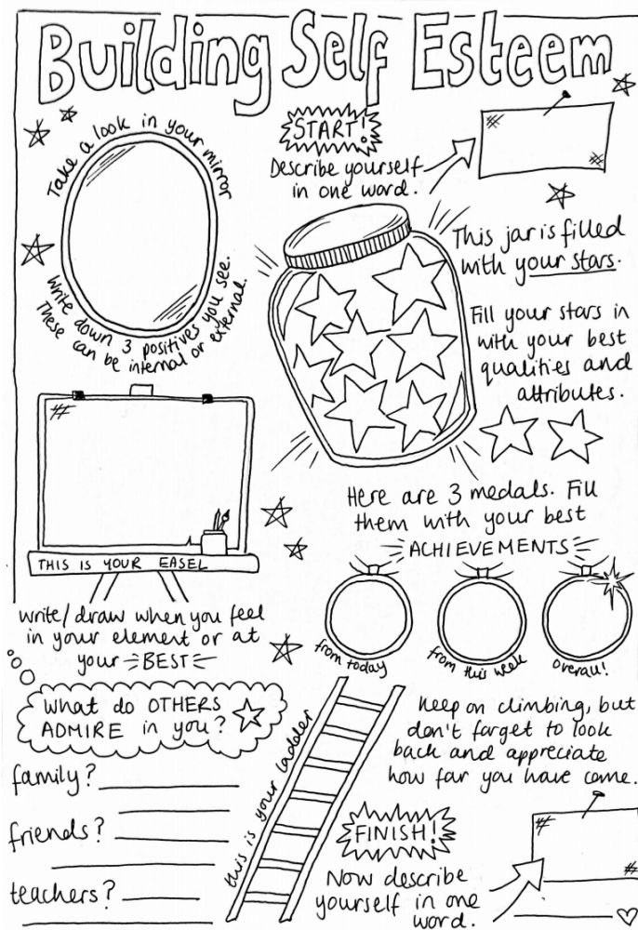
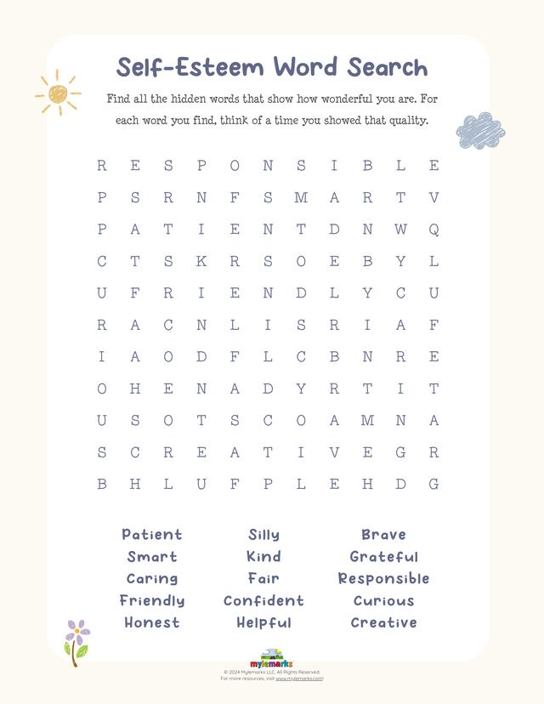

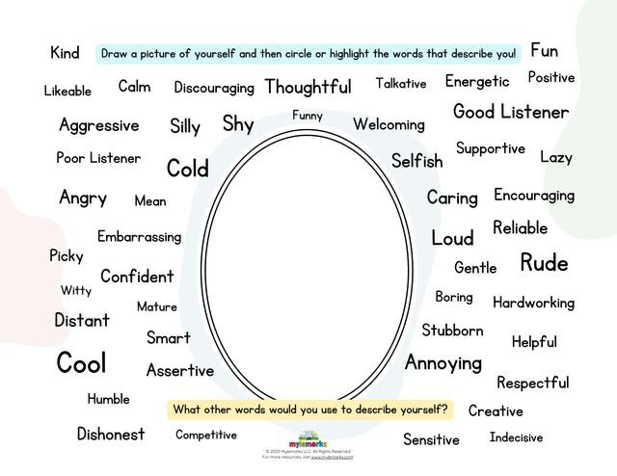

Getting to know each other
You have now spent a little bit of time working together in this group. Let’s take some time to really get to know one another! You will roll the dice twice, take down your first roll – that will be the decider of what question you answer! Have fun
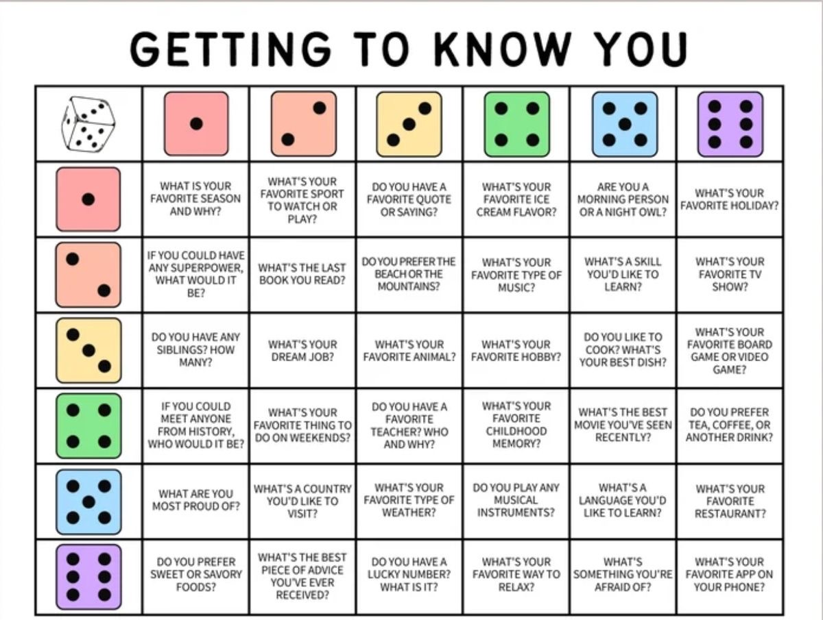

Mindfulness colouring break!
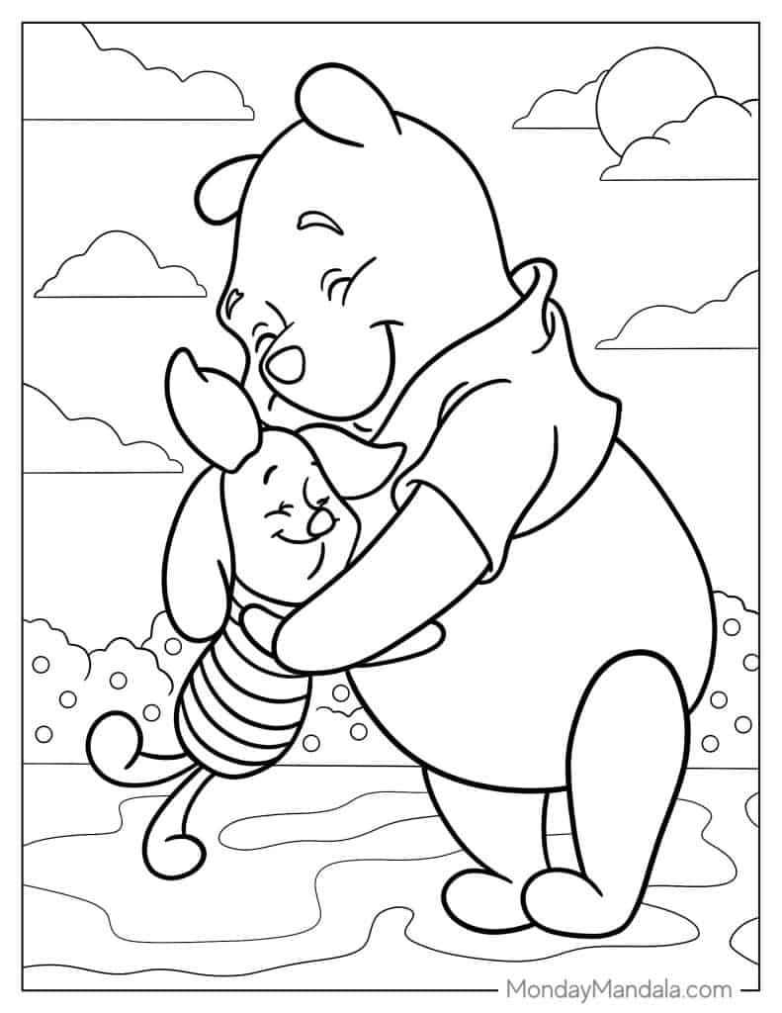
Who am I?
Have you ever taken the time to really think about who you really are? What are your likes and dislikes? Take some time now to really get to know YOU!

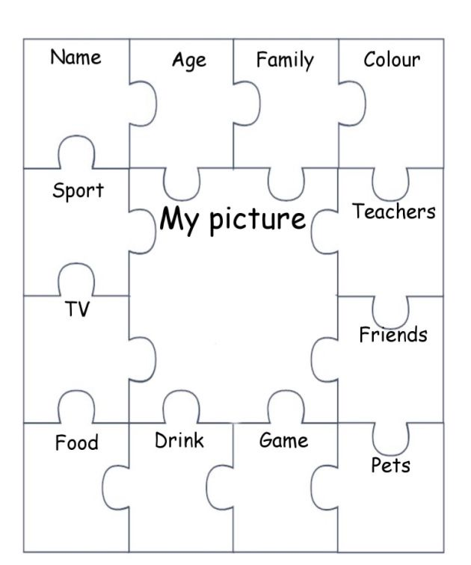

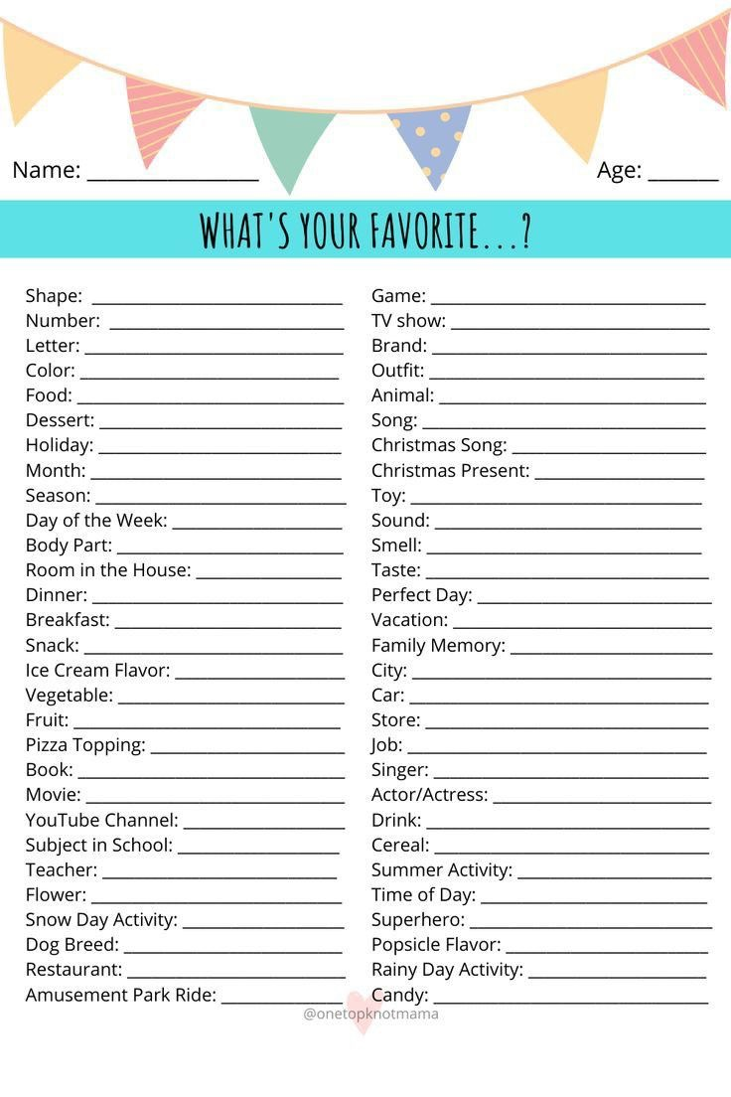

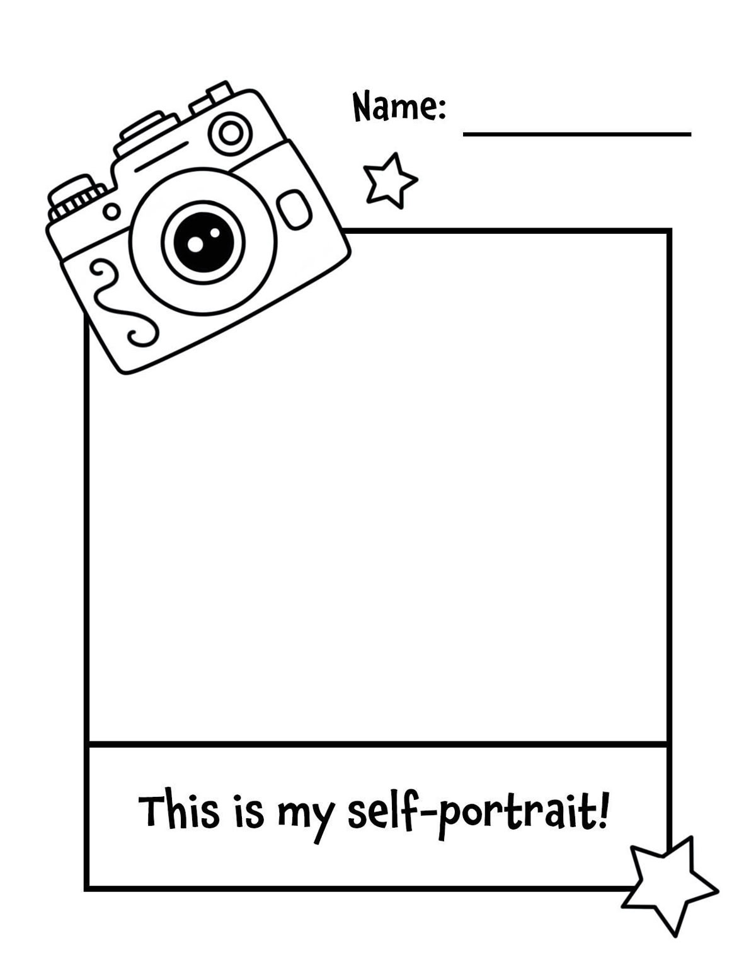

Who am I?

Getting to know yourself is not something you finish. It’s something you keep discovering as you grow! Just because we have finished this part of the booklet doesn’t mean your work stops there. Continuing to discover who you are, and your likes, dislikes, hobbies, interests and fears is an important part of growing and becoming the best version of you!

There are no right or wrong answers when learning about yourself. What matters is noticing and understanding. You are allowed to change your mind, your feelings and your understanding of yourself.

Now that you have learned more about yourself, we can begin exploring emotions. What you’ve discovered here will help you in the next part of this booklet.

Emotions
What are emotions? We ALL deal with emotions everyday – the emotions we experience can range depending on what happens during the day, meaning that we can experience a number of different emotions in just one day!

What emotions have you experienced today or throughout the week? Write them down:

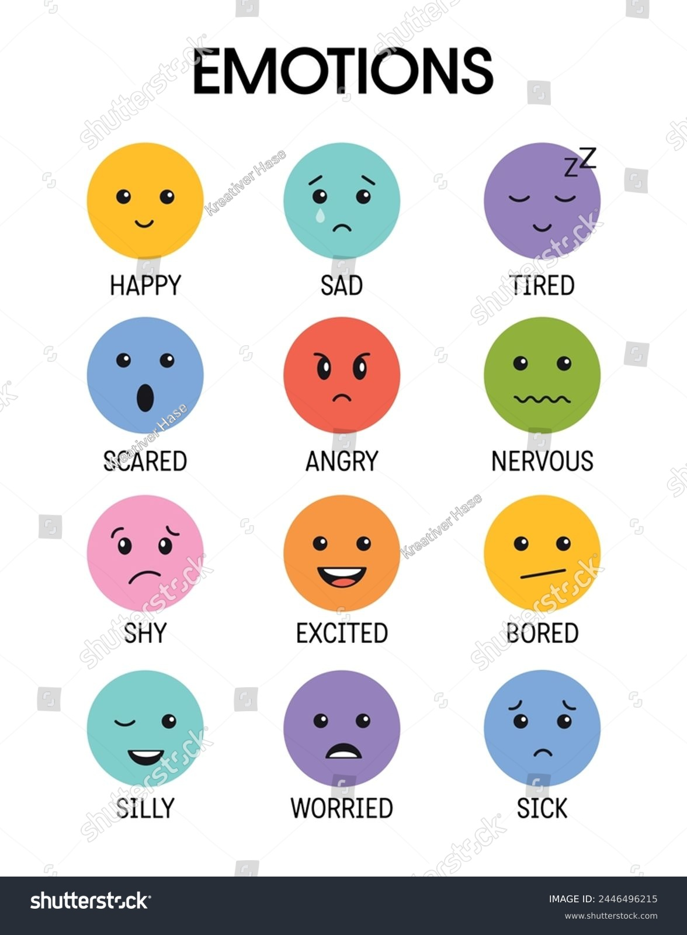

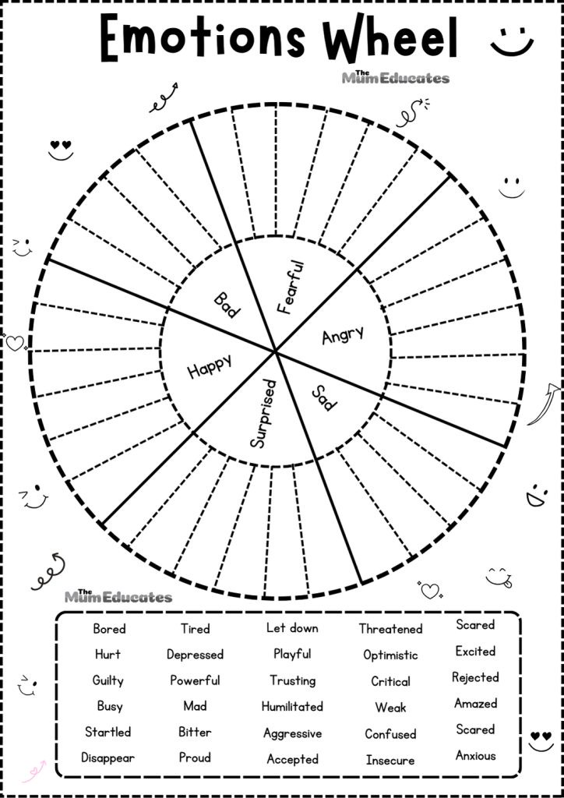

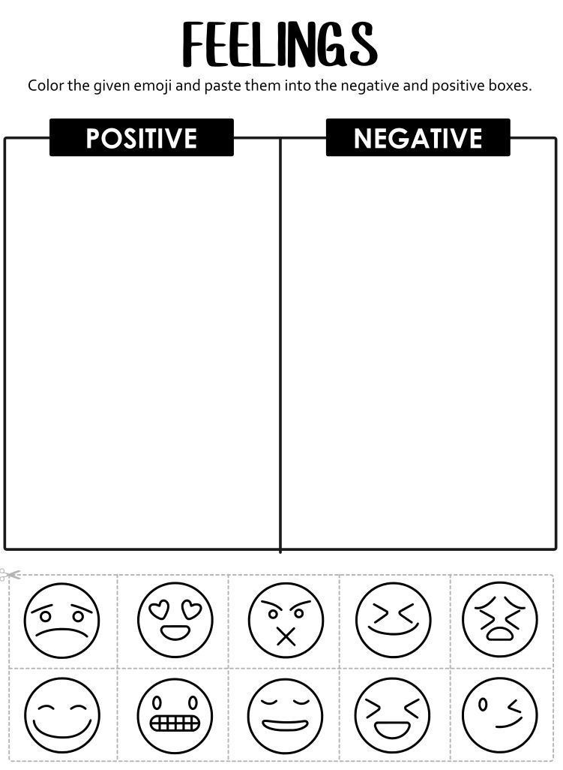

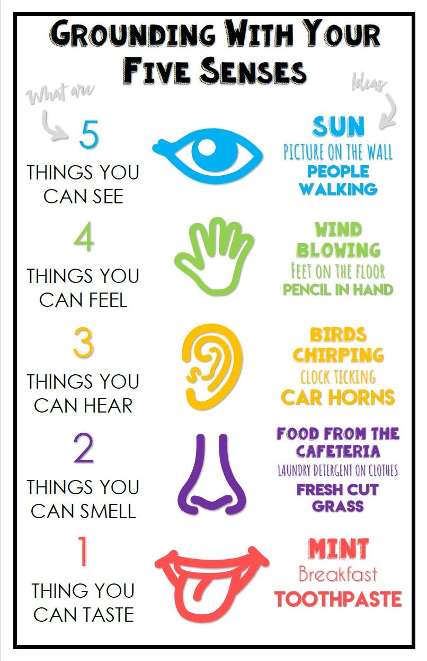

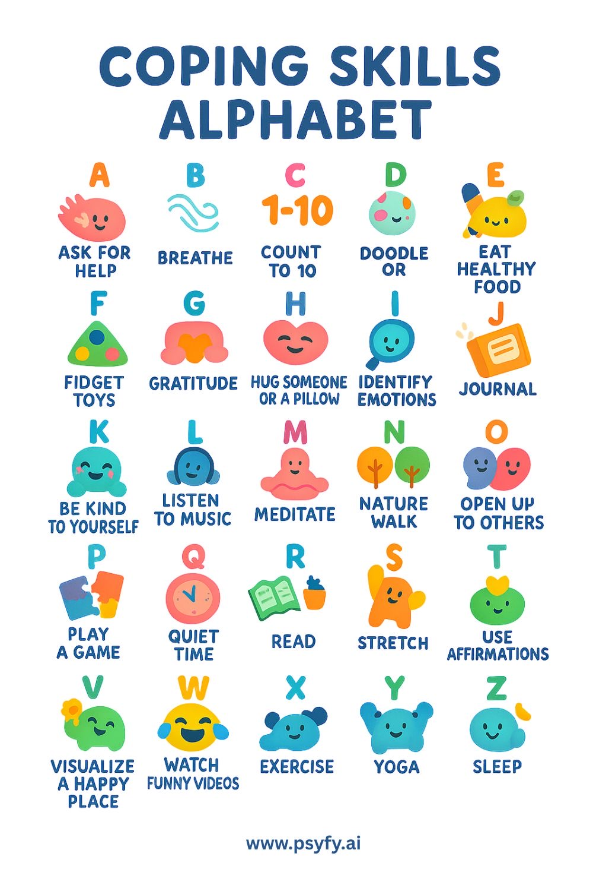

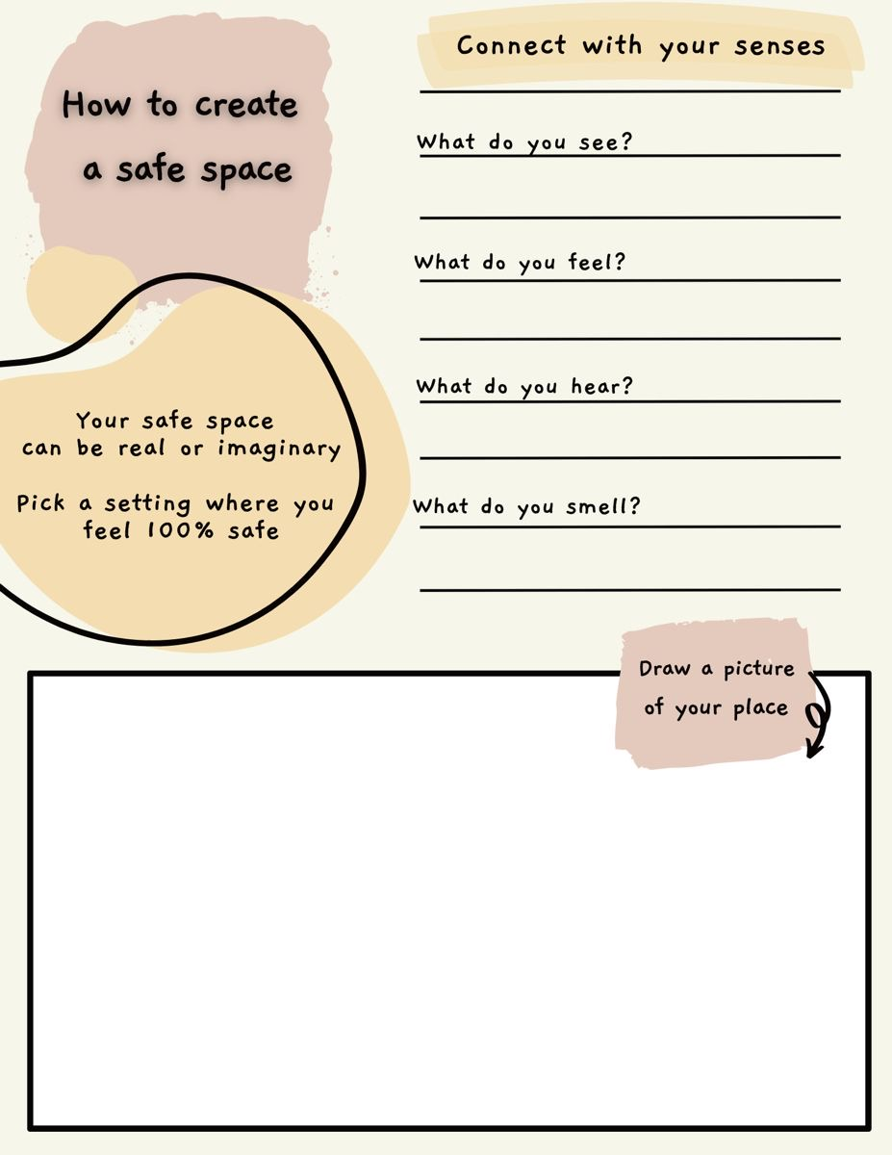

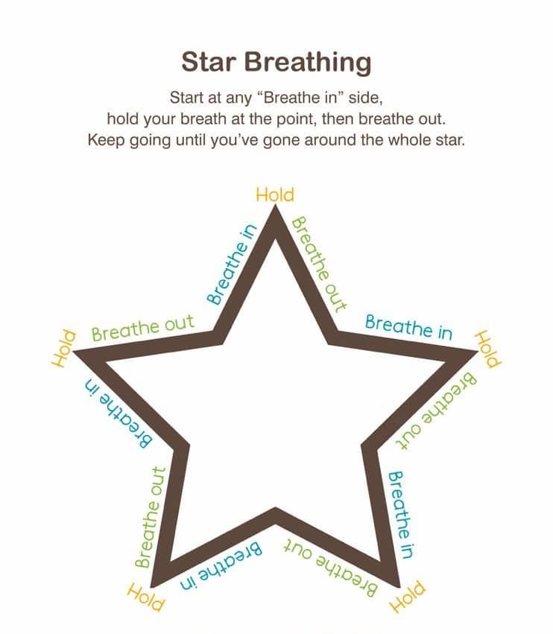

Mindfulness colouring break!
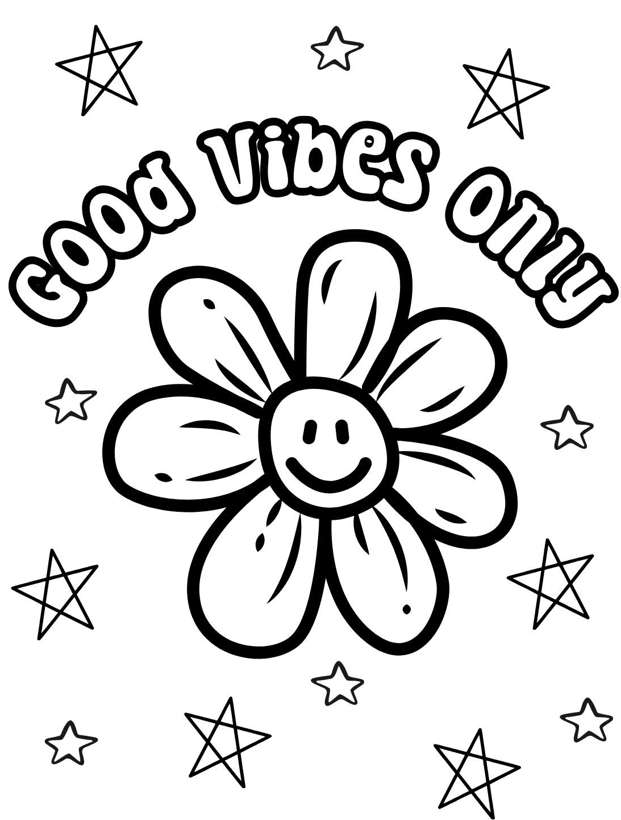

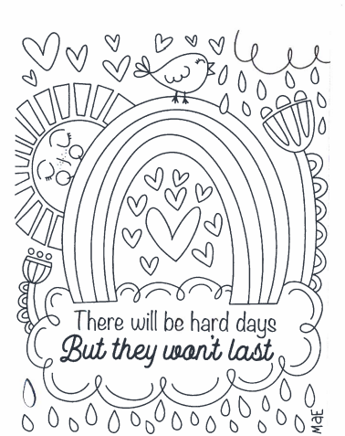

Emotion focus: Anger
You have lots of different emotions. At different times you may be happy, sad, or jealous. Anger is just another way we feel. It’s perfectly OK to be angry at times – in fact, it’s important to get angry sometimes!
Anger must be released in the right way. Otherwise, you’ll be like a pot of boiling water with the lid left on. If the steam doesn’t escape, the water will finally boil over and blow its top! When that happens to you, its no fun for anyone.

How can I tell when I’m angry?
There are different ways people feel anger. Usually, your body will tell you when you are angry.
Are you breathing faster? Is your face bright red? Are your muscles tense and your fists clenched tight? Do you want to break something or hit someone?
Anger can make you yell or scream at those around you, even people you like or love.

What should I do if I get angry?
Don’t lose control if you get angry. Taking it out on others never solves anything. Instead, admit to yourself that you are angry and try to figure out why.
What can you do to keep the situation from happening again? If your little sister gets a toy and you don’t, it’s not OK to break that toy. Maybe you can ask her to share it with you.
Or if your Science homework is too hard, don’t rip up your jotter. Ask your teacher or someone at home for help instead.
It helps to talk about your anger with an adult, such as a parent, teacher, or relative. Once you talk about anger, those bad feelings usually go away.
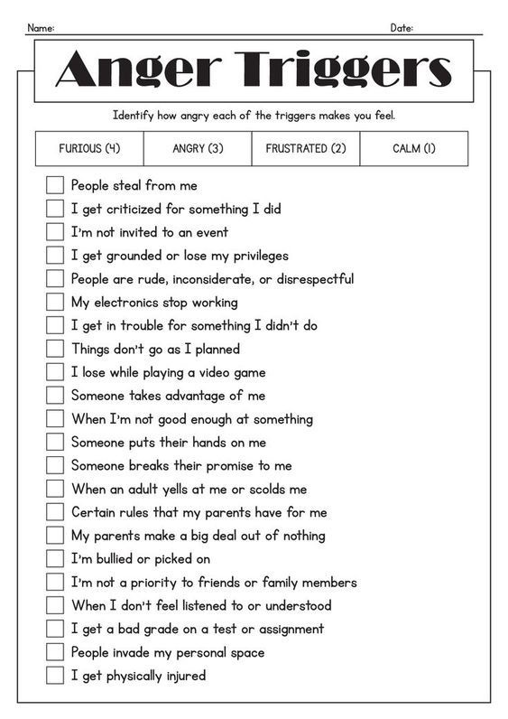

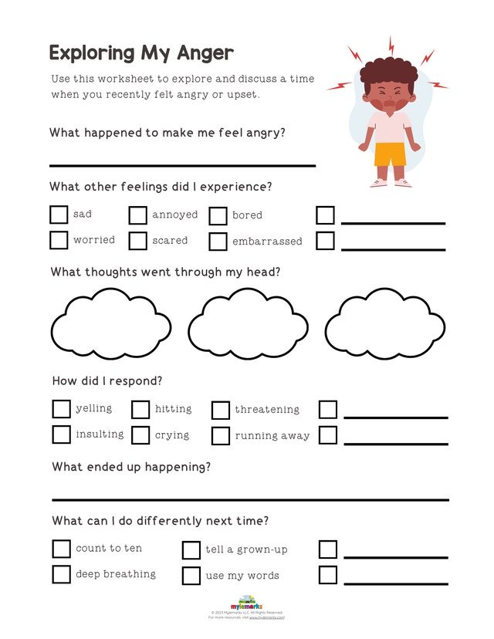

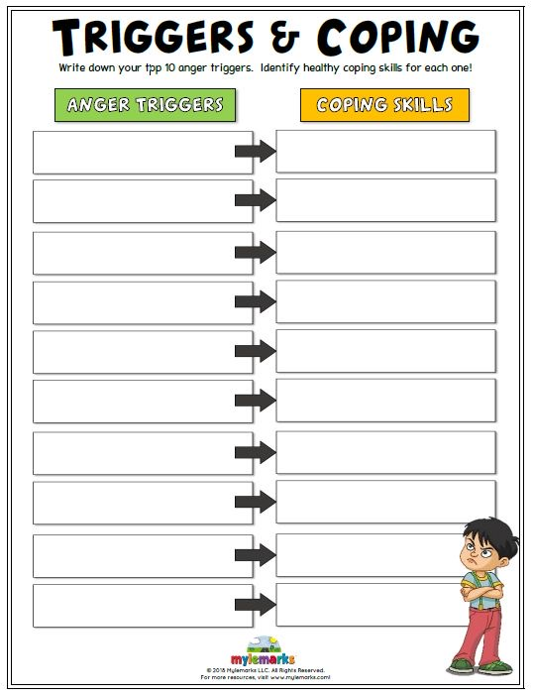

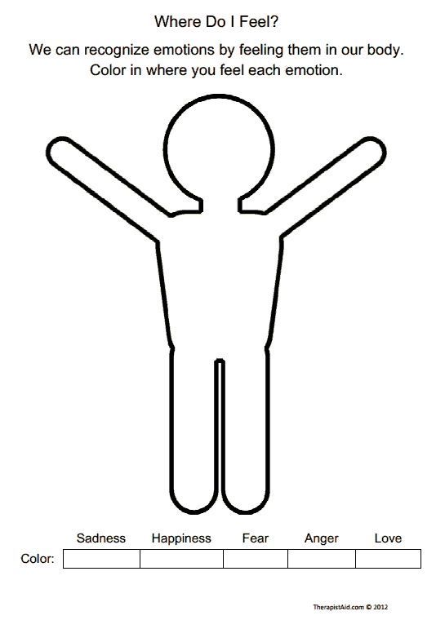

Mindfulness colouring break!


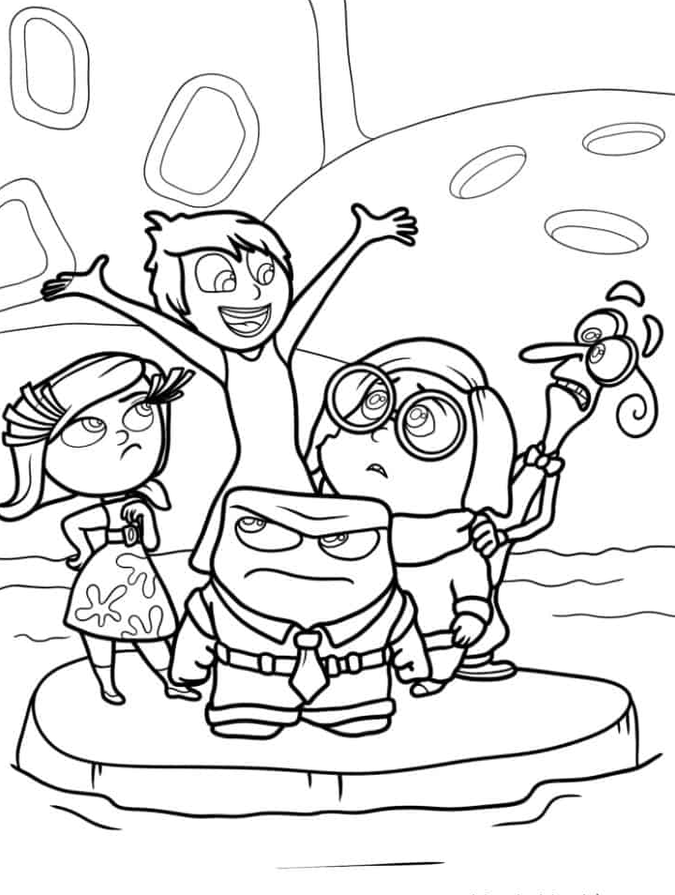

Self-reflection
You have now come to the end of your booklet.
Is there anything you feel you have learned about yourself from completing this booklet with your teacher and group?

Make an Instagram post to summarise how feel/what you have learned during the last few lessons.
