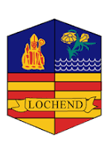
Lochend Community High School ASL Update November 2025

Here are some updates from support across the school.
- SQA Assessment Arrangement information has been shared with pupils and parents/ carers. Interviews taking place with the pupil to make sure they are happy with the arrangements.
- All Stage 2 Supports will pause due to SfL staff commitment to exam supports- SfL staff will link back in with pupils before Christmas to review their supports.
- Senior Phase Prelims 1st Dec- 15th December.


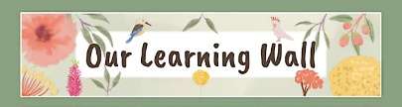
Legislation Supports

Using ICT in Lochend

ICT supports learning by enhancing engagement, offering diverse resources, and enabling new methods like remote and collaborative learning. It allows for personalised instruction, helps students develop essential digital skills for the future. Tools of support:-
- iPad Accessibility
- Read & Write
- Clicker
- Immersive Reader
- Book Creator
- Showbie

https://enquire.org.uk/enquire-resources/additional-support-for-learning-a-guide-for-parents-and-carers/
https://www.glasgow.gov.uk/article/4726/Additional-Support-Needs
https://glasgow.gov.uk/article/4906/Every-Child-is-Included-and-Supported

We use the four pillars of inclusion to support the delivery, assessment, review and evaluation of inclusive quality practice, these are, • present, • participating • achieving • supported
Check out this resource to support Inclusive practice:
https://education.gov.scot/media/raqp5dzk/circle-secondary-resource-int.pdf
Tele: 0141 582 0170

Our Aim

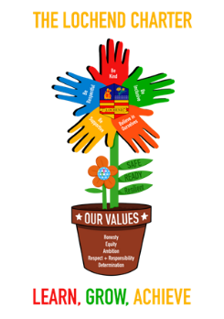
Next Meeting:
Friday 30th January 2026 9.15- 10.15






