LOCHEND COMMUNITY HIGH SCHOOL

Promoting Positive Relationships

Strategy

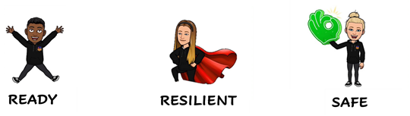



At Lochend Community High School we have created our School Charter through consultation with young people and staff. It was agreed that our School Charter should be used by young people and staff to guide everyone towards creating a consistent and nurturing learning environment which supports young people to *Learn, Grow and Achieve*.

See appendix 3 for Charter creation

Young people, staff and partners are being consulted at the start of Session 2025/26 on the best way to launch and embed our agreed Charter into school life.

**Contents**

1. PPR strategy group
2. Mobile phone policy
3. Procedures for pupils entering another class without permission
4. Procedures for pupils leaving class without permission
5. Steps to ensure a positive classroom environment
6. Emergency supports
7. Area supervision support
8. SLT Support and call log
9. School uniform
10. Rewards
11. Referrals
12. Scripted Intervention guidance
13. Appendices

PROMOTING POSITIVE RELATIONSHIPS STRATEY GROUPS

Our Promoting Positive Relationships Strategy Group work together to try to support a consistent positive ethos across the school. They do so in the following ways:

* Develop collaborative activities for whole staff meetings. These sessions involve the voices of young people as much as possible.
* Review all feedback from staff collaboration sessions to plan for future sessions.
* Annually review the PPR policy in line with school specific feedback, Local Policy and National Policy.
* Review school vision and values.
* Review pupil views through pupil focus groups.
* Organise termly reward trips for young people.
* Organise termly enjoyment and wellbeing afternoons for pupils.
* Gather parent/carer views on any potential changes to policy.

The PPR strategic timeline of improvement can be found in Appendix 1.

In session 2025/26 we aim to:

* Launch our LCHS Charter and explore expectations of this
* Launch our refreshed school vision
* Launch our Charter Champions rewards
* Embed our ensuring positive classroom conduct further to ensure consistent approach
* Review the use of ready, resilient, safe

At Lochend Community High School we are committed to ensuring that:

* All pupils, staff, and visitors feel safe, respected and valued
* Positive behaviour is encouraged and reinforced
* Our school values and charter is embedded in all aspects of school life.

To create this environment, we have consistent procedures in place for the following situations:

* Mobile Phones in class
* Pupils leaving class without permission
* Pupils entering class without permission

MOBILE PHONE POLICY

Following consultation with all stakeholders, a mobile phone policy was implemented in October 2024. See appendix 2.

Mobile phones should be:

* In school bags that are placed at the front or back of the classroom.
* Alternatively, they can be placed in the green tray that is available in every classroom.

Mobile phones will be removed from any young person by a member of SLT and the Middle Leadership Team if they are visible in the classroom.

YOUNG PEOPLE ENTERING ANOTHER CLASS WITHOUT PERMISSION

* Class teacher to ask pupil for an explanation to clarify the situation.
* Direct the pupil to leave class and return to correct classroom.
* Class teacher should phone the school office to alert duty SLT
* SLT will interview pupil involved and contact home.

YOUNG PEOPLE LEAVING CLASS WITHOUT PERMISSION

* SLT will interview pupil involved and contact home

STEPS TO ENSURING POSITIVE CLASSROOM CONDUCT

STEPS TO ENSURING POSITIVE CLASSROOM CONDUCT

All young people are held responsible for their behaviour. Staff will deal with behaviour without delegating. Staff will use the steps for dealing with poor conduct.

**Behaviours constituting an Emergency Call to the office include: violence, racism, homophobia, dangerous conduct, threats to other young people or staff. In an emergency call the school office straight away and act to keep yourself and other young people safe.**

|  |  |  |
| --- | --- | --- |
| **Lead** | **Steps** | **Actions** |
| **Class Teacher** | **Step 1: Reminder**  Reminders may be numerous and should be tailored to the needs of each individual learner. | A reminder of the expectations delivered privately.  Repeat reminders if necessary. Deescalate and decelerate where reasonable and possible and take the initiative to keep things at this stage. The teacher makes the learner aware of their behaviour and the learner has the choice to do the right thing. |
| **Class Teacher** | **Step 2: Caution** | A clear verbal caution **delivered privately**, making the learner aware of their behaviour and clearly outlining the consequences if they continue.   1. The learner has the choice to do the right thing. 2. Learners will be reminded of their previous good conduct to prove that they can make good choices |
| **Class Teacher** | **Step 3: Last Chance**  **A Scripted approach is encouraged at this stage** (see scripted intervention below) | **30 second intervention**   1. Speak to the learner **privately** and give them a final opportunity to engage. 2. Gentle approach, personal, non-threatening, side on, eye level or lower 3. State the behaviour that was observed and which rule/expectation/routine it contravenes 4. Tell the learner the consequences of their action. Refer to previous good behaviour/learning as a model for the desired behaviour 5. **Walk away, allow the learner time to decide what to do next. If there are comments as you walk away write them down and follow up later.**   It is important to resist endless discussion around behaviour but rather spend our energy on returning learners to their learning. |
| **Class Teacher**  **PTPC** | **Step 4: Reset** | At this point the teacher, as privately as possible, will give the learner an opportunity to reset away from the situation.   1. Boundaries are reset 2. Learner is asked to reflect on their next step. Again, they are reminded of their previous good conduct/attitude/learning 3. Learner is given a final opportunity to reengage with the learning/follow instructions 4. The assumption should always be that the learner will re-engage once they have had a chance to reset |
| **Class Teacher**  **PT C**  **SLT** | **Step 5: Parking and Reparation**  **If a young person refuses to ‘reset’ or commits a serious breach then the teacher must log the incident as a Seemis referral to their PT Curriculum** | If a young person refuses to ‘reset’ they should be offered a safe space away from the classroom.  A restorative meeting should take place as soon as possible after the incident and before the next lesson. In this instance both the learner and staff member need to agree to the meeting. It should only take place when they are both ready.  If they do not attend or engage with the restorative meeting then the appropriate member of SLT should be consulted. |

EMERGENCY SUPPORTS

AREA SUPERVISION SUPPORTS

Faculty head support timetable has been created collaboratively by all curricular leaders to ensure that they can access support from colleagues across the school if required.

SLT SUPPORT & CALL LOG*

*School office will update support log

SCHOOL UNIFORM

All young people are expected to wear full school uniform. If a young person arrives at your class in non-uniform items, please ask them to remove them and allow them into class. If SLT/PTPC are aware of a reason for no uniform, the young person will be provided with a note. Please submit a referral if non-uniform becomes a repeated issue.

We have a supply of uniform items which will be given to those not in uniform.

**REWARDS**

**Charter Champion**

* Each week staff will have 2 (1 BGE and 1 SP) charter champion tokens to allocate to pupils who have displayed conduct in line with our charter. Please tell pupils why they have been awarded your token.
* Pupils will then redeem their token for a prize each Friday from SLT.

**Additional Rewards**

* Recognition Board
* Phone Call Home
* Post Cards
* Praise Slips
* Stickers

**Referrals**

**SCRIPTED INTERVENTION**

In any interaction with regard to behaviour, we are always aiming to achieve a positive outcome. A scripted intervention is encouraged at Step 3 with the following considerations:

1. Use a gentle approach which is personal, non-threatening, side-on and at eye level or lower.
2. State the behaviour that was observed and which expectation it contravenes.
3. Tell the learner what the consequences of their action are. Refer to previous good behaviour as a model for the behaviour desired.
4. Walk away; allow the learner time to decide what to do next. If there are comments as you walk away, write them down and follow up later.

**FAIRNESS**

* Learners must not be able to reduce negative consequences
* Teachers must not take away rewards that have been given
* Don’t make deals with sanctions
* Negative sanctions must be proportionate – don’t suffocate learners with punishment
* Whole class punishments are always unfair
* Try not to invent punishment on the spot – you will regret it
* Tell the learner the negative consequences
* Write down warnings/reminders given privately
* New day, clean sheet every time
* Don’t jump sanction steps or accelerate sanctions

**APPENDICES**

**APPENDIX 1**

**PROMOTING POSITIVE RELATIONSHIPS STRATEGIC TIMELINE SESSION 2024/25**

**APPENDIX 2**

**Mobile Phone Policy Consultation: Session 2024/25:**

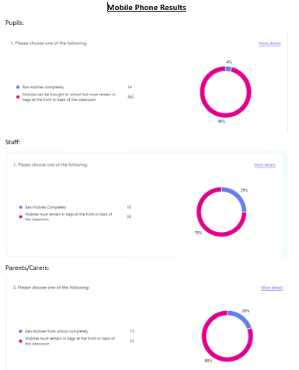

**APPENDIX 3**

Our School Charter was created through a consultation with all stakeholders in Session 2024/25.

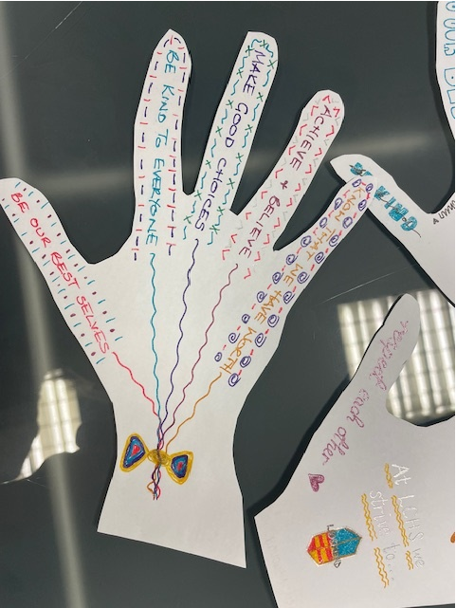 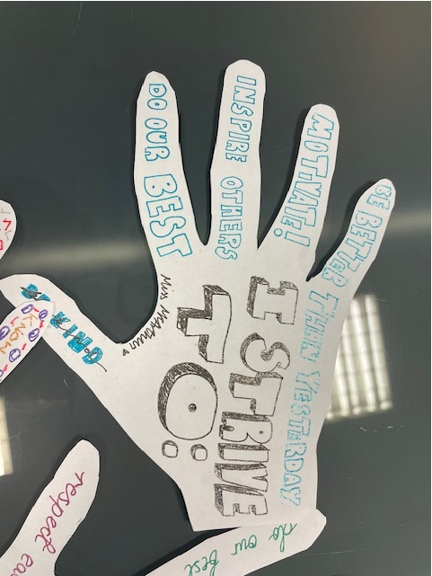

School staff, pupils, partners and parents were given the opportunity to write down 5 charter phrases which related to behaviours they think all stakeholders should strive to demonstrate in the school.

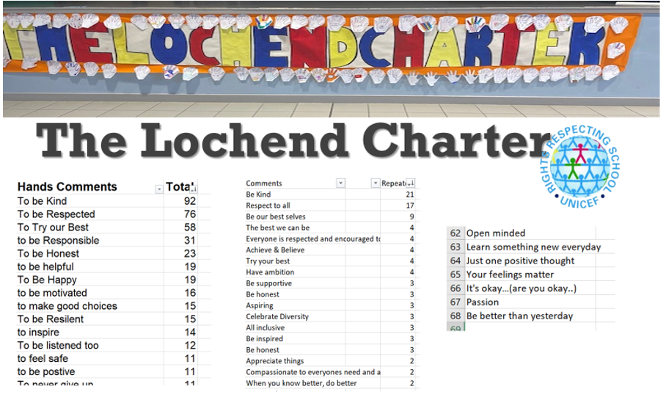 These votes were collated.

We then voted on the most popular statements: 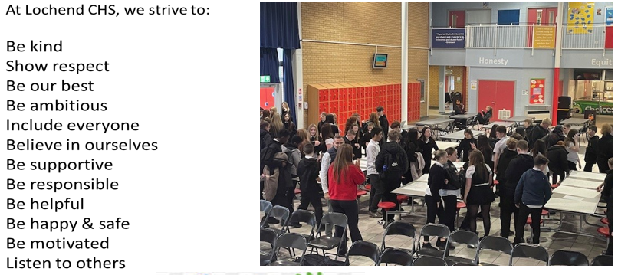

The Pupil Leadership Team then counted the votes, decided on our 5 charter phrases and developed logo/image ideas.

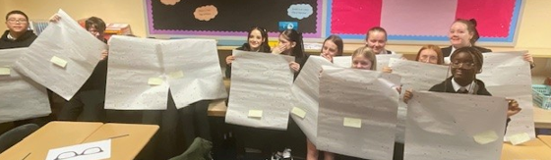

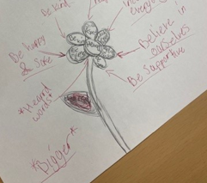 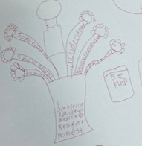

Final design…

Appendix 4

Previous ready, resilient, safe posters used in 21/22-23/34

