

**Learning**

**and**

**Engagement**

**Policy**

**Contents**

1. Our School Charter
2. Purpose of our policy
3. Learning & Engagement Strategy Group
4. Glasgow pedagogy
5. Learning at Lochend
6. Lesson Evaluation Toolkit
7. The Lochend Lesson
8. Class profiles & sprint squads
9. 24/25 Update

* Differentiation
* Class Profiles

1. 23/24 Update

* Feedback

1. Appendices
2. References

At Lochend Community High School we have created our School Charter through consultation with young people, staff and partners. It was agreed that our School Charter should be used to guide everyone towards a creating a consistent and nurturing learning environment which supports all young people to *Learn, Grow and Achieve.*

This document should be used for the following purposes:

* To support new and existing staff in understanding our approaches to learning and engagement
* To support collaboration at departmental meetings
* To support professional review and development collaborations
* To support young people to engage in the learning process

Learning and Engagement Strategy Group

Our Learning and Engagement Strategy Group work together to try to support a consistent culture of effective learning and engagement across the school. They do so in the following ways:

* Develop collaborative activities for whole staff meetings. These sessions involve the voices of young people as much as possible.
* Review all feedback from staff collaboration sessions to plan for future sessions.
* Develop activities for Departmental meeting collaborations. These sessions involve the voices of young people as much as possible.
* Annually review the Learning and Engagement Policy in line with school specific feedback, Local Policy and National Policy.
* Annually review the Lesson Evaluation Toolkit which is used to support a consistent approach to Lesson Observations and Pupil Focus Groups.

The Learning and Engagement strategic timeline of improvement can be found in Appendix 1.

In session 2025/26 we aim to:

* Increase the voices of young people in Staff and Departmental collaboration sessions.
* Provide a collegiate structure which encourages increased opportunities for sharing practice.
* Create CLPL opportunities for all staff.
* Develop whole school learning and engagement pedagogy sessions of to promote consistency in lessons.
* Develop departmental follow up activities to further embed pedagogical practice
* Develop a whole school approach to lesson planning
* Develop a school homework policy.
* To review the impact of class profiles and adapt if required.

**Learning at Lochend**

Our approaches to Learning and Engagement at Lochend are guided by the Glasgow City Council Strategy: Glasgow’s Pedagogy. This provides guidance for all staff in relation to the expectations of learning experiences within a Glasgow learning environment.

During 22/23, in collaboration with all staff, the Lochend Lesson Evaluation Toolkit (LET) was created. This was influenced by ‘The Teaching Delusion’ by Bruce Robertson (2021).

This provides a consistent guide for all staff when lesson planning, self-evaluating, coaching and collaborating. The Toolkit has three main areas: Classroom Climate, Lesson Structures and Supporting Learning.

**Lesson Evaluation Toolkit Summary:**

**Planning**

* Class Profiles

**Classroom Climate**

* Meet and greet
* High expectations
* Classroom Management

**Lesson Structures**

* Connect the learning
* Learning intentions and success criteria
* Active learning
* Assessment
* Review and recall

**Supporting Learning**

* Pace
* Challenge
* Differentiation
* Feedback

In addition to this being used by teachers to reflect, we also use a variation of this to carry out classroom visits and a pupil version to gather pupil views through whole school and departmental focus groups. A copy of the LET, the classroom visit LET and pupil LET can be found in Appendix 2.

The Lesson Structure section outlines what a Lochend Lesson should look like: Connect the Learning, Learning Intentions and Success Criteria, Active Learning, Assessment, Review and Recall.

**Lochend Lessons: LET Lesson Structures**

**Planning for Learning**

All staff should use the online Support Spreadsheet to complete the Class Profile (Appendix 3). This supports a detailed understanding of the pupil needs and allows for planning to support these.

**Connect the Learning**

Each lesson should begin by giving the ‘big picture’ - connect what pupils would like to know to what they already know and what the class has learned together. Starters are an excellent means of engaging pupils from the offset.

**Learning Intentions and Success Criteria (updated 24/25)**

At Lochend we aim to ensure that **learning intentions** are:

* clear, concise, and accessible.
* written in pupil-friendly language and are referenced throughout the lesson.
* written using Bloom's language to highlight skills being developed.

At Lochend we aim to ensure that **success criteria** is:

* linked to learning intentions
* relevant, specific, and easy to assess.
* differentiated or co-created by pupils.

**Active Learning**

Active learning encourages pupils to fully participate in the lesson. It is about the interaction between pupils and teachers, supported by appropriate resources. A good lesson is **active**, **collaborative** and **cognitive**.

This requires teachers to understand learners, the learning process and knowledge of a range of strategies and techniques.

**Active** I’ve been involved

I’ve explained to others

I’ve worked things out

I’ve listened

**Collaborative** I’ve shared ideas

I’ve contributed

I’ve taken turns

**Cognitive** I’ve asked questions

I’ve answered questions

I’ve offered solutions

**Assessment**

Learners should be given the opportunity to demonstrate what they have learned and understood to the teacher and others. Taking part in and learning new activities means processing new skills and information put into practice through classroom activities.

Pupils can demonstrate their learning by:

* contributing to class debate
* explaining to others
* verbal responses
* presenting information
* demonstrating a skill
* answering questions
* writing an essay

Class teachers will provide appropriate feedback to all forms of assessment.

**Review and Recall**

Learners are more alert and learn more at the beginning and middle of a lesson.

A plenary session will allow learners to make sense of the activities in the lesson by focussing on what they have learned. Teachers should:

* refer back to learning intentions and success criteria
* recap on the main learning points
* make sure key questions have been asked and explained
* re-cap key vocabulary
* allow learners to evaluate their progress
* allow for reflection time and look forward and connect to the next lesson
* praise achievements
* regularly set homework to consolidate and promote further learning
* ensure a calm end to the lesson before pupils leave for their next class

**LET : Supporting Learning – updates**

During session 24/25, we discussed differentiation during sprint 3 and 4.

**Supporting Learning : Differentiation**

Differentiation is using different approaches with learners so that they can make maximum progress in their learning and reach their potential.

At Lochend, we aim to ensure that all lessons are accessible and challenging via a wide range of strategies including but not limited to:

* Chunking learning
* Questioning
* Assistive technology
* Scaffolding
* Collaborative learning

Pupil profiles contain further information about the strategies that support them to learn best.

The differentiation deviser also proves a wealth of ideas to support classroom practice.

 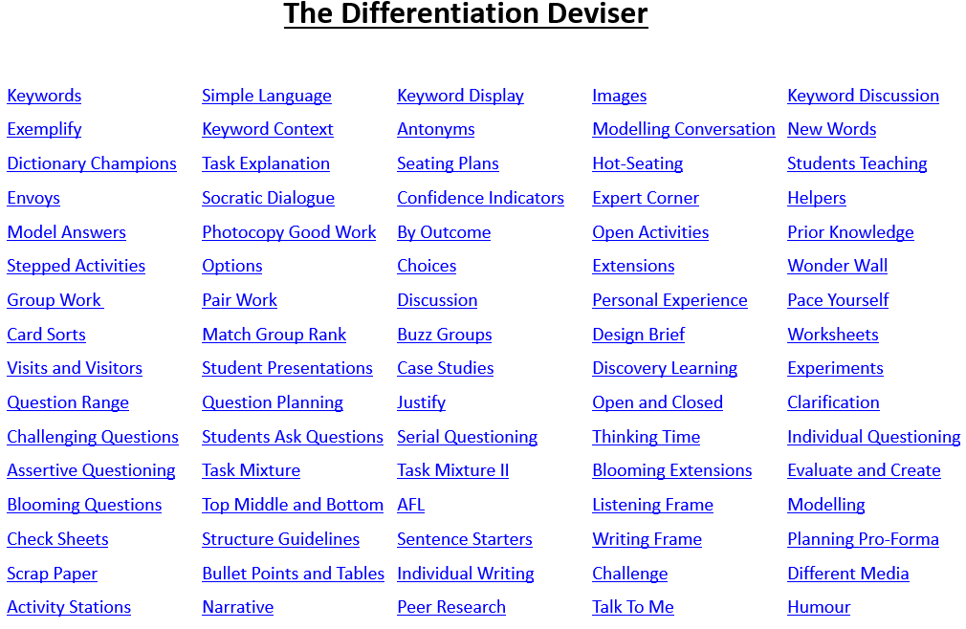

**Class Profiles**

Following whole staff input on differentiation in session 24/25, it was agreed through consultation that all staff would complete a class profile to plan effectively for the support needs of young people in their classes. These were completed based on pupil profile information, information from previous teachers and alongside learner conversations where young people were able to articulate to teachers what helps them to learn. Blank class profile at appendix 3.

Learning at Lochend 24/25 overview infographic available at appendix 4.

**Sprint Squads**

During session 24/25, staff worked in cross curricular sprint squads to collaboratively support one another to achieve classroom consistency. This will be continued into session 25/26.

During session 23/24, we had a whole school focus on feedback and agreed the following:

**Supporting Learning : Feedback**

At Lochend we know that effective feedback has a high impact on learner outcomes (EEF, 2021) and will ensure that a range of feedback is given that is specific, positive and encourages progression. Through consultation with all staff, we define feedback at Lochend as:

**Feedback is the exchange of information aimed at improving learning.**

* A wide range of feedback is given in **every lesson** in many different ways including:
  + Immediate
  + Verbal
  + Written
  + Digital
  + Self and peer feedback
* Teachers will select feedback strategies to promote learning, specific to their subjects.
* As a school we actively promote using all feedback strategies and ensure that feedback is not limited to pointing out errors.
* Feedback will allow learners to understand **how** to improve and should help move learning forward.

**Appendices**

Appendix 1-Learning and Engagement Timeline 24/25:

**Appendix 2 – Lesson Evaluation Toolkits**

Lesson Evaluation Toolkit (The Teaching Delusion by Bruce Robertson in consultation with all staff)

|  |  |
| --- | --- |
| *Elements* | *Examples of Practice* |
| Meet and Greet/Arrival | * Learners are met at the door * Every period is a ‘fresh start’ * Reiterate whole-school language (non-uniform items/4-minute travel time/iPads on desk) at the start/end of lessons * Activate prior knowledge |
| High Expectations | * Positive and professional interactions * Clear expectations for each lesson (e.g. *in the next ten minutes see if you can…/by the end of this period you will have done…*) * Praise the positive, drawing first attention to good behaviour * Focus and effort encouraged * Allow appropriate reflections * Homework issued to support all learners |
| Classroom Management | * Learners remain on task * Resources and homework supported by Showbie, to encourage self-study * Behaviour issues dealt with as discreetly as possible * Latecomers welcomed into each lesson, with follow-up afterwards if appropriate |
| Connect the Learning | * Contextualisation of learning; why is this relevant to the learner? * Starter activities to assess prior learning and promote recall for all learners * Thinking routines to introduce new content (*See, Think, Wonder etc.)* * Appropriate links to meta skills/CMS made |
| Learning Intentions and  Success Criteria | * Explicit goals communicated (*learners will know/be able to/understand etc*.) * Referred to during lesson and in plenary * Clear examples of success (*I can…/key features/exemplars*) * Learners encouraged to self-assess their progress against criteria |
| Active Learning | * Clear presentation of lesson content, supported by visual/digital aids * Tasks scaffolded appropriately, to the needs of each learner (at all levels) * Thinking routines used to support questioning and discussion; learners provided opportunities to work collaboratively (*think, pair, share*) * Guided, supported and then independent practice displayed * Learners encouraged to *Try 3 Before Me* * Learners presented with appropriately challenging tasks and extension activities as required. |
| Assessment | * Appropriate low stakes assessment in every lesson (Show me boards, effective questioning (incl. cold calling and wait times, multiple choice and true or false questions), exit passes, digital assessments (Menti etc.)) * Appropriate and varied assessment methodologies (incl. learner self-assessment) * Clear, precise feedback given to learners, including whole class ‘key’ messages * Reference to Success Criteria, and learner progress towards meeting this |
| Review and Recall | * Exit passes – what has been learned? Was the lesson enjoyable? * Thinking routines to promote recall (*I used to think, now I think*) * Link to prior learning (recall – what did we learn today, recently and some time ago) * Allow for structured reflection (including homework) |
| Pace | * Transitions between activities are smooth (minimal breaks in the lesson flow) |
| Challenge | * Learners supported to increase and deepen their knowledge through effective questioning, further independent practice and collaborative working * Additional in class tasks extend learning in a meaningful way |
| Differentiation | * Cognisance is given to learner profiles, including AAA * Support to complete tasks differs from learner to learner to encourage personalisation and choice * Learners are supported to make the most appropriate choices on the supports they use, given available assessment information * Digital technologies are used to support learners |
| Feedback | * Feedback A range of methods should be used – verbal, whole class, digital… * Feedback is focussed and specific – linking clearly to the success criteria * Feedback is given in a positive way and not limited to pointing out errors * Learners are supported to understand how to improve * Learners are encouraged to think/act on feedback |

Pupil Evaluation Toolkit (created in consultation with all staff and pupil focus groups). For use by class teachers, middle and senior leaders during evaluation of lessons or during focus groups. During session 25/26, this will be used by pupils.

|  |  |
| --- | --- |
| Elements | Pupil Prompts |
| Classroom Climate | |
| Meet and Greet/Arrival | * Tell me a good example of a meet and greet you’ve experienced. Why does that example stand out? * What other ways does your teacher help you to feel welcome in class? * Do teachers remind you to be ‘Ready, Resilient and Safe’ as you enter the class? * Does this help you to settle in class? Or is there anything else your teacher could do to help you settle? |
| Classroom Management | * Do you work hard and stay on task in classes? Why/why not? * Have you been in trouble in class? Do you feel that you were treated fairly? * Are you praised or encouraged when you do things well? |
| Lesson Structures | |
| Connect the Learning | * Do you understand how your learning links to the wider world/careers? * Give an example of a starter you have enjoyed. * Do you use thinking routines in classes (See, think, wonder…)? Or are you asked to think about what you already know and encouraged to think about what else you’d like to learn more about? * How well are you able to describe the skills you are developing through your learning and how clear are you about how you will use these skills out of school? * Do you understand that the skills you learn in some subjects can be transferred and used in another? Do you have any examples of this? |
| Learning Intentions and  Success Criteria | * Are learning intentions and success criteria regularly shared at the beginning of lessons? Do you find knowing this useful? Why? * Is what you are learning about referred to during lessons and in plenary (end of lesson)? * Is what you need to do to be successful in a lesson clear? I can/will be able to… * Do teachers ask for your views when planning future lessons? |
| Active Learning | * Are lessons clearly presented? Use technology? Ipads? * Are you provided with opportunities to work with others? (think, pair, share) * In your classes, are you given the chance to learn independently? * Are you given some challenging tasks and extension activities if needed? |
| Assessment | * What different ways does your teacher use to assess you? (A chance to remind pupils of different ways to assess) * Is your understanding of what is going on in class regularly checked by the teacher? (Show me boards, asking questions, asking questions without hands up, exit passes) * Does homework help support your learning in class? * How often do you receive homework? Do you think that is enough? * Do you feel confident in assessing your own work? Do you understand if your work has met the targets of the lesson? * Are you asked to self/peer assess? Do you feel confident in doing this? |
| Supporting Learning | |
| Differentiation | * Do teachers understand your particular learning needs? * Do you have any examples of a teacher adapting the lesson (giving you a different task…) to support your learning? * Do you feel that we are all able to learn in ways that suit us best or is everyone expected to do the same things the same way? * Do you feel that you have opportunities to choose how and what you learn about? * Do you have all the resources and equipment you need to learn? Do you bring everything you need to school every day? * Are your lessons split into chunks to make it clear what you should be doing? (e.g. in the next ten minutes see if you can…) |
| Feedback | * How does the teacher let you know how you are getting on? * How helpful is the written or verbal feedback you get from your teachers? * When you get feedback, do you understand how to improve? Is feedback specific? * Do you get the chance to reflect on your learning and think about how you can improve? Does your teacher ask you to do anything with the feedback you are given? * What type of feedback do you prefer? * Are you making progress in your classes? How do you know? |

**Lesson observation proforma (simplified version of lesson evaluation toolkit)**

**Appendix 3 : Class profile**

**Appendix 4 : Overview of Learning and Teaching in 24/25**

**References**

Robertson B, 2021, The Teaching Delusion 3: Power up your pedagogy, John Catt Educational Ltd