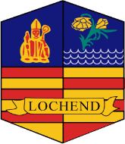
Parent Council Meeting 3
Date: Thursday 28th November
Present: Katy Anderson (HT), Claire Goldie, Tracey McNamee, Heather Kerr, Jane McGurk, Carla Gordon
Apologies:
Minutes

Discussion Points | Person Responsible
Fundraiser for Filip’s Family

HT Shared update and thanks from family regarding the generous donation from the Parent Council.

Family Christmas Event

- Family Christmas Movie night is confirmed for Dec 4th.
Action Points:
CG to buy sweets and make sweet bags for event
HK to organise event and decoration
EL to organise hot food
TMcMN, CG, JMcG will attend event and support with supervision

