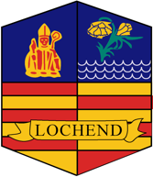

Lochend Community High School
Parent Council

Agenda
Monday 11th December 2023
4.30pm Start

1/ Cost of the school day – New name for Survey/some suggested first steps within school

2/ Fundraising – Remind Carrie Anne to share the email from Kathryn Farrow

3/ Bank Account

4/ Merit/Demerit Poster

5/ Main Entrance of School

AOCB
- Cultural Day 2024
- Parental Engagement 2024 – ICT sessions
- Parental Numeracy Sessions – Glasgow Life

