**Langside Primary School**

**Relationship Policy**

**Rationale**

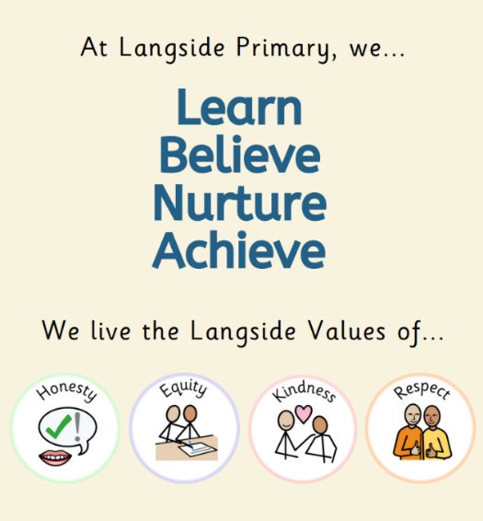At Langside Primary School, we are committed to fostering a safe, inclusive, and nurturing environment where all children can thrive. Our Relationship Policy promotes positive interactions among students, staff, and families, ensuring that every child feels valued and respected. We recognise the importance of trauma-informed practices in building healthy relationships and supporting the emotional well-being of our students. In alignment with the United Nations Convention on the Rights of the Child (UNCRC), we uphold the rights of all children to ensure their dignity and well-being.

All staff have engaged in CLPL focused on implementing the nurture principles and restorative approaches into their daily practice and our school ethos. Our Vision, Values, Aims & Rationale reflect our commitment to placing relationships at the heart of all that we do.

**Principles**

1. **Respect and Dignity**: Every individual within our school community deserves to be treated with respect and dignity. We celebrate diversity and promote an inclusive environment.
2. **Safety and Well-being**: The physical and emotional safety of children and staff is paramount. We encourage open communication and a supportive atmosphere where everyone can express their feelings and concerns.
3. **Collaboration**: We believe that strong relationships between staff, learners, and families contribute to the well-being and success of all. We encourage collaboration and partnership in supporting children's learning and development.
4. **Empowerment**: We strive to empower children to develop their social skills, emotional intelligence, and conflict resolution abilities, helping them build healthy relationships with peers and adults.
5. **Restorative Practices**: We are committed to using restorative practices to address conflicts and restore relationships, emphasising accountability, empathy, and healing rather than punishment.
6. **Co-Regulation and De-escalation**: We recognise the importance of co-regulation in helping learners manage their emotions. Staff will employ de-escalation techniques to support children in moments of distress, fostering a calm and supportive environment.
7. **Trauma Informed Practice**: **We u**nderstand and respond to the needs of children affected by trauma, recognising its impact on behaviour and relationships.

**Aims:**

* To foster an environment of mutual respect and understanding among all members of the school community (UNCRC Article 19).
* To provide education and resources on healthy relationships, including friendship, teamwork, conflict resolution, and emotional regulation (UNCRC Article 28).
* To establish clear guidelines for addressing and managing conflicts or negative behaviours through restorative practices and co-regulation strategies, ensuring a fair and consistent approach (UNCRC Article 39).
* To engage families in the development of their children's social skills and understanding of relationships (UNCRC Article 12).

**Implementation**

1. **Education**:
   * Incorporate relationship education into the curriculum through PAThS and other subjects, including topics on restorative practices, emotional regulation, and co-regulation techniques.
   * Provide training for staff on promoting positive relationships, implementing restorative practices, and employing de-escalation strategies.
2. **Support Systems**:
   * Establish clear reporting procedures for students to voice concerns about relationships, bullying, or harassment (‘Talk to’ System & Anti-Bullying Ambassadors).
   * Provide access to support services, such as school counsellors or external agencies, for children and families in need.
3. **Restorative Practices**:
   * Implement restorative circles and conferences as tools for resolving conflicts and rebuilding relationships. These practices encourage open dialogue and promote understanding among those involved.
   * Train staff and learners in restorative techniques, helping them take responsibility for their actions and understand the impact of their behaviour on others.
4. **Co-Regulation and De-escalation**:
   * Equip staff with de-escalation techniques, such as active listening, calm communication, and providing personal space, to help children regulate their emotions during challenging situations.
   * Encourage a culture of co-regulation, where staff model emotional regulation and provide support to learners in managing their feelings effectively.
5. **Behaviour Expectations**:
   * Set clear expectations for behaviour, emphasising our values of Kindness, Respect, Equity and Honesty.
   * Implement a positive relationship policy that recognises positive relationships and good conduct.
6. **Communication**:
   * Maintain open lines of communication between school staff and families regarding child behaviour and relationships.
   * Regularly update parents and guardians about relationship education initiatives and how they can support their children at home.

**Langside Strategies**

**Serious incidents**

Red triangle signifies that a member of staff requires immediate assistance from another adult in the room. Most times, the most appropriate adult will be a member of Senior Leadership Team (SLT), however a child may hand it to the first available adult. This adult will decide the best course of action. In the unlikely event that a child or member of staff experiences violence in school, they should immediately contact a member of SLT.

Blue triangles are used in a situation that another adult is required in the classroom for support but not a serious incident.

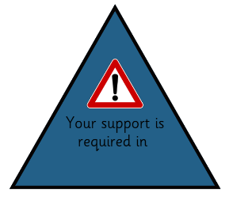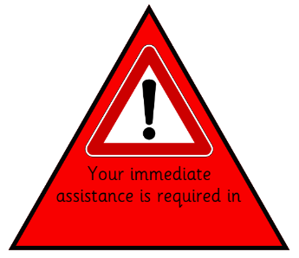

**Radio System**

All members of the Leadership Team (LT) and Support for Learning Workers (SfLW) will carry a radio at all times. Only initials of children should be used over the channel (no full names). In the event of a serious incident, SLT may radio for all available members of LT and SfLWs to gather in Central Hall (Discovery Zone) for further instructions.

**In Class**

* Avoid extrinsic motivators such as group/ individual points.
* Emotional Check-ins are used to help children share their feelings with their class teacher.
* If a system is required to promote positive behaviours, a recognition or ‘Above and Beyond’ board can be used, with specific targets in mind.
* Use class charters and jointly agreed class rules to promote a positive ethos.
* School Values should be displayed in every classroom.
* We do not promote traffic light systems (or equivalent) for displaying a child’s ‘Readiness to Learn’.
* If individualised motivators are required for children with ASN, this should be discussed with SLT prior to implementation.
* Movements breaks, Calm Corner or ‘Quiet Time’ cards are used to help children regulate their emotions.
* Adults consider and use TALK strategies when engaging with learners.

**In School**

* While walking through the school, we expect classes to be quiet, polite and mannerly but not silent.
* Adults recognise when a child displays good manners and model this too.
* High expectations are placed upon respecting shared spaces including resources.
* Children participate in a soft start from 8:45am. After break and lunch, children make their way into their classroom independently.
* The Starlight Room is timetabled for individuals but can be used as a responsive resource.

**In Playground**

* Children can be kept off the playground for making unsafe/ dangerous choices, as per a Risk Assessment carried out by SLT. Class teachers must consult SLT before any decisions are made.
* Anti-bullying Ambassadors are trained in restorative approaches to help with conflict in the playground, as are our SfLWs.
* SfLWs have restorative conversation prompts on their lanyards.
* SfLWs can radio for a member of SLT for more serious incidents in the playground.
* Where possible, conflicts should be resolved in the playground and teachers informed.
* Children who find the playground overwhelming have access to an Alternative Lunch Club held in the Learning Lounge.

**Rights Respecting School**

**Rationale:**

Our UNICEF Rights Respecting School Recognition of Silver Commitment was achieved in June 2024 recognising we have embedded the UN Convention on the Rights of the Child (UNCRC) within our whole school ethos. Children and adults work together to recognise and act upon the rights of the child within our school, our local community and the wider world. We believe that by understanding their own rights, children learn to respect and value the rights of others.

**United Nations Convention on the Rights of the Child (UNCRC)**

* The Convention sets out the rights of children in 54 Articles. These basic rights encompass survival, protection, development and participation.
* The UNCRC is underpinned by 4 principles:

1. Non-discrimination

2. Commitment to the best interest of the child

3. The right to life, survival and development

4. Respect for the views of the child

* Rights are universal and cannot be taken away.
* The main responsibility for ensuring that all children enjoy their rights lies with the adults.
* All rights are equally important.

**Rights Respecting Values underpin Leadership and Management:**

* Development as a rights respecting school is an integral part of strategic planning.
* All decisions are taken in the best interest of children.
* As school policies are reviewed, links with the values and principles of the UNCRC are made explicit.
* Refresher training takes place annually for all staff to ensure that knowledge and understanding remains relevant.

**The Whole School Community Learns about the UNCRC**:

* Every year group learns about the UNCRC, and view different areas of learning from a rights perspective.
* Displays should be linked to the UNCRC articles.
* All members of the community are encouraged to be ambassadors for children’s rights.

**The School has Rights Respecting Ethos:**

* All members of the community model rights respecting values.
* The environment is safe, physically and emotionally.
* Conflicts are resolved using restorative approaches where children are empowered to seek solutions to problems.

**Children are empowered to become active citizens and learners:**

* Learners’ opinions and thoughts are sought, encouraged and respected in all aspects of the school’s work.
* Pupil Leadership is an integral part of the school’s approach. Children are given opportunities to lead aspects of school life through a range of groups including Pupil Council, Eco Committee, Equalities and Diversities Committee, Rights Respecting Schools Committee and our Pupil Action Group time on Friday afternoons.
* Children are encouraged to identify themselves as Global Citizens and given opportunities to develop their knowledge and awareness of how they can have a positive impact on the world, now and in the future.

**Roles and Responsibilities**:

It is the duty of every member of the school community to ensure that Langside Primary School continues to move forward with our Rights Respecting School agenda and that the rights of all children are met and respected. The main responsibility rests with adults in the form of teaching the children about their rights and how to respect the rights of others.

**Monitoring and Review**

This policy will be reviewed annually to ensure its effectiveness and relevance. Feedback from children, staff, and families will be collected to continuously improve our approach to fostering positive relationships. Next review: August 2025.

**Conclusion**

At Langside Primary School, we are committed to creating a positive and supportive school community where all individuals can thrive. We believe that strong relationships are the foundation of a successful learning environment, and we will work together to uphold these values through restorative practices, co-regulation, and de-escalation strategies.

