**King’s Park Secondary School**

**Pupil Health and Wellbeing Profile**







Name: __________________

Class: __________________

Pastoral Care Teacher: ________________

**S1 Health and Wellbeing Profile**

|  |  |  |  |  |
| --- | --- | --- | --- | --- |
| Subject | Physical Education | Food Technology | PSE | Art and Design |
| H&W Grade |  |  |  |  |
| H&W Overall Grade |  | | | |

|  |  |
| --- | --- |
| Date Completed |  |
| Attendance |  |
| Discussion Points |  |
| Subject Targets |  |
| Wellbeing Web Targets |  |

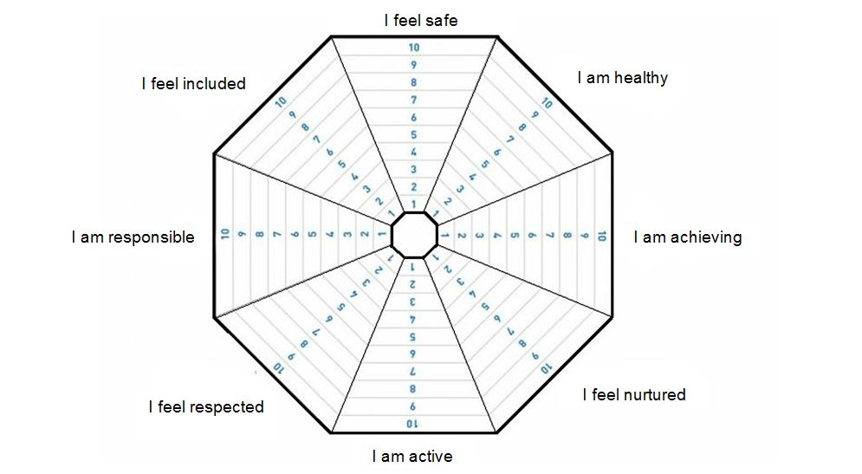



|  |  |
| --- | --- |
| Date Completed |  |
| Attendance |  |
| Discussion Points |  |
| Subject Targets |  |
| Wellbeing Web Targets |  |

|  |  |
| --- | --- |
| Date Completed |  |
| Attendance |  |
| Discussion Points |  |
| Subject Targets |  |
| Wellbeing Web Targets |  |



**S2 Health and Wellbeing Profile**

|  |  |  |  |  |
| --- | --- | --- | --- | --- |
| Subject | Physical Education | Food Technology | PSE | Art and Design |
| H&W Grade |  |  |  |  |
| H&W Overall Grade |  | | | |

|  |  |
| --- | --- |
| Date Completed |  |
| Attendance |  |
| Discussion Points |  |
| Subject Targets |  |
| Wellbeing Web Targets |  |



|  |  |
| --- | --- |
| Date Completed |  |
| Attendance |  |
| Discussion Points |  |
| Subject Targets |  |
| Wellbeing Web Targets |  |



|  |  |
| --- | --- |
| Date Completed |  |
| Attendance |  |
| Discussion Points |  |
| Subject Targets |  |
| Wellbeing Web Targets |  |



**S3 Health and Wellbeing Profile**

|  |  |  |  |  |
| --- | --- | --- | --- | --- |
| Subject | Physical Education | Food Technology | PSE | Art and Design |
| H&W Grade |  |  |  |  |
| H&W Overall Grade |  | | | |

|  |  |
| --- | --- |
| Date Completed |  |
| Attendance |  |
| Discussion Points |  |
| Subject Targets |  |
| Wellbeing Web Targets |  |



|  |  |
| --- | --- |
| Date Completed |  |
| Attendance |  |
| Discussion Points |  |
| Subject Targets |  |
| Wellbeing Web Targets |  |





|  |  |
| --- | --- |
| Date Completed |  |
| Attendance |  |
| Discussion Points |  |
| Subject Targets |  |
| Wellbeing Web Targets |  |