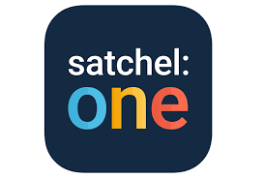
16th August 2021

Dear Parent/Carer,

SATCHEL: ONE

I am writing to inform you about the online homework recording system that we will be using with all S1 pupils at King’s Park Secondary School. Satchel: One (previously known as Show My Homework) is an online facility where pupils can access their homework and keep an accurate record of homework submission dates. Parents and carers can also have full access to the overview of homework issued to their child and the submission dates. Notifications can be set up on Satchel: One which can be used by parents/carers to support their child to balance their workload at home.

Your child will use their Glow log on details to access their Satchel: One account. Alongside this letter you should receive a note of the unique PIN number for you to use and with instructions to enable access from home. This unique PIN will allow you to have an overview of your child’s Satchel: One account. Satchel: One can be accessed via mobile phone, tablet, laptop or PC and will be an app that is available on the school iPad that your child will soon receive.

S1 pupils will be given time in class to log on to their Glow and Satchel: One accounts to ensure their profile is working over the next couple of weeks. Pupils will be supported with the use of the new system as they are issued homework by their class teachers.

Please do not hesitate to contact our school office if you have any questions about Satchel: One.

Yours sincerely,

Alison Thyne
Depute Head Teacher

