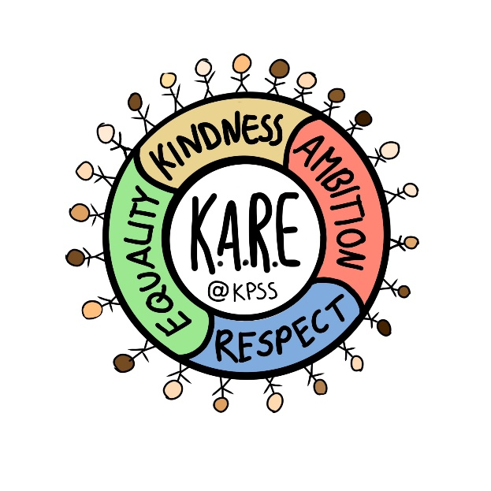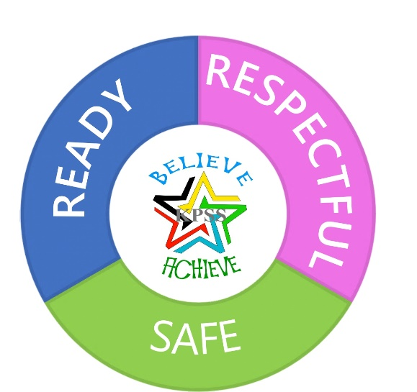

Establishment Policy on

**Nurturing Relationships**

**King’s Park Secondary School**



(Updated August 2025)



**Nurturing Relationships**

Glasgow City Council’s ‘Nurturing Relationships’ policy (May 2025) articulates our commitment to the inclusion of all children and young people and our belief that they should fulfil their full potential whilst in our care. It has been informed by a range of key national and local documents in particular Glasgow City Council’s revised Additional Support for Learning policy, *‘Every Child is Included and supported’’* (June 2016).

Each establishment is required to produce and keep under a review, a policy on Nurturing Relationships. This policy is derived from the Council’s *‘Nurturing Relationships’* and will take account of the circumstances of this establishment.

In addition, a new **Relationships and Behaviour in Schools Action Plan** has been launched by Scottish Government and Education Scotland regarding behaviour and relationships in schools. hese changes aim to create safer, more inclusive, and supportive environments for all young people. The Action Plan outlines 20 actions across 8 key themes in response to recent research showing an increase in challenging behaviours and highlights the need for trauma-informed and inclusive approaches.

**Key Themes:**

* Safe and Consistent Environments
* Staff Support and Professional Learning
* Pupil Voice and Participation
* Multi-agency Collaboration
* Data and Evaluation
* Policy and Guidance Updates
* Parental Engagement
* Equity and Inclusion

Schools are encouraged to adopt whole-school approaches to behaviour, with predictable consequences and strong home-school partnerships. The goal is to ensure every child feels safe, respected, and supported.

Our school policy outlines how King’s Park Secondary Schoolwill ensure ***Ready, Respectful, Safe*** is at the heart of our approach to learning, behaviour and relationships by:

• Educating the whole child and developing their personal and social skills to ensure their own wellbeing and that of others.

• Providing safe and stimulating learning environments for all children and young people that enable them to reach their full potential and become successful learners, effective contributors, responsible citizens and confident individuals.

• Ensuring children and young people have regular opportunities to develop an understanding of their rights and responsibilities.

• Developing an awareness of the promotion of positive relationships across the school community and roles and responsibilities in working towards this.

• Developing a desire in all children and young people to participate positively and contribute at all times.

As with all our practice, it is dependent on successful relationships across our school community with children and young people, parents and carers, partners and staff. I hope you find the contents of this document helpful to you.

Signed:



Kirsty Ayed

Head Teacher

**Nurturing Relationships - Strategies Employed**

King’s Park Secondary School operates a range of initiatives and strategies, which allows members of staff to promote positive relationships both in the classroom and across the Learning Community.

These include:

* Our motto of ‘*Believe, Achieve’* encompasses values such as, respect, honesty, hard work, responsibility and equality. Believe, Achieve was created by our school pupils and staff and underpins our ambition for every young person.
* Our ‘*Ready, Respectful, Safe*’ strategy is an approach to learning which supports the school community and gives everyone clear expectations of our high aspirations of learning, behaviour and relationships.
* *Ready* – Our expectation is that pupils will be in full school uniform, have their iPad charged and available for use and a focused and engaged attitude. Our expectation is that staff provide a positive welcome at the door, a clear purpose of learning and effective class routines and engaging activities for all.
* *Respectful –* Our expectation is that pupils and staff are polite and kind, active listeners and inclusive.
* *Safe -* Our expectation is that pupils and staff create a nurturing classroom, and maintain positive relationships and remain calm.
* *Mobile Free Classroom/Corridors* - Following parental, staff and pupil feedback and a series of inputs about the impacts of mobile phones on health and wellbeing and learning during PSE lessons, King’s Park Secondary School has introduced a ‘Mobile Free Classroom and Corridor’ policy in line with our Ready, Respectful Safe expectations. Mobile phones are kept out of sight in school bags or placed in the purple tray. Our Mobile Free Classroom and Corridor strategy is part of our ready to learn expectation because it encourages a focused and engaged attitude, encourages collaboration and prevents unnecessary distractions.
* *Rights Respecting School* – As a Gold Rights Respecting School, our vision is to create a nurturing and inclusive environment where the voice of every young person is heard and acted upon. Where young people feel they belong, are valued and feel empowered. As duty bearers, staff uphold the articles within the UNCRC and aim to equip young people with the skills and knowledge to be good citizens. Diversity is celebrated and an inclusive environment is established for all young people.
* All members of staff can award Believe Achieve merits through Satchel:One to all pupils. These can be awarded for a number of reasons including good uniform, good effort and showing kindness. Each month there is a whole school focus where pupils can be awarded a ‘badge’ for meeting the focus. This system ties together with our House system and helps to celebrate achievements appropriately.
* The school’s focus Digital Learning and Nurture Principles fully embedded within our Learning and Teaching strategy, continues to promote opportunities for pupils to succeed and engage actively in their learning.
* Expectations of pupils, staff and parents are clear and are outlined fully in the School Handbook. (follow this [link](mailto:http://www.kingspark-sec.glasgow.sch.uk/PlainText/PlainText.aspx?SectionId=fc401e09-db26-4a99-b60a-b4bf0fffe373&subject=Handbook) for more information)
* We have high expectations of our pupils, working in partnership with staff and parents, ensuring that learners are progressing as they should be.
* The responsibility for the promotion of positive and purposeful relationships lies with the classroom teacher, as indicated in the GTCS Standard for Full Registration (2021), 3.2.3 – As a registered Teacher ‘we promote and develop positive and purposeful relationships with and between learners’. Please follow link for further details ([GTCs Standards for Full Registration](https://www.gtcs.org.uk/wp-content/uploads/2021/09/standard-for-full-registration.pdf))
* Should there be concerns about a pupil’s behaviour that persist, then various strategies should be used by the class teacher (Appendix 1)
* If there is a serious incident, then the class teacher should contact their subject Principal Teacher immediately. If the PT is not available, the class teacher should contact the school office who will contact a member of SLT or Loraine Bertolini (PT Pupil Support). (Appendix 4 outlines what defines a serious incident and Appendix 3b outlines the procedures to be followed regarding serious incidents).
* Persistent incidents of low-level behaviour and incidents of a serious nature should be reported via the Seemis Behaviour Referral system. Guidelines for how to use this system are outlined in Appendix 5.
* Some pupils may benefit from targeted intervention through our Pupil Support Team, who offer a number of strategies focusing on social, emotional and behaviour support. The ‘Learning Zone’ can be used by pupils who require a quiet space or calm to allow time to adjust and return back to class. After assessment, this is put in place on an individual basis and a prior arrangement agreed by Pupil Support and House DHT.
* If the interventions of support are not adequate to bring about a positive change in pupils’ behaviour, a pupil might be placed into NEST (New Expectations, Setting Targets). This allows for some further reflection and time out of classes to continue with their class work, supervised in our NEST room (Appendix 6).

**Strategies that are built on mutual trust and respect:**

* Wellbeing for all staff and pupils is a key focus for King’s Park Secondary. The relationships between staff and pupils are of great importance to developing a shared culture of mutual trust and respect.
* In May 2025 we were very proud to achieve our Rights Respecting Schools ‘Gold Award’, after achieving ‘Silver’ in June 2023 and involved the whole school community to support progress.
* Based on Article 12, we are offering increasing opportunities for young people to be involved in decisions that affect them including learning and teaching and our curriculum. We have established an active Learner Participation group who work together with staff sharing ideas and taking forward different initiatives to enhance the learning experience. We have also formed a Curriculum Innovation Group where young people and staff are working together to revise our Curriculum Rationale and plan Project Based Learning for BGE pupils.
* The promotion of ‘Restorative Approaches’ to restore relationships is being developed across our school community (Appendix 2)
* In our work towards being a ‘Nurturing’ school, some pupils are supported and are given opportunities to thrive in a nurturing environment. This includes various supports and interventions that are ongoing and mostly based in our Nurture and Wellbeing Hub.
* We have a flexible approach to our curriculum delivery where identified young people engage in a bespoke programme of support with a focus on skill development and wider opportunities through Rangers, Clay Café and Castlemilk Youth Complex.
* Pupil voice is promoted and listened to through the Youth Parliament which has representatives from all year groups. Pupils are elected by their peers and, in turn, represent their year groups.
* S5-6 School and S1-6 House captains have been elected by their peers and selected through interview to have their leadership role. They lead by example and support a variety of school events through the school year both in school and in the wider community.
* There are opportunities for meaningful teacher - pupil dialogue through learner conversations to review progress and identify next steps in learning. These take place and coincide with tracking and monitoring with all year groups.
* There is a clear focus on raised expectations, encouraging our pupils to aim higher than they have previously. This message is reinforced in all curricular areas and at assemblies led by young people, Pupil Support staff and the Senior Leadership Team.
* All pupils are encouraged to take on active leadership roles. All year groups have leaders who help out at school functions and information evenings. Pupils often take the lead at assemblies and information evenings to inform parents/carers about their learning and experiences.
* There is an active Parent Partnership group who organise and support various events throughout the school year.
* We work closely with our partners who support the wellbeing and progression of our young people. These include Motivation, Commitment, Resilience Pathways (MCR), FARE, Action for Children Counselling provision, Skills Development Scotland (SDS) and Developing the Young Workforce (DYW).

The Nurturing Relationships Policy will be monitored and reviewed through feedback from pupils, staff and parents/carers.

**Meeting Learning Needs through Staged Intervention**

Our school ensures that all children and young people, including those with more challenging circumstances and require significant input from partner agencies, will become successful learners, confident individuals, responsible citizens and effective contributors.

We believe that early intervention and a co-ordinated approach by Education, Social Services and Health Services are essential in enabling the most vulnerable children, young people and their families more choices and chances to achieve.

We ensure that children and young people receive inputs at levels required to meet their additional support needs by using Glasgow’s Staged Intervention Model (*Every Child is Included and supported, June 2016.* [*Policy link*](https://www.glasgow.gov.uk/CHttpHandler.ashx?id=32783&p=0) *for further details*)

**Stage 3**

Resources external to

establishment

**Stage 2**

Within establishment

**Stage 1**

In class

**Stage 4**

Multi-Agency

Involvement

The needs can be met only by education staff, including Psychological Services, working closely with staff from other services and appropriate agencies.

The additional support needs cannot be fully met by staff in the establishment and the resources available there, but within education services.

The young person requires specified support over a sustained period at a level beyond the classroom teacher.

The needs of children and young people are met within the classrooms by the class teacher.

**School Expectations and Ethos**

* Our ‘Ready, Respectful, Safe’ and Mobile Free Classroom/Corridors strategy gives everyone clear expectations of our high aspirations of learning, behaviour and relationships as follows:

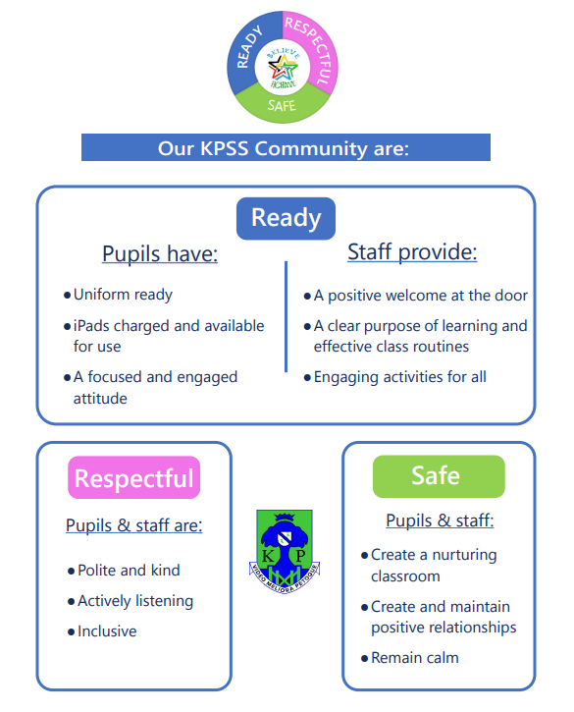

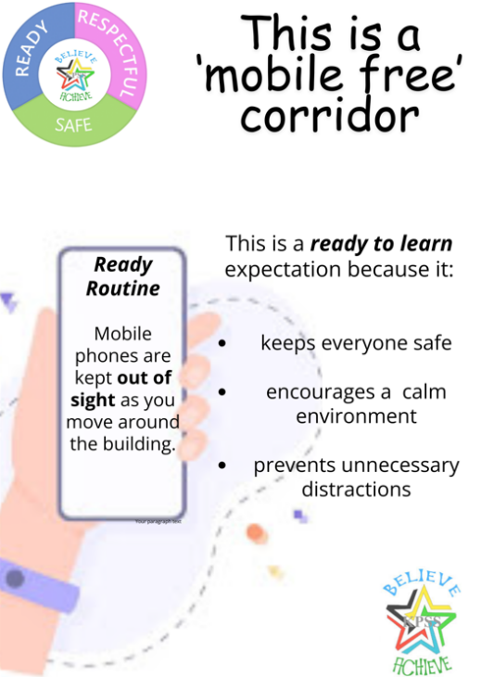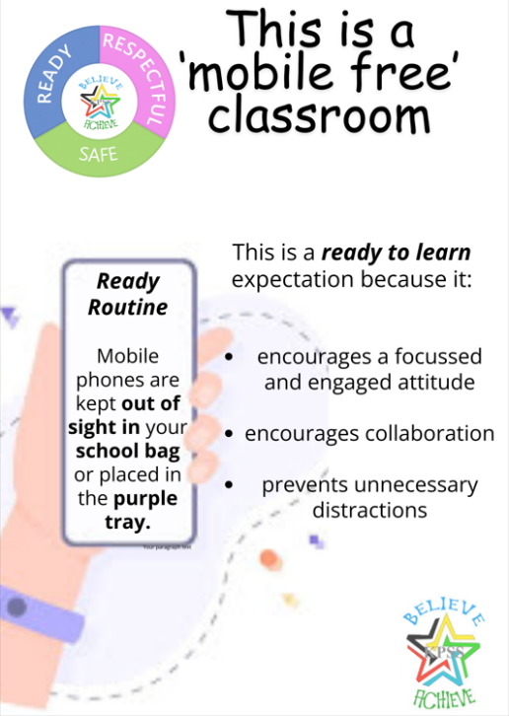

**Mobile Free Classroom and Corridor strategy**

We have introduced a ‘Mobile Free Classroom and Corridor’ policy in line with our Ready, Respectful Safe expectations.

The agreed procedures for staff and young people are as follows:

* All classrooms have the ‘mobile phone’ classroom poster on their classroom door as well as being positioned somewhere prominent in their classroom.
* Teachers will remind pupils at the door of the no mobile phone policy when they are welcoming pupils to their lesson as per the ready to learn approach. A suggested statement is as follows: “**Our mobile phone policy states that all mobile phones should be out of sight in your schoolbags during lessons. If you do not have a school bag with you the phone should be placed in the purple tray until the end of the lesson when you can collect this from your teacher.”**
* If a pupil does not follow the above and uses their phone without permission they will be reminded of the policy again and will be asked to put their mobile phone out of sight. If a pupil continues to use their phone, the pupil will be asked to put their phone in the purple tray until the end of the lesson. Where this situation arises again with the same pupil, they will be referred to the Principal Teacher where appropriate consequences will be put into place. If there is no change, this will be passed on to the Link Depute and House Team and contact will be made with parents/carers.
* During the changeover of classes or where pupils are using the corridor, phones should be out of sight. Teachers will support this by reminding pupils regularly.
* Pupils should use headphones only to support their learning and are not permitted to listen to music using their mobile phones.
* Pupils are permitted to use their mobile phones during break and lunchtimes in social areas.
* Where there are exemptions, these will be discussed at House level and communicated to all staff. This may be for medical reasons, for example, young people with diabetes who use their mobile phone to regulate their blood sugar levels.
* On entry to PE, pupils should bring their mobile phones to their PE teacher who will place the mobile phone in a valuables box which will be locked away and returned at the end of the lesson.
* Mobile phones that are found in the school and whose owner cannot be located should be handed to the school office.
* Mobile phones are the personal responsibility of pupils.

**Out of Class Pass**

In response to concerns raised regarding the amount of missed learning, we have implemented an Out of Class Pass system to allow class teachers, PT Pupil Support and House DHTs to monitor when pupils are out of class. In order to maximise learning and teaching, it is important that young people are in the learning environment as much as possible. The purpose of the Out of Class Pass allows us to monitor the reasons for young people being out of class and the amount of teaching and learning they are missing.

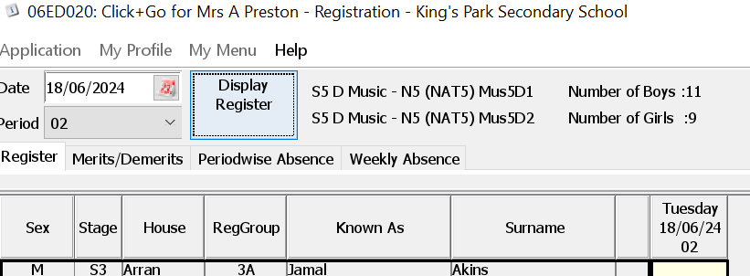

Class teachers should use the Seemis De-Merit system to record pupils who are given permission to leave the classroom for any reason (toilet, music lesson, meeting).

The simplest way to do this is selecting the Merits/Demerits tab on your seemis register.

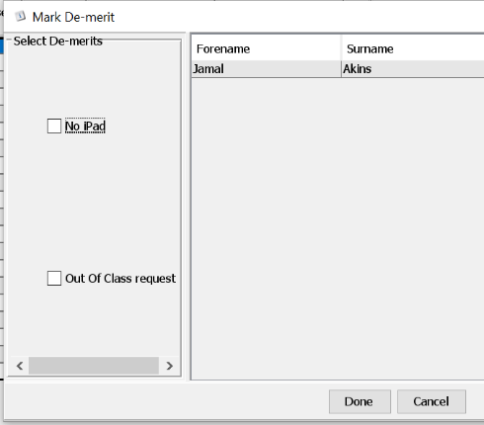

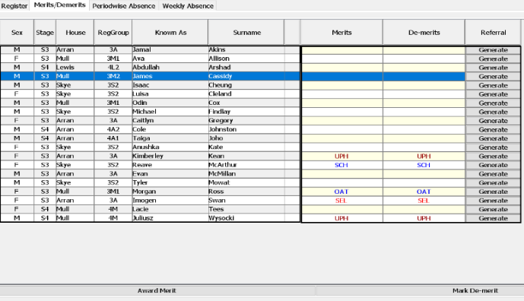

Select the pupil and select **Mark De-merit** (bottom right).

There are only two De-merit options currently available to choose from: **Out of Class Request** or **No iPad**. Select **Out of Class** **Request** and click **Done**.

Please note, to access this for a **cover class**, please do the following:

**Select: Application-Behaviour-New Behaviour**. You can either filter by pupil name or by class for all and add a demerit this way.

**Toilets**

In response to concerns raised by young people around feeling safe accessing the toilets we have implemented the following strategies:

* Pupils should not use the toilets during the first and last 10 minutes of the period to ensure accurate registration and key components of the lesson are not missed.
* Pupils should sign out of class and leave their mobile phone in their bag/teacher’s tray for those pupils who have not brought a bag to school as per our Mobile Free Classroom policy.
* Toilet Passes are available due to medical needs and these can be requested by parents/carers from Pupil Support/DHT.
* Pupils must not congregate in the toilets to allow access for everyone.
* Pupils must not eat, drink or vape in the toilets.
* The toilets will be monitored by staff at interval and lunch time.
* There is a rota in place where staff take part in a walk around the school building each period, checking the toilets and encouraging young people back to class.

**Learning and Teaching**

* Our Learning and Teaching Strategy outlines key areas which are integral for effective Learning and Teaching on which all lessons should be based upon. Planning is an integral part of the process.
* Be at your class before pupils, meeting them at the door. Have an established routine to be followed as pupils arrive, and make sure that the pupils know these.
* The learning intentions of the lesson should be shared clearly at the beginning of the period, as well as the success criteria, co-created by pupils and the teacher where appropriate.
* Adapted materials should be provided in order to accommodate individual learning needs.
* Pupils should be given very clear directions about the activities they are being asked to undertake.
* The teaching methodology should be varied to take account of the different learning styles of pupils.
* A seating plan should be drawn up for each class.
* Ready, Respectful, Safe and Mobile Free Classroom posters should be clearly displayed and frequently re-visited.
* The work of the pupils should be attractively displayed.

**Appendix 1: Strategies for Dealing with Low Level Disruptive Behaviour (Nurture Principles).**

**‘The Classroom Offers A Safe Base’ – Feeling Secure, Reduces Stress-Related Behaviours**

* **Structuring**.
* Think in advance what might cause difficulties.
* Look at the room and try to keep potential trouble to a minimum.
* A well-planned lesson with a seating plan is crucial.
* Young people with emotional difficulties are less likely to be able to cope with change; therefore a structured environment may be more effective.
* **Scaffolded Activities.**
  + Ensure all pupils have structured support to access and engage with the lesson.
  + Adapted materials must be considered.
  + All behaviour is communication – misbehaviours can be a sign the pupils are not able to do the set task.

**‘Language is a Vital Means of Communication’ – PACE: Positive, Accepting, Curious, Empathic**

* **Re-Directing.**
* When pupils are beginning to be unsettled, suggest an alternative activity, or an alternative way of doing the same activity.
* Redirecting pupils or reminding them of the task and checking for understanding may be enough to defuse a situation.

*For example: “Why don’t you come and help me . . .?” “Why don’t you try this . . .?”*

* **Esteem-Builders**.
  + Young people with emotional or behavioural difficulties often have low self-esteem and their behaviour is designed to keep others at a distance.
  + Use opportunities to build up their self-esteem.
* **Direct Statements.**
  + Use positive statements to reinforce expectations.
* **Catch the Pupil Behaving Well**.
  + Recognise and quickly respond to appropriate behaviour.
  + This quick action will encourage the pupils to display the desired behaviour more often.
  + Be aware that some pupils may need this to be reinforced quietly or non-verbally to prevent embarrassment in front of peers.
* **Offer a Choice, and Apply Consequences**.
  + If the instruction is not followed, you might issue a choice to the pupil.  This can be done after the first, second, or third request.
  + Give the pupil a choice between following the command or facing a consequence for disobedience.  For example: *"Jim, you have a choice. You can sit down now or you'll sit with me during the interval.”*
  + If you find it necessary to implement the consequence, make it clear to the pupil that he or she made the decision as to which option will occur.  The consequence should be administered quickly and in a calm, matter-of-fact manner.

**Dealing with more Serious Incidents**

There may be occasions when the situation reaches a fairly advanced stage of conflict or hostility. The following strategies may be helpful:

* **Reflect on the Situation**.
  + Simply state what appears to be happening. This means reflecting without judging or employing any threats or sanction, e.g. *“I can see that you are really wound up here.”*
* **Remove Audience Participation**.
  + Cut down space between yourself and the pupil misbehaving to deny them an audience.
* **Be Honest, know what you Control.** 
  + During a crisis, it is important to be honest and not make promises that you are not in a position to keep, e.g. do not promise that there will be no consequence if it is very likely that the pupil will have one.
* **Get Support.** E.g**.** peer teacher /PT/FH
* **Distraction**
  + Sometimes the pupil can be distracted from their emotions if you keep them talking.
* **Listen**. E.g.hear the concerns the young person is speaking about, allow them to speak.
* **Legitimise Emotion**
  + *“It is okay to be angry, but it is never okay to act out this anger by throwing something/hitting someone.”*

**Appendix 2 - Restorative Approaches**

Restorative Approaches is a national tool which every authority is being encouraged to implement. Glasgow's Restorative Approaches Framework (GRAF) has been created to support the implementation of Restorative Approaches within a whole-establishment setting. At King’s Park Secondary, we are following the key principles of GRAF in implementing Restorative Approaches across our school community. Restorative Approaches complement our work towards being a Nurturing school.

The key themes are:

Theme 1: Relationships promote positive and attuned interactions.

Theme 2:  Accountability and responsibility for self and others.

Theme 3:  Children and young people are active participants in conflict resolution.

A restorative conversation could take place, as detailed in the book, ‘When Adults Change, Everything Changes’ by Paul Dix (2017), “when trust is broken or when behaviour has gone under and below minimum standards. When tempers have frayed, when manners have disappeared or when things have been said that should not have been said.”

A restorative conversation is more than a process or a set of questions. The behaviour of the adult lies at the heart of it all and is an everyday approach to building stronger relationships.

Five key restorative questions to support and facilitate the restorative conversation are below:

1. What happened?

2. What were you thinking at the time?

3. What have your thoughts been since the incident?

4. Who do you think has been affected by your actions? In what way were they affected?

5. What do you need to do to make things right?

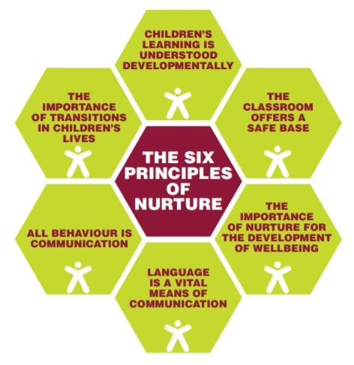Children have the right to be listened to and to say what they think about things.” (UNCRC, Article 12)



**Appendix 3a Persistent Low Level Disruption**

Examples: Dept. monitoring card, regular check-ins, host Restorative Conversations during interval or lunch

**Appendix 3b – Serious Incident**

**Appendix 4 – Criteria for classification of a Serious Incident and Exclusion**

**Criteria for classification of a Serious Incident:**

* Assault on a member of staff or other adult or young person (violent incident).
* Throwing desks / chairs etc (violent incident).
* Possession and / or use of an offensive weapon (violent incident).
* Fire raising (violent incident).
* Verbal assault on a member of staff or other adult or young person (non-violent incident).
* Significant misconduct (non-violent incident).

**Exclusions**

We use the national guidance, *Included, Engaged and Involved Part 2* and local authority policy (MC8) to inform our practices around exclusions.

* Restorative approaches, nurturing principles and the promotion of Ready, Respectful, Safe are used to minimise the need for exclusions.
* Where challenging behaviour persists and interventions do not bring a positive change, pupils may be placed into NEST (New Expectations Setting Targets) to allow further reflection as well as a 1:1 debrief with Pupil Support to explore behaviour.

There are two reasons a young person can be excluded from school:

1. The authority is of the opinion that the parent/carer of the pupil refuses or fails to comply, or to allow the pupil to comply, with the rules, regulations, or disciplinary requirements of the school.
2. The authority considers that in all the circumstances to allow the pupil to continue his attendance at the school would be likely to be seriously detrimental to order and discipline in the school or the educational well-being of the pupils there.

You can report a serious incident to GCC using the HANDS Incident Reporting system. For further information around how to use the system please see: Appendix 1 HANDS Incident Reporting System School User Guide.pdf

To report a serious incident visit <https://gcc.info-exchange.com/Schools> . Please alert your link DHT if you report the incident through this link.

**Appendix 5 - Seemis Referral System**

We use the Seemis Behaviour Referral system to **Create and Manage Referrals**.

* Application
* Behaviour
* Referral System
* Create Referral Later

1. Use filter to display pupils
2. Select the relevant pupil
3. Using the drop down calendar, enter the Date of the Incident
4. Select In class or Out with class as appropriate
5. Click Proceed

If selecting **In class**, confirm the teacher, room and subject is correct by clicking **Proceed**. This information can be changed if necessary using the dropdown lists provided. If selecting **Out with class**, the teacher should be selected from the list and the location would need to be entered.

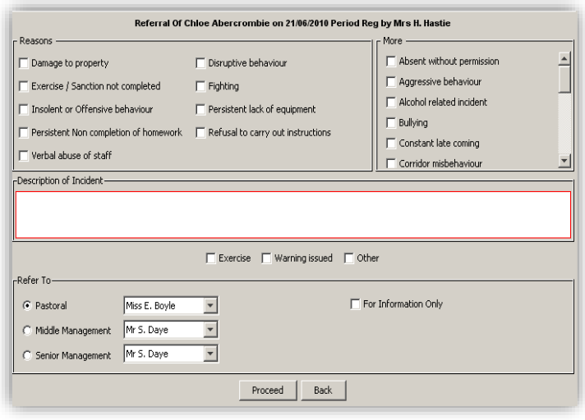

1. Select reason(s) for referral from the list provided.
2. Enter Description of Incident and if appropriate select action taken, e.g. Exercise.
3. Select **Refer To Pastoral**, **Middle Management** or **Senior Management**.
4. From the dropdown list select the appropriate member of staff.
5. Click **Proceed.**
6. Click **Save** to generate the referral, **Cancel** to remove the referral or **Back** to return to previous screen.

**Managing Referrals**

This facility allows the user to view or manage a referral already generated. A letter advising of the referral details can be printed or saved in this screen.

* Application
* Behaviour
* Referral System
* Manage Referrals

1. Use the filter to display referrals
2. The referrals are colour coded, click View Legend
3. Select the required referral and click Next to proceed.
4. Select the relevant Action Taken, more than one can be selected if necessary
5. Enter Comments, this is a mandatory field
6. The referral details can be printed out using **Print Preview**.
7. Using the transfer option the referral can be sent to another member of staff
8. To close the referral click **Signoff And Close**
9. To update the referral without closing it, click **Save**

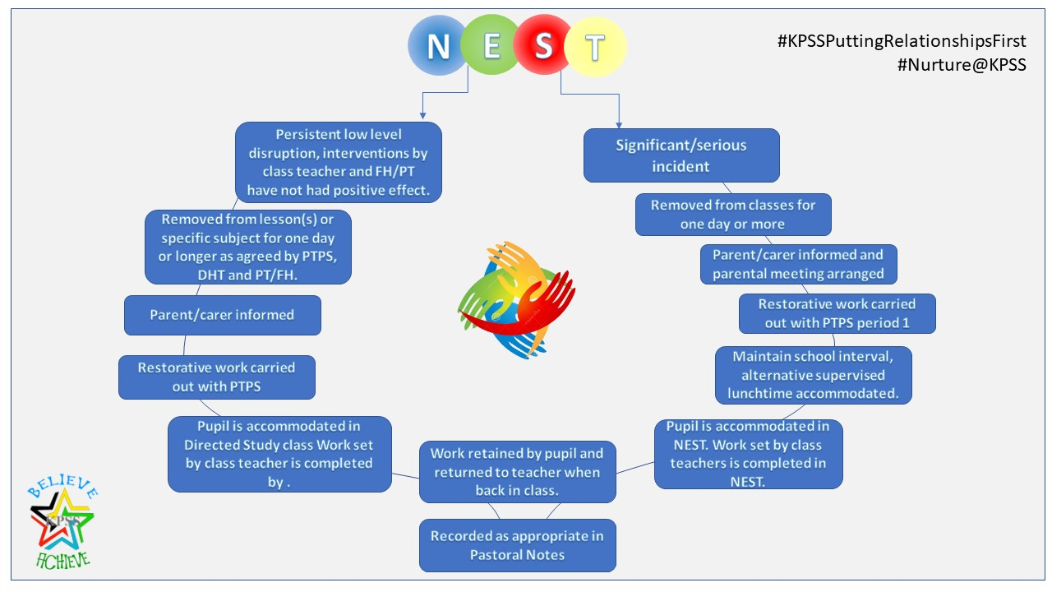**Appendix 6 – New Expectations, Setting Targets (NEST)**