Signal:
FIRE ALARM (Fire Evacuation)
CONTINUOUS REPEATED RINGING of SCHOOL BELL (Evacuation, Non-fire)

Ground Floor | Evacuation Route
Primary 1  Room 2 | Out classroom door, left through fire door, down front stairs (use right side of stairs) and out the main door.
Primary 2/1  Room 1 | Out classroom door, across the hall, through fire door, down back stairs (use right side of stairs) and out the back door.
Nursery Class  Room 6 | Out Nursery door, right, through double door, out the main door, towards the main entrance, down front stairs (use right side of stairs) and out the main door.
Hall | Leave via the closest exit, through the double doors, and down the front/back stairs and out the main/back door.
Badger’s Den  Room 3 | Out classroom door, left through the hall, through the double doors, down back stairs (use right side of stairs) and out the back door.
School Office | Out office door, left through the hall, through the double doors, down back stairs (use right side of stairs) and out the back door.
Nursery Office | Out Nursery office door, right through the hall, leave with Nursery Class, through the double door, towards the main entrance, down front stairs (use right side of stairs) and out the main door.
Head Teacher’s Office | Out Office door, down back stairs (use left side of stairs) and out the back door.
Head Teacher’s Meeting Room | Out Meeting Room door, through the door to hall, right across the hall, through the double doors, down back stairs (use left side of stairs) and out the back door.

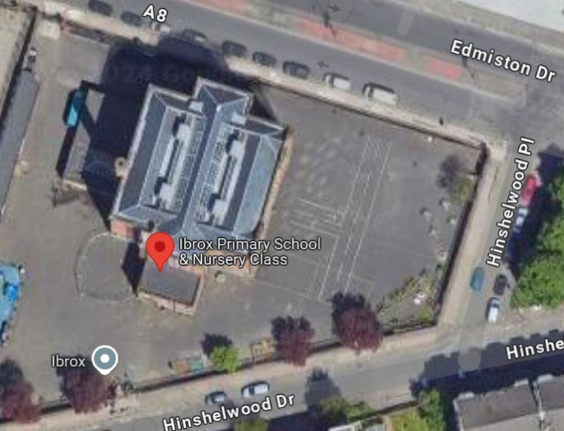
Please Note:
- Teachers carry registers for roll call at ASSEMBLY POINT at marked area
- Raise register when class are all accounted for.
- Clerical to complete staff register.
- Follow classroom route unless it is affected by fire. If route affected, USE SHORTEST WAY OUT
P7
P6G
P6T
P55
P4
- Do not return to the building until told to do so by the Call Challenge Team.
Staff/Visitors
Nur
P1
Signal:
FIRE ALARM SOUNDS (Fire Evacuation)
CONTINUOUS REPEATED RINGING of SCHOOL BELL (Evacuation, Non-fire)

First Floor | Evacuation Route
Primary 3/2  Room 6 | Out classroom door, down front stairs (use right side of stairs), through the front door, down stairs and out the main door.
Family Room  Room 5 | Out classroom door, left, through the double doors, down back stairs (use left side of stairs) and out back door.
Pre-Loved Shop  Room 4 | Out shop door, down back stairs (use left side of stairs) and out back door.
EAL Room  Room 9 | Out classroom door, across the landing, right through double doors, down back stairs (use left side of stairs) and out the back door.
Primary 3  Room 8 | Out classroom door, across the landing, right through double doors, down back stairs (use left side of stairs) and out the back door.
Resource Room  Room 7 | Out classroom door, left around the landing, left through the double doors, down front stairs (use left side of stairs) and out the main door.
Staffroom | Out Staffroom door, straight down back stairs (use left side of stairs) and out the back door.
PT Office | Out office door, left down front stairs (use left side of stairs) through the front door, down the stairs and out the main door.

Please Note:
- Teachers carry registers for roll call at ASSEMBLY POINT at marked area
- Raise register when class are all accounted for.
P7
- Clerical to complete staff register.
- Follow classroom route unless it is affected by fire. If route affected, USE SHORTEST WAY OUT
P6G
P6T
P55
P4
- Do not return to the building until told to do so by the Call Challenge Team.
Staff/Visitors
Nur
P1

Signal:
FIRE ALARM SOUNDS (Fire Evacuation)
CONTINUOUS REPEATED RINGING of SCHOOL BELL (Evacuation, Non-fire)

Second Floor | Evacuation Route
Primary 7A  Room 16 | Out classroom door, straight down front stairs (use left side of stairs) through the front door, down the stairs and out the main door.
Library  Room 15 | Out Library door, left, through the double doors, down back stairs (use left side of stairs) and out back door.
Primary 7T  Room 14 | Out classroom door, straight down back stairs (use left side of stairs) and out back door.
Primary 4  Room 12 | Out classroom door, across the landing, right through double doors, down back stairs (use right side of stairs) and out the back door.
Primary 5  Room 11 | Out classroom door, left across the landing, left through double doors, down front stairs (use right side of stairs) through the front door, down the stairs and out the main door.
Primary 6  Room 10 | Out classroom door, across the landing, left through the double doors, down front stairs (use left side of stairs) through the front door, down the stairs and out the main door.
Depute Head’s Office | Out Office door, straight down front stairs (use left side of stairs) through the front door, down the stairs and out the main door.
Active School’s Office | Out Office door, straight down back stairs (use left side of stairs) and out back door.

Please Note:
- Teachers carry registers for roll call at ASSEMBLY POINT at marked area
- Raise register when class are all accounted for.
P7
- Clerical to complete staff register.
- Follow classroom route unless it is affected by fire. If route affected, USE SHORTEST WAY OUT
P6G
P6T
P55
P4
- Do not return to the building until told to do so by the Call Challenge Team.
Staff/Visitors
Nur
P1
P2
P3
P2/1

 | Route
Floor | Front Stairs | Back Stairs
Ground Floor | Hall  Nursery  P1 | Hall  P2/1  Badger’s Den  Office  HT Office  HT Meeting Room
First Floor | P2  Resource Room  PT Office | Family Room  Pre-loved Shop  P3  EAL Room  Staffroom
Second Floor | P7  P6G  P5  DHT Office | Library  P6T  P4  Active School Office

