



Photographs
Not all of our children have permission to have their photographs taken, before taking any pictures whilst visiting Ibrox Primary and Nursery Class, please ask a member of staff.
Further information
Scan the QR code below for full details of our Child Protection and Safeguarding Policy. Copies are also available in our school office.

Thank you on behalf of all of our school community for your diligent support of our children’s welfare and working with us to ensure that every child is kept safe.

Visiting our school
When visiting Ibrox Primary or Nursery Class:
- Please sign in at the School Office
- Visitors will be issued with a visitor badge (you will find contact details for the child protection officer displayed on the back) this must be displayed at all times.
- Visitors will be asked to remain under the supervision of a designated member of staff whilst on site.
- Remember to sign out at the school office and return their badge when leaving.




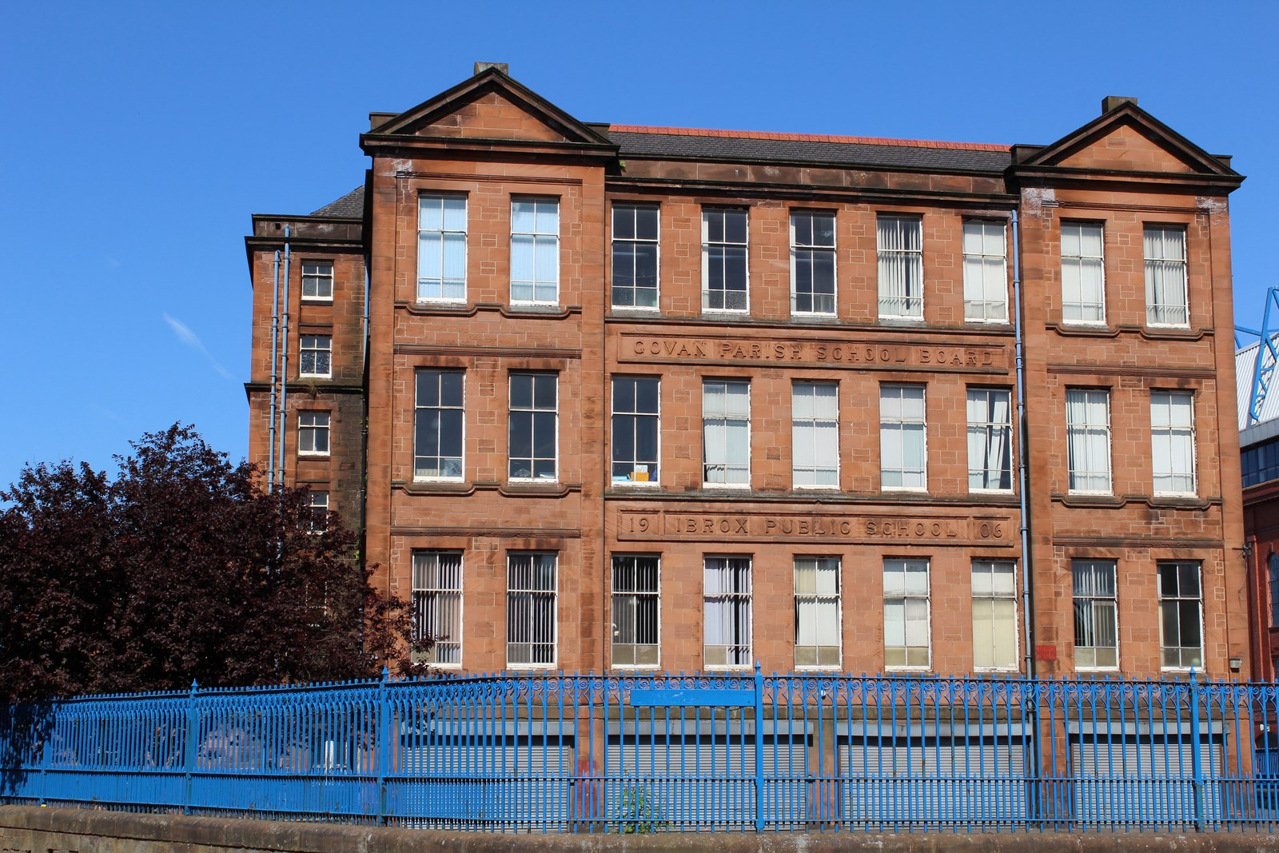





All educational establishments and services must take positive steps to help children and young people protect themselves.

At Ibrox Primary and Nursery Class we maintain a positive ethos and climate which actively promotes children and young people’s welfare and safety.

If you become concerned about
- A specific incident you see or hear about.
- A disclosure made by a young person or parent/carer.
- A child’s behaviour that may place them at risk or harm.
- Adult behaviour that may place a child at risk.
- A variety of minor concerns which put together give rise to concern.

Please report your concerns immediately to Mrs Young, Child Protection Coordinator or if she is unavailable, one of our Deputy Child Protection Coordinators.

Keeping Our Children Safe
Subheading
Drag your own photos onto any image placeholders in this template, then crop or resize them if you wish.
Subheading
To add an image caption, select the image and then tap or click the Style tab in the Format controls.
Subtitle
To add photos, image galleries, audio clips, videos, charts or any of more than 700 customisable shapes, tap or click one of the insert buttons in the toolbar or drag and drop the objects onto the page.
You can layer objects, resize them and place them anywhere on the page. To change how an object moves with text, select the object and then tap or click the Arrange tab in the Format controls.
Article 19:
Every child has the right to be free from violence, abuse and neglect.
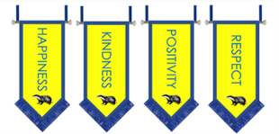

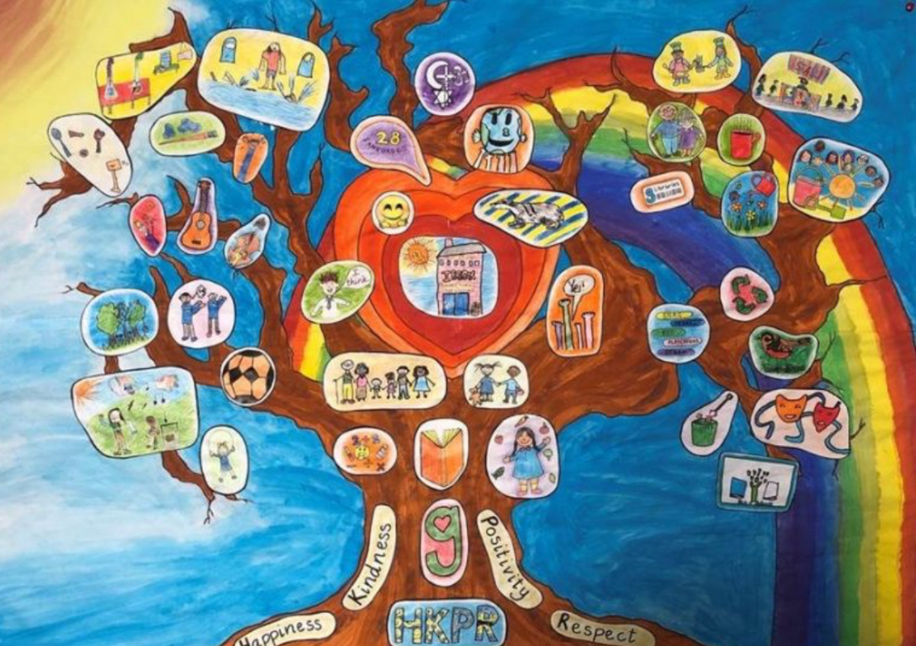
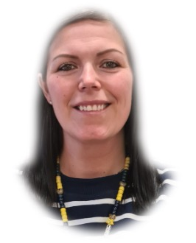
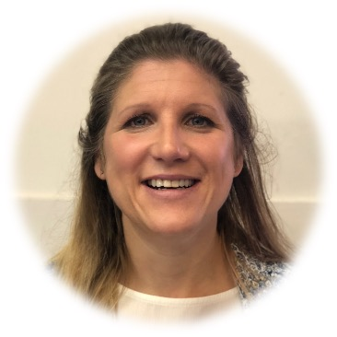
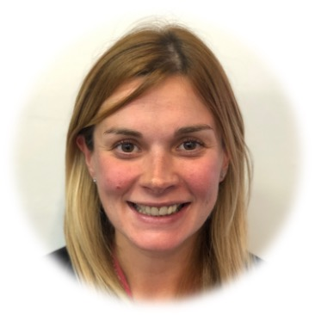
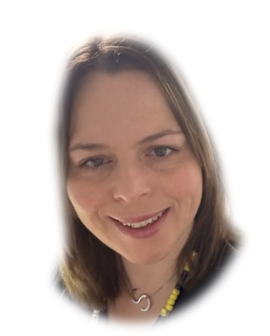
A child disclosing information can be alarming or upsetting but it is important that in this situation you stay calm and controlled;
- Listen carefully to what the child is telling you.
- Do not show shock or disbelief.
- Do not promise confidentiality, reassure the child but do not make promises that might not be possible to keep.
- Reassure the the child that you will tell Mrs Young/Mrs Chalmers, Mrs McDonnell or Charlene, who will be able to help.
- Do not interrogate or ask leading questions,
- Reassure the child that it was right for them to tell.
- Inform Mrs Young immediately or I her absence, one of the Depute Child Protection Coordinators, Mrs Chalmers, Mrs McDonnell or Charlene Murphy.
- Do not discuss the disclosure with anyone else.
- You maybe asked to record what the child said in their own words, including how the account was given.
- You may be asked to a Record of Concern, Appendix 3, copies are available in the school office and staff room.

What to do if a child discloses information to you?

Deputy Child Protection Coordinators
Ms Charlene Murphy
Nursery Team Leader
If Mrs Young is not available, please report your concerns to one of our Deputy Child Protection Officers.

Child Protection Coordinator
Mrs Gail Chalmers
Deputy Head Teacher
Should our visitors have any concerns regarding the welfare of any child they must report these concerns to our Child Protection Coordinator and Head Teacher, Mrs Young.

Child Protection Coordinator
Mrs Fiona Young
Mrs Sarah McDonnell
Principal Teacher

