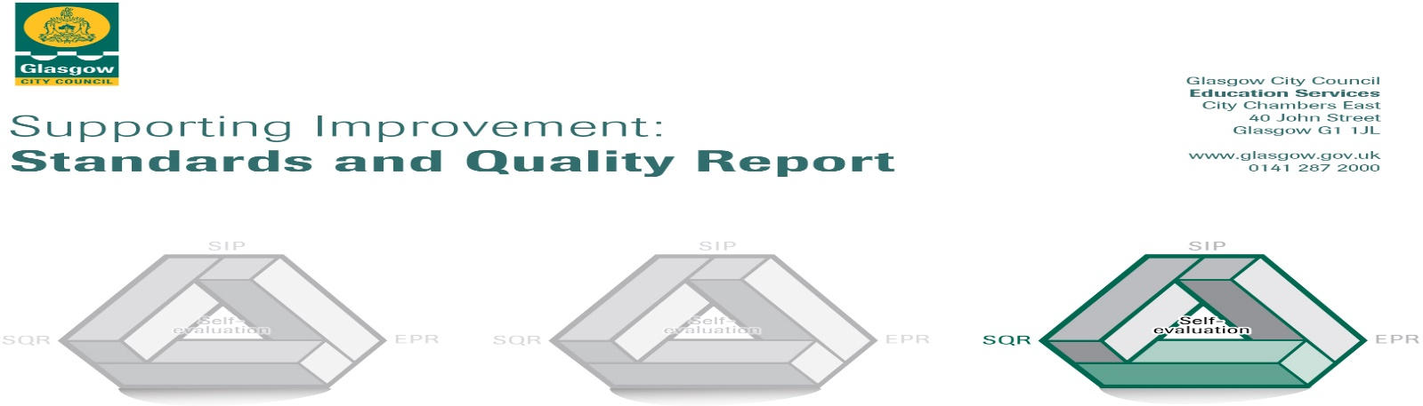

**Ibrox Primary School - Nursery Class**

**2021/2022**

The summary report is provided for parents/careers and partners to outline our achievements this session and our priorities for next session. Throughout this session we have taken forward our priorities as detailed in our school improvement plan. Through our processes of self-evaluation, we have identified how we can improve outcomes for our children and young people.

|  |  |
| --- | --- |
|  | **Our achievements and improvements this year.** |
| We would like to highlight the following improvements/achievements:  **Key developments**  Charlene Murphy began her post as Team Leader in our Nursery Class at the start of the 21/22 session. She established herself in the role very quickly and worked hard throughout the year to build on the good work of the nursery. She has built positive relationships with children, parents and staff alike.  Parents have been extremely positive about the nursery experience for their children this year. Parents were asked if they were happy with the nursery and all parents responded that they are happy with the nursery. Their children felt the same.  During our annual survey parents reinforced this message through sharing the following comments –  "If it wasn't for the staff my grandchildren wouldn't be where they are now. The staff are amazing, total credit to them all"  “it has been a very good time at Ibrox nursery – big thank you to all the staff for their hard work”  "Yassin loves it here, she is more confident and so helpful thank you, thank you, thank you"  As a result of feedback from a questionnaire, it was evident that the majority of parents would prefer email as additional method of communication. The team leader then began to use email as a direct contact with parents and vice versa. It was also used to send out important information and newsletters.  Parents feel well informed, especially working families, through regular updates about nursery information through a range of communication methods; Twitter, SHOWBIE App, virtual meetings, Parent Council meetings and monthly newsletters.  Parental partnerships were strengthened throughout the year with the reintroduction of events in the nursery such as; Circle of Security, Maths Week celebrations, Tea and Talk on Zoom, Spring Tea, Bookbug, Park Visits, Sunflower completion, parent meetings and transition to school sessions.  A CDO from our nursery worked with the children and staff in P1 which resulted in increased staff knowledge and understanding of the learning in Primary 1. The additional support also benefited the children.  **Developments in learning and teaching and assessment**  Session 21/22 had a clear focus on the wellbeing of children and supporting them to reconnect with the nursery and their friends.  Digital learning was a key focus for throughout the year with the children developing skills in using the IPad, spheros and the Smartboard. In addition to being a communication tool, Twitter and SHOWBIE, also became focussed on the learning experiences of the children.  Our pre-school children benefited from the Leaders of Early Learning (LEL) “Transition Project” which supported families to engage with literacy and numeracy activities at home with their child, helping them to prepare for Primary 1. As part of this project our Lead Practitioner of Attainment (LPA) translated the book “Starting School” for the LEL team to allow families to access the story in their mother tongue.  The focus of our Lead Practitioner of Attainment (LPA) changed from the development of numeracy and maths skills to the development of literacy skills, particularly focussing on listening and talking. All children working with the LPA made improvements.  The reintroduction of family learning events allowed the opportunity to reconnect with families, build relationships and support them to support their child at home.  **Progress in promoting well-being, equality and inclusion**  We continued to work closely with a number of partners including our Parent Council, PEEK, Govan Help, NSPCC and Glasgow the Caring City to provide support to our families.  Nursery children visited the Flower Field garden each week to work with Stuart (Elderpark Housing Association). Through this the children experienced planting, vegetable growing, games and arts and crafts. The nursery also visited the garden with the P1 children which enhanced the nursery to P1 transition programme. P6 buddies also visited the nursery to work with the children. They developed relationships with the children through story telling and digital learning.  Emotion Works (Colour Monsters) and PATHS continue to be used to support the children’s emotional wellbeing. These provide the children with a clear structure to understand and express their emotions.  To enhance the lunchtime experience for our children we looked at the national document “Setting the Table”. The children and nursery staff worked in collaboration with the dinner staff to create a menu that was both healthy and appealing.  **Progress in children’s learning/raising attainment and recognising achievement**  This year we encouraged parents/carers to become involved in their child’s learning by introducing the SHOWBIE App.  The attainment of our pre-school children improved from the previous year, in both literacy and numeracy. The children have settled well into P1 and the P1 staff have commented on their readiness for the transition to school.  The introduction of a big book by the Team Leader to record the journey of the nursery throughout the session was a success. It provided evidence of quality learning and improvements. |

|  |  |
| --- | --- |
|  | **Here is what we plan to improve next year.** |
| In session 2022/2023 we plan to:  1. Look at “Our Nursery” – reviewing our Vision and Aims, looking at “How Nurturing is our Nursery?” and developing children’s voice.  2. Develop the use of Showbie, particularly focussing on using it to support the assessment of children’s learning and the tracking of children’s progress over time.  3. Continue to focus on high quality learning experiences for our children to ensure they maximise their successes and achievements and fulfil their potential. |

|  |  |
| --- | --- |
|  | **How can you find out more information about our school?** |
| Please contact us directly if you require further information or if you wish to comment on the report.  The contact e-mail address is: [headteacher@ibrox-pri.glasgow.sch.uk](mailto:headteacher@ibrox-pri.glasgow.sch.uk)  Our blog: <https://blogs.glowscotland.org.uk/gc/ibrox/>  Our telephone number is: 0141 427 0922  Our school address is: Ibrox Primary School and Nursery Class, 46 Hinshelwood Drive, Glasgow, G51 2XP  Further information is available via: newsletters, the nursery Twitter account @ClassIbrox, Ibrox Primary School App, our Blog, Ibrox Primary School & Nursery Class YouTube channel and the nursery handbook.  In addition to this there are always staff available at the beginning and end of the nursery day to speak to you about any concerns you may have. |