|  |  |
| --- | --- |
| **Curricular Area** | **Details** |
| **Language and Literacy**  **kids-writing[1]** | This term primary seven will focus on **reading** World War II non-fiction texts and novels. As a class, we will read the novels, ‘Once’ and ‘Then’ written by Morris Gleitzman. Pupils will learn about genres of books and themes within books. They will develop skills in summarising texts and identifying the main purpose and ideas of a variety of texts. They will learn the skills of skimming and scanning texts in order to locate key information. P.7 will independently keep a reading journal, where they will log their reading progress, strengths and areas/ skills to be developed further.  Our **writing** will focus on both fiction and non-fiction texts. Skills development will focus on presentation skills, an awareness of the audience they are writing for and the purpose of their writing, e.g to inform, to persuade etc. pupils will become more independent in their ability to edit and improve their writing.  **Listening and talking** lessons in term 4 will require pupils to prepare and present a talk to the class. This will be on an area of World War II which interests them. |
| **Mathematics and Numeracy**  **math[1]** | Skills to be developed in numeracy and maths throughout term 4:  \***multiplying & dividing** whole numbers and decimals by 10, 100 & 1000  \***BODMAS**- learning about the order of operations when brackets are used  \***multiples & factors** of numbers  *learning to accurately draw and label a 4quadrant grid and plot points within each quadrant  \***time**- learning about units of time, 12 hour and 24 hour clock, reading and creating their own timetables  \***angles**- identifying angles in real life, drawing and measuring angles accurately to 2°, calculating angles in triangles, finding complimentary and supplementary angles. |
| **Interdisciplinary**  **Learning (IDL)** | Our IDL for term 4 will be based around our topic WWII. This topic allows for a variety of learning experiences in several curricular areas, including Social Studies, Literacy, RME and Health and Wellbeing.  We would love to hear about any family involvement, family stories or see photographs from WWII, as we could use these to support and enhance our learning. |
| **Social Studies** | **WWII**- pupils will develop the skills to use a range of resources to research events of the past. They will learn how events in history changed and shaped society. They will participate in activities which will allow them to compare and contrast life during WWII to their own life. They will learn about key people from WWII, including, Hitler, Anne Frank and Alan Turing. |
| **Sciences** | Our **science** lessons will be on **Biodiversity and interdependence,** this involves learning about plants and animals, their ecosystems and how they are classified into different groups. |
| MC900290193[1]**Technologies** | We will continue to use the iPad within the classroom and Further develop skills in using them. Pupils will learn about the importance of copyright and the rules apply to websites. |
| **Religious and Moral Education** | Judaism will be our R.E topic for term 4. We will learn about the Story of Esther, the meaning behind the story and identify common themes to stories from their own religion or a religion of their choice. We will learn about the persecution of Jewish people – the Holocaust. |
| **Health and Wellbeing**  **respect** | In P.E pupils will develop their stamina by playing team games, participating in dance (WWII style) and through the bleep test activity. Pupils will keep track of their performance and set themselves goals to help improve their stamina. |
| **Expressive Arts** | We will continue to work on our performance of The Wizard of Oz. This will be performed for families during May. The pupils are really enjoying the planning, creating, singing and the drama involved in this. |
| **How you can help/Other Information** | Please encourage your child to complete all Homework and return it to school on the correct day. |

P.7’s Curricular Newsletter

Term 4 Session 2022/23

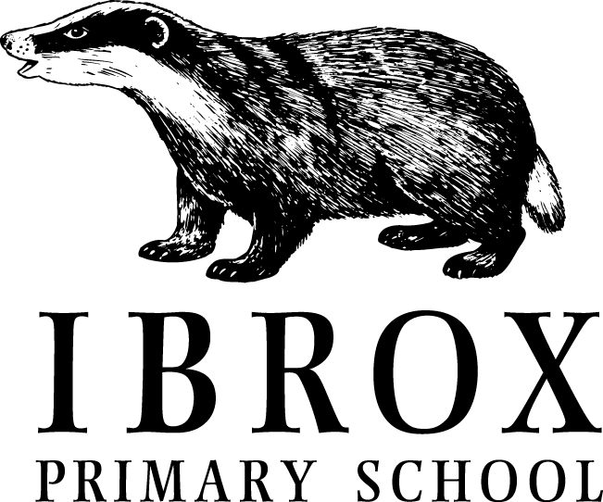

C:\Users\sm00120716\AppData\Local\Microsoft\Windows\Temporary Internet Files\Content.IE5\B1K9PSVG\blockpage[1].gif

**Welcome to P7’s last Newsletter!!**

Thank you to all parents and carers for all of your support throughout the year. It has been an extremely quick 4 terms, pupils would agree. We are planning a few activities for P.7 before they leave. Pupils voted on whether to have a leavers’ prom, the majority did not want this. Instead, we plan to have a leavers’ farewell for families and pupils, where P.7 children will be presented with their leavers’ certificate etc. There will be a disco afterwards for them to enjoy. Previously, parents/carers have enjoyed being involved in the planning of this, if you would like to become involved, contact the school office on **0141-427-0922**

We have also planned a camping trip for P.7, this will take place on 20th June. It would be lovely if all pupils were able to come along**.**

**Information on other P.7 events will come to you nearer the time 🙂**

**Dates for your Diary**

**Monday 24th April** - Filming for Your Body Matters promotional video (see April School Newsletter for details)

**Thursday 27th April** - 2.15pm Term 3 Supertreat Assembly

**Friday 28th April -** 11.30am Values Party - KINDNESS

**Monday 1st May** - HOLIDAY

**Friday 5th May (10 am)** - King’s Coronation Party in collaboration with Right There charity - families welcome (see April School Newsletter for details)

**Monday 8th May** - HOLIDAY

**Friday 12th May -** P5 IntoUniversity focus day - Zoology

**Thursday 18th May (pm)** - P4 & P5/4 to visit Ibrox Parish Church

**Friday 19th May -** P7 IntoUniversity focus session - Transitions

**Thursday 25th May** - INSET Day 5 - school closed to pupils

**Friday 26th & Monday 29th May** – HOLIDAY9’

**Week beginning Tuesday 30th May** - Health Week

**31st May** - P1 & P7 Dental Inspections

**Friday 9th June** – P6 IntoUniversity Focus Session- - Becoming an Independent Learner

**Thursday 15th & Friday 16th June -** P7 to Bellahouston Academy

**Tuesday 20th June**- P.7 camping trip

**Friday 23rd June** - School closes at 1pm

**Class Information**

Homework should be completed and returned on time.

Our P.E day this term is a **Wednesday**, please ensure all jewellery is left at home on this day.

**Super Treaters**

I can’t believe that we are now in our final term of the year, and looking forward to finding out who will be the last set of SUPERTREATERS for the session 2022/23!

Well done to everyone who has been nominated this year….and good luck to everyone else. It could be you this term, so keep living those Ibrox Values.

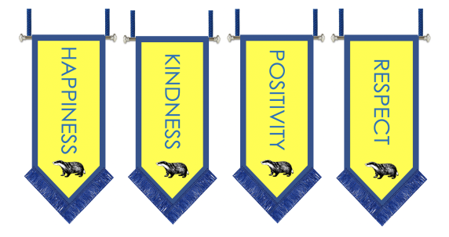**Assemblies** 

We are now delighted to be welcoming our Primary 1 children to assembly on a Friday.

Our Friday assemblies are where we share the learning that is happening across the school, and also celebrate any special achievements of the children. Please don’t forget to let us know of anything that your child has done that they would like to share. We love hearing about all their amazing successes 😊



**Class Achievements**

**As this is the last newsletter your child will receive at Ibrox Primary School, I would like to take the opportunity to thank everyone in the class for being a delightful group of pupils. I have thoroughly enjoyed teaching them throughout their time in P.7 and I will really miss them when they move on to secondary school.**

**Thank you P.7! You are all stars!** ⭐️