|  |  |
| --- | --- |
| **Curricular Area** | **Details** |
| **Language and Literacy**  **kids-writing[1]** | Phonics: We are continuing to learn and consolidate single sounds, digraphs and consonant blends which will support writing and reading in class. We will say, write, read, and hear all taught sounds and will continue to break, blend, and read unfamiliar words. Spelling: Spelling words are taught weekly, and a spelling assessment will take place every Friday. Reading: ORT books will be distributed on a Monday and should be read at home nightly. We will begin to use information we have learned from fiction and non-fiction texts to develop opinions. P2 will complete close reading tasks and will be encouraged to be independent readers. Using non-fiction texts, we will learn how to search for information in alphabetical order. Writing: Genres of writing this term will include explanation and instructions. P2 will learn how to add titles, introductions, and graphics to writing. We will continue to develop the following core writing skills: punctuation, connectives, adjectives, and verbs. Listening and Talking: P2 will listen for new and unfamiliar vocabulary in a range of texts and will gather information to present to others. |
| **Mathematics and Numeracy**  **math[1]** | P2 will learn how to multiply and divide this term. We will make and identify halves and quarters, share and group equally and show that a quarter is half of a half. We will learn how to multiply by 2 and 4, using concrete materials and repeated addition strategies. P2 will also learn how to divide by 2 and 4, using concrete materials and repeated subtraction strategies. Exploring data handling, P2 will read, record and label information in a bar graph, pie chart and table. The class will learn how to record information using tally marks and determine the best way to record information digitally. P2 will also discuss how numeracy skills are an important part of being successful in the world of work. |
| **Interdisciplinary**  **Learning (IDL)** | The World of Work: Working collaboratively with P3, we are going to explore different jobs and the key literacy, numeracy and social skills needed to be successful. We will invite guest speakers into school to share information about their job and P2 will ask suitable questions. P2 will link this area of learning to explanation writing. Deadly Animals: This is a pupil-led learning context which will develop research and digital skills. P2 will create a digital information document about an animal of their choice and will present their work to their peers. We will use data handling skills to record key information about deadly animals and will create musical instruments, linked to our science topic, to match the sound animals make in the wild. |
| **Social Studies** | The World of Work - P2 will participate in decision making and learn how to create opinions from facts. In relation to this, we will learn about different types of jobs in our community and describe how businesses are successful and how they use decision making strategies. |
| **Sciences** | Vibrations and Sound: We will learn about the pitch of sounds and will take part in experiments to explore how we can change the volume and pitch of sounds that come from vibrations. P2 will change variables such as tightness, length, and width. Space: P2 will learn new vocabulary such as ‘axis’ and ‘lunar’ and will learn how day and night are created in connection to the orbits of the Earth, sun, and moon. The class will create a model to display their learning and will recall key facts about orbits and the phases of the moon. |
| MC900290193[1]**Technologies** | Technology lessons this term will focus on using a search engine online. P2 will begin to search information on Google, discuss what should be searched for online and how to do this safely. P2 will use iPads to carry out this area of their learning. |
| **Religious and Moral Education** | This term we will learn about festivals and celebrations, focussing on Eid and Ramadan. We will encourage learners in class to share their experiences. |
| **Health and Wellbeing**  **respect** | PE: This term we will focus on both basketball and indoor hockey. In basketball we will develop the following skills: dribbling, chest passing, bounce passing, shooting and defence strategies. For indoor hockey, we will develop dribbling, stopping, passing, and shooting. P2 will prepare for ‘Sport’s Day’ and will compete later in the term. RSHP: We will also begin the ‘Relationships, Sexual Health and Parenthood’ learning in class where P2 will name and label all body parts, discuss privacy, private parts and explore the themes of friendship, positivity, kindness, and empathy. All parents and carers will be notified before this learning begins in class. |
| **Expressive Arts** | Drama: P2 will develop key drama skills this term with Mrs. Thompson. The class will perform familiar stories using voice, gestures, and facial expressions. Dance: P2 will learn how to jump, turn, and perform dances with control. We will vary the speed of our dancing, work individually and with a partner, explore jazz, hip-hop and Scottish dancing, and experience rehearsal time. |
| **How you can help/Other Information** | If you need log-in information for Sumdog or Showbie, please ask. Assessment work and children’s ‘Proud Work’ will be added to their Showbie account this term. Please continue to label your child’s belongings and encourage them to keep all belongings in their school bag. |

P2’s Curricular Newsletter

Term 4 Session 2022/23

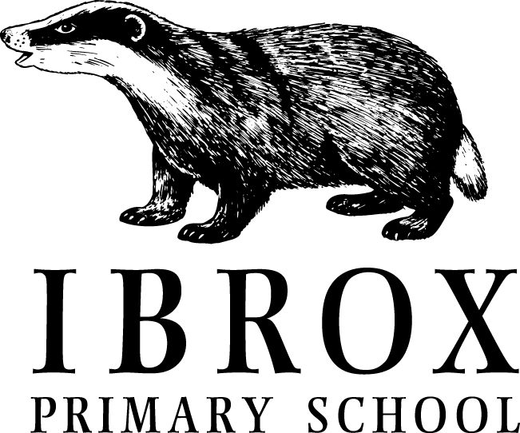

C:\Users\sm00120716\AppData\Local\Microsoft\Windows\Temporary Internet Files\Content.IE5\B1K9PSVG\blockpage[1].gif

Welcome to the Term 4 newsletter for Primary 2. Here is all the information you need to know for this term.

Important information and class learning will be posted on Twitter this term, so please ensure you are following the class Twitter page: **@IPSMISS**. I will begin to add resources and links to support learning at home and to help with weekly homework tasks.

If you have any questions or concerns about your child’s time in school please do not hesitate to contact us. The school number is **0141-427-0922.**

Here’s to a great final Term in P2!

**Dates for your Diary**

**Monday 24th April** - Filming for Your Body Matters promotional video (see April School Newsletter for details)

**Thursday 27th April** - 2.15pm Term 3 Supertreat Assembly

**Friday 28th April -** 11.30am Values Party - KINDNESS

**Monday 1st May** - HOLIDAY

**Friday 5th May (10 am)** - King’s Coronation Party in collaboration with Right There charity - families welcome (see April School Newsletter for details)

**Monday 8th May** - HOLIDAY

**Friday 12th May -** P5 IntoUniversity focus day - Zoology

**Thursday 18th May (pm)** - P4 & P5/4 to visit Ibrox Parish Church

**Friday 19th May -** P7 IntoUniversity focus session - Transitions

**Thursday 25th May** - INSET Day 5 - school closed to pupils

**Friday 26th & Monday 29th May** – HOLIDAY9’

**Week beginning Tuesday 30th May** - Health Week

**31st May** - P1 & P7 Dental Inspections

**Friday 9th June** – P6 IntoUniversity Focus Session- - Becoming an Independent Learner

**Thursday 15th & Friday 16th June -** P7 to Bellahouston Academy

**Friday 23rd June** - School closes at 1pm

**Class Information**

**PE in the Gym Hall**

We will go to the gym hall on a Thursday between 11 and 12. Please ensure you provide your child with indoor shoes for these lessons as we are focussing on basketball and hockey skills this term.

**Homework**

Homework is issued on a Monday and is to be returned on a Friday. Reading books are to be brought to school **every day**.

**Allergies and Sharing Snacks**

Please ensure that all snacks and school lunches are NUT FREE. P2 have also been reminded not to share their snacks with friends at break time.

**Super Treaters**

I can’t believe that we are now in our final term of the year, and looking forward to finding out who will be the last set of SUPERTREATERS for the session 2022/23!

Well done to everyone who has been nominated this year….and good luck to everyone else. It could be you this term, so keep living those Ibrox Values.

**Class Achievements**

Saad received the latest **Values** **Award** for kindness. Well done, Saad.

Congratulations to both Gursahaj and Juliusz for being awarded ‘**Supertreaters’** for Term 3.

Well done to Ozain for uplevelling in **taekwondo**.

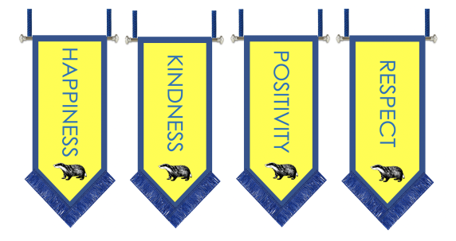**Assemblies** 

We are now delighted to be welcoming our Primary 1 children to assembly on a Friday.

Our Friday assemblies are where we share the learning that is happening across the school, and also celebrate any special achievements of the children. Please don’t forget to let us know of anything that your child has done that they would like to share. We love hearing about all their amazing successes 😊

