|  |  |
| --- | --- |
| **Curricular Area** | **Details** |
| **Language and Literacy**  **kids-writing[1]** | Phonics: We are continuing to learn a range of digraphs with consonant and vowel sounds which will support writing and reading in class. We will practise saying, hearing, reading and writing taught sounds. Spelling: Spelling words are taught weekly, and a spelling assessment will continue to take place on a Friday. Reading: ORT and Big Cat books will continue to be distributed to support key reading skills this term; developing vocabulary, identifying patterns in words, reading unfamiliar words, and discussing characters, setting and storylines. Writing: Genres of writing this term will include procedural, character and setting writing. P2 will learn procedural vocabulary, begin to use headings, use adjectives to describe as well as continue to punctuate sentences correctly. There is a big focus on self-assessment with writing this term and all learners will be encouraged to read their own work and ensure it makes sense. Listening and Talking: P2 will focus on listening for new information this term and sharing what they have learned. They will make connections to their own experiences and begin to answer an increasing range of questions based on what they have listened to. |
| **Mathematics and Numeracy**  **math[1]** | Estimation: We will estimate the number of objects in a group, pile or row and check our answer by counting. The class will learn how to calculate the ‘difference’ by counting on.  Directions: P2 will learn directional language (full, half, quarter turn, North, East, South and West) to give and follow instructions. We will learn about right angles and find then in our learning environments. Money: We will recognise and order coins to £1, make totals of money using different coins and give change within £1. Equations: Using our knowledge of number bonds to 10, and 20, the class will solve missing number problems and equations. Application of addition and subtraction strategies will be used. |
| **Interdisciplinary**  **Learning (IDL)** | Our learning contexts this term are ‘Scotland’ and ‘Dinosaurs’. For Scotland, we will focus on Scottish artists and learn to critique an artist using the visual elements and language: line, shape, tone, colour, pattern, and texture. We will research both Charles Rennie Mackintosh and Steven Brown and compare their work. With the Dinosaur topic, P2 will focus on creative writing and role-play in the ‘Dinosaur Museum’ in class. |
| **Social Studies** | This area of learning is linked to our ‘Scotland’ learning context. P2 will research a significant individual from the past and discuss their influence in Scotland. We will look at our local area in Govan and how Charles Rennie Mackintosh has impacted Glasgow. |
| **Sciences** | P2 will learn about forces this term and will predict and investigate how push, pull and friction forces operate. The class will experiment with magnets and learn the language that will allow them to discuss a non-contact force. |
| MC900290193[1]**Technologies** | Technology lessons this term will focus on using a search engine online. With support, P2 will begin to search information on Google, discuss what should be searched for online and how to do this safely. P2 will use iPads to carry out this area of their learning. |
| **Religious and Moral Education** | Mrs. Thompson will be teaching RME this term to P2. The class will learn about Christianity, Judaism and morals and will have opportunities to share what is important to them in their life. |
| **Health and Wellbeing**  **respect** | Gymnastics will be a key focus in gym. The class will learn to create and follow a sequence of gymnastic moves and explore their flexibility. Learners will have the opportunity to improve their communication skills through partner work and small group activities. P2 will also have a dance coach for 5-weeks and will learn Scottish dances and will perform in front of an audience. We will learn about safety this term and how to respond in emergency situations. |
| **Expressive Arts** | P2 will be working with music teacher, Mrs. Thomas, for 8-weeks. The class will learn to keep the beat with movement and body percussion, play a beat to a song, experiment with different vocal sounds and have the chance to sing individually or as part of a group. In drama the class will act out familiar and created stories using gestures, movement, and facial expressions. For Art and Design lessons, the class will recreate famous paintings by Steven Brown and Charles Rennie Mackintosh, concentrating on tone and colour. |
| **How you can help/Other Information** | Please ensure all reading books (Oxford Reading Tree and Big Cat) are returned with homework on a Friday. This is to ensure that all books are shared amongst classes fairly. I would also like to remind everyone that we are a **nut-free school**. |

P2 Curricular Newsletter

Term 3 Session 2022/23

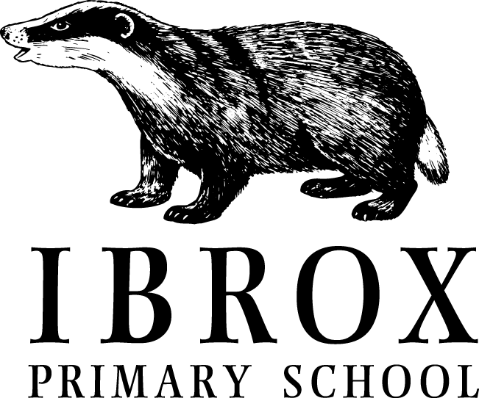

C:\Users\sm00120716\AppData\Local\Microsoft\Windows\Temporary Internet Files\Content.IE5\B1K9PSVG\blockpage[1].gif

**Dates for your Diary**

**Return**

Wednesday 4th January

**Strike Days**

Tuesday 10th January

Monday 16th January

**Whole School Scottish Celebration of Learning**

Week Beginning 6th February – date TBC

**February Mid Term Break**

Monday 13th February

Tuesday 14th February

Wednesday 15th February (InService Day)

**Spring Break Holiday**

Friday 31st March – school closes at 2:30pm

Monday 17th April – Children return

**Welcome to P2’s Newsletter**

Welcome to your Term 3 newsletter. Here is all the information you need to know for this term.

If you don’t already follow the class twitter page, or have the school blog downloaded, please follow **@IPSMISS** on twitter and download the ‘Scot Ed’ app to see all up-to-date information.

If you have any questions or concerns about your child’s time in school please do not hesitate to contact us. The school number is **0141-427-0922**

Here’s to another great term!

.

**Class Information**

Gym Days

P2 will have a gym lesson on a Friday afternoon between 2 and 3pm. Please ensure your child wears suitable clothing for this day.

Coaches

P2 will be working with a dance coach for 5-weeks on a Tuesday. You can also bring your gym kit for this.

Homework

Homework will continue to be distributed on a Monday and should be returned on a Friday.

**Super Treaters**

Congratulations to our second term Supertreater winners. We had a lovely assembly celebrating their achievements, and we look forward to celebrating our term 3 winners in March.

What can you do to become the next

SUPERTREATER?



**Class Achievements**

Well done to all children who received a ‘Values’ certificate in Term 2: Ollie, Sahaj, Cody and Aila.

Congratulations to both Sahaj and Sara for being selected as Term 3’s Supertreater!

Essa has also been chosen to join the Rights Respecting School committee to represent the school.

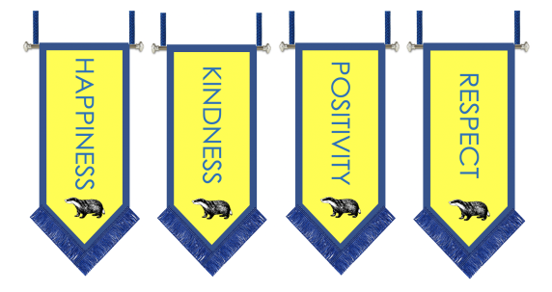**Assemblies** 

The children come together twice a week (Monday and Friday) for whole school assemblies. During this time, we do many different things, such as sharing information about what is happening in the school, asking the children for their ideas and opinions on different aspects of school, celebrating achievements and birthdays and also giving the children the opportunity to find out about the learning that is happening in other classes. They are very busy gatherings!