Ibrox Guide  to  Microsoft  Translator  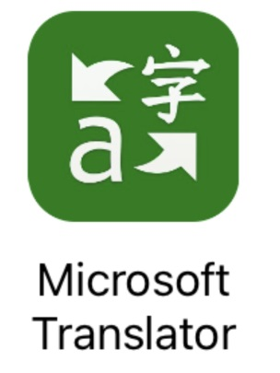  January 2021 | How to install the app  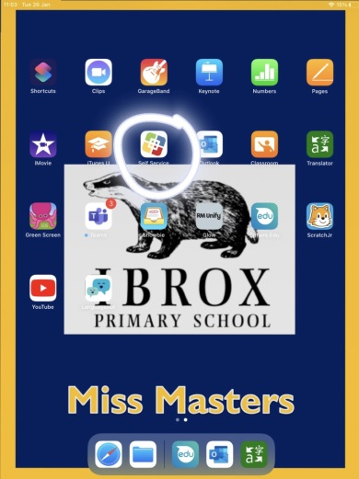  On your home screen, tap the ‘Self Service’ icon  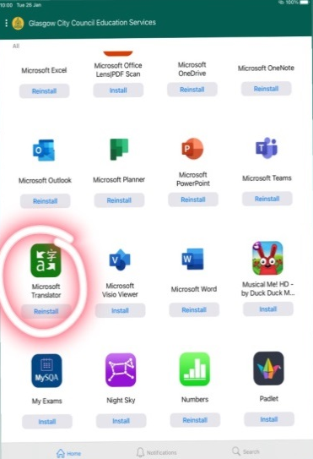  Apps are listed alphabetically. Find ‘Microsoft Translator’ and tap ‘install’. | Getting Started - Setting Up Features  The first time you use the app, there will be some features to set up.  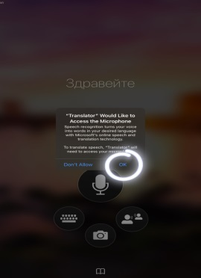  When you tap the large microphone icon, it will ask for permission to access your iPad’s microphone. Press ‘OK’.  This screen below will appear. Tap on the languages at the bottom.  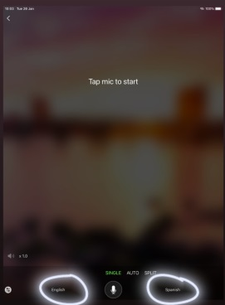  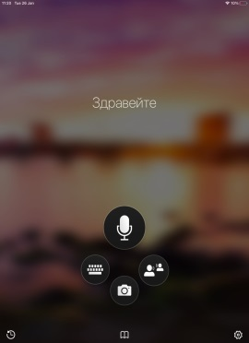  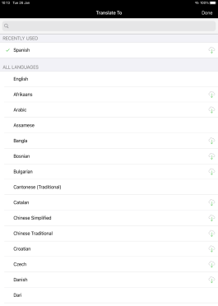  Select your languages from the list, or search.  This function is now ready to use.
Setting Up Features- continued  Tap on the camera icon. It will ask for permission to access your iPad’s camera. Tap ‘OK’.  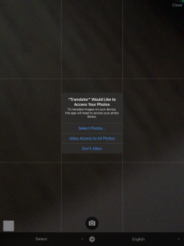  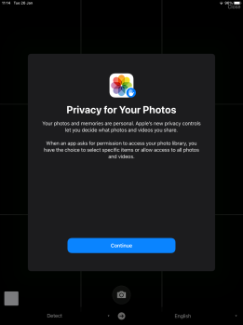  It will then ask which pictures it can access. Press ‘Continue’, then ‘Allow Access to All Photos’  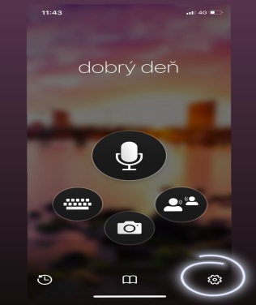  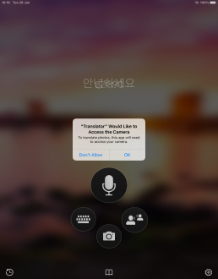  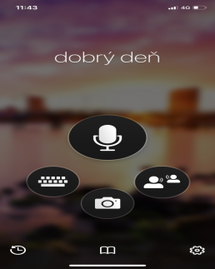  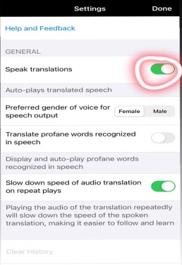  Tap the settings icon.  Ensure ‘Speak Translations’ is turned on. Tap ‘Done’. | How to Use-  Translating Speech  From the app’s main screen, tap the microphone icon.  Choose your languages if necessary (see page 2).  Tap the microphone and start speaking.  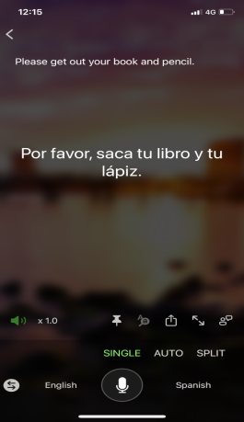  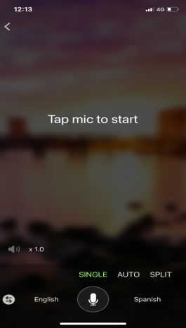  Tap the microphone again when you are finished.  Your translation will be shown in writing and spoken aloud. Tap the small speaker icon to change the speed of speech, or to repeat it. | How to Use- Translating Text  From the app’s main screen, tap the keyboard icon. Choose languages if necessary.  Begin typing and it will translate automatically.  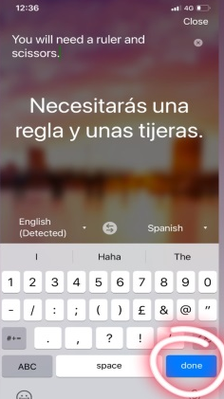  Tap ‘done’. To hear the translation aloud, tap the small speaker icon.  Translating documents  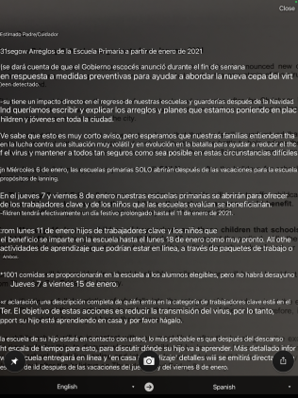  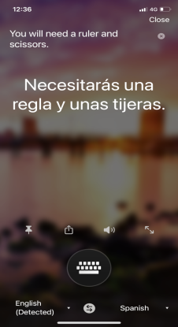  Tap the camera icon and choose the required languages.  Take a photo of the document.  It will translate automatically over the top of the original.

