

Hillpark Secondary School
Maximising Pupil Attendance Policy



Hillpark Helps – Maximising Pupil Attendance

Our Vision – Creating an environment which supports pupil attendance and engagement built on the principles of nurture.
Our school vision is to create a learning environment where everyone feels welcome, safe, respected, valued and wants to attend. To achieve this culture, we embrace our whole school values:
We value:
- Achievement
- Support
- Positivity
- Innovation
- Resilience
- Equity
Promoting attendance
We promote attendance in our school by:
- building relationships and prioritising wellbeing and care
- having a curriculum which is relevant, engaging, and meets the needs of all our learners
- using a range of teaching styles and approaches are adapted for our learners
- Specific adults to help learners and families who may need a little bit of extra support
- treating parents and carers as partners in supporting attendance
- linking into other supporting structures such as Assemblies, Parent Councils, Family-Community Supports, Other School Policies

Towards the Nurturing City
As a Glasgow school we share in the ambition to be ‘the nurturing city’. A nurturing city has schools in which children and young people feel they belong; they are listened to and they and their families are valued. Positive school attendance is key to ensuring that all children and young people achieve their fullest potential.
Nurturing approaches allow key adults to create safe contexts for learning, underpinned by an understanding of children’s attachment and development needs. Strong, nurturing relationships support children and young people to develop skills, strengths, and resilience. These can act as protective factors throughout life. Children and young people who attend school regularly can build positive relationships with key adults allowing them to thrive.

Importance of attendance
Our Attendance Policy complements Management Circular 5a: A Positive Approach to the Promotion of Attendance in Glasgow Schools
Attendance is important because:
- it supports wellbeing, social connections and social growth
- it gives us the opportunity to access and engage with learning in all its contexts and within a safe, calm and caring environment
- it provides opportunities to develop skills and confidence, to contribute to and be part of a wider community and somewhere to develop and learn about ourselves, our emotions, and how we relate to, and respect, others.
WHY ATTENDANCE MATTERS
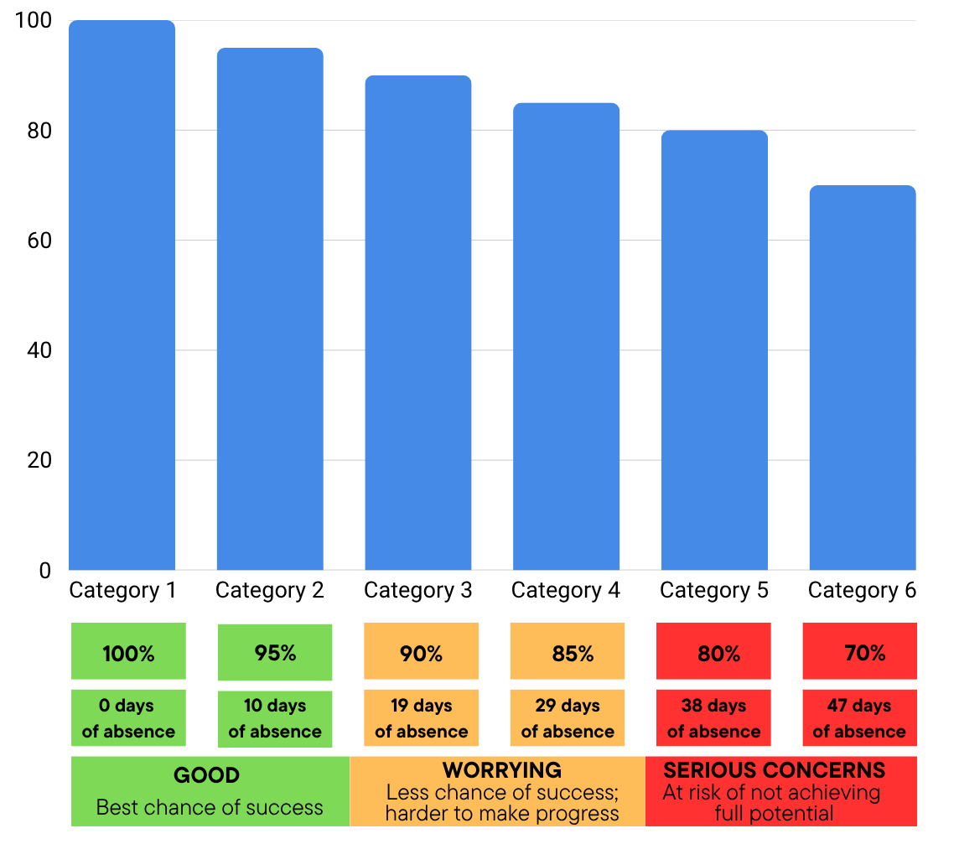

As the graph shows, one week’s absence results in 3% of learning lost which, if it accumulates, vastly reduces the chances of academic attainment. To maximise pupil attendance, it is vital that the parents/carers, pupils and teachers in Hillpark all work together to achieve better attendance, leading to more positive outcomes for the young people in our school.

The Role of the Learner
- Take personal responsibility for attending as often as possible
- Be on time for school
- Engage in all aspects of the life of the school including learning and other social activities
- Contribute to the daily life of the school and encourage peers to attend
Timekeeping
Being in school on time makes a real difference to a pupils overall educational experience. Being on time each day:

- Allows you to get vital information at Registration
- Establishes routines that create patterns for the future
- Helps you get the most from your education
- Prepares you for life after school in the workplace
- Leads to more time in classes and therefore a better chance of achieving!

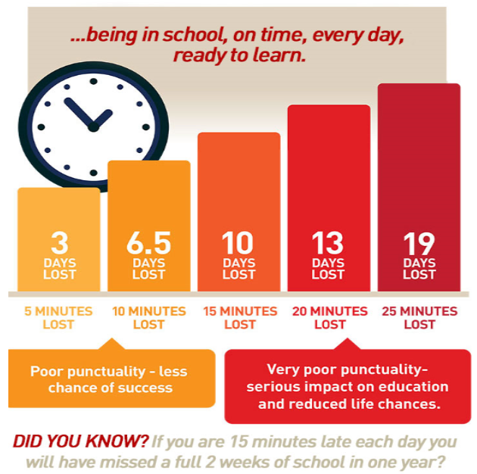

The Role of the Parent/Carer
Reporting a pupil’s absence
Section 30 of the 1980 Education Act lays a duty on every parent of children of ‘school age’ to ensure that their children attend school regularly. Regulation 7 of the Education Regulations (Scotland) 1993 requires each child’s absence from school to be recorded in the school as authorised, that is approved by the authority, or unauthorised that is unexplained by the parent (truancy) or temporarily excluded from school.

Parents and carers should:
- ensure their child understands the importance of education and attendance
- support their child to attend as often as possible
- notify the school as soon as possible when their child is absent
- work with staff to minimise absence and reduce any barriers to attendance
- book medical appointments outside school hours where possible and give advance notice if an absence is unavoidable
- keep the school up to date with telephone numbers and emergency contacts
- Every effort should be made to avoid family holidays during term time as it both disrupts the young person’s education and reduces learning time. Parents should inform the school by letter if they are going on holiday outlining the dates and this absence will then be recorded as parental holiday.

If your child is absent from school, you should:
- Call the Glasgow City Council absence reporting line on 0141 287 0039 to make them aware of the absence, reason and duration if known.
- Give your young person a note on their return to school, to be passed to their register teacher, confirming the reason for the absence and the duration.

If we are not notified of an absence from school, then you will receive a text from the school to make you aware of this. These text’s will be sent from the school office to parents/carers and so it is vital that the contact details we have on record for you are correct.

Attendance is recorded every period during the school day. If your young person is late then this will also be recorded. This allows us to monitor pupils’ attendance and timekeeping throughout the school day. Pupils who are taking part in school activities will be marked accordingly. Authorised absences include illness, medical or dental treatments and extenuating circumstances. Unauthorised absences are unexplained absences and cover truancy or if a parent provides no explanation for the absence.

The Role of Teaching Staff
Teachers play a key role in capturing and promoting pupil attendance by:
- proactively developing respectful and supportive relationships that support a positive ethos and culture.
- regularly promoting good attendance through lessons, assemblies, informal and formal conversations, and events.
- making learning engaging and relevant, and supporting learner engagement using a range of strategies that meet the needs of all learners.
- keeping regular and accurate records of attendance for every learner every period in the school day.

Recording pupil attendance
Pupil’s arriving in the class will be marked ‘Present’ by default and as such, it is vital that, where there is pupil absence, this be amended and the correct Seemis code entered.
Any incomplete register will count as a pupil being marked ‘Present’ and so, staff must ensure their registers are completed at the end of each period. This includes instances in which staff cover classes or where their teaching commitment also applies to the Enhanced Nurture Provision (ENP).
Where a pupil requires a code to be entered on a Seemis class register, the following may be used by class teachers (full list of Seemis codes can be seen on the following site: https://www.goglasgow.org.uk/Pages/View/68):
Seemis Code | Meaning | Description
LAT | Late (arrives before mid-opening) | Where a pupil has arrived late but during the first half of the opening, this will be marked as late (L1). This is regardless of whether the lateness is for a valid reason. For schools using period-by-period registration, any registration in periods beginning in the first half of the opening will be converted to an overall L1 code for the opening (even if a later period is missed)
TBC | To Be Confirmed (Reason for Absence) | Includes all absence for which no adequate explanation has been provided.

The School Office is capable of assigning different codes to reflect events organised by teachers, including pupil working groups and class trips. It is, therefore, vital that the names of any pupils involved in these be provided to the school office in advance of events, to allow Seemis to accurately reflect their attendance.

The Role of Pastoral Care
Our Pastoral Care Team are dedicated to supporting the pupils within our 6 House Groups. The Pastoral Care Teacher for each House Group plays a key role in supporting pupil attendance through careful monitoring, proactive discussion and linking with pupils/parents/carers/external agencies to both reduce instances of absence and support pupils in their transition back into Hillpark following a prolonged period of absence.

The responsibilities of Pastoral Care in improving and sustaining pupil attendance include:
- Daily analysis of discrepancies and updating Seemis to reflect accurate attendance data, and following up of discrepancies with young people and their parent/carers.
- Discussions with pupils, parents/carers around absences and the possible reasons for such, offering support.
- Early warning phone calls to parents when a pattern of attendance is becoming a concern.
- Meeting with parent/carers and pupils to discuss attendance and implementing intervention strategies to support improved attendance.
- Solution focused and staged intervention approaches (SIIM/JST)
- Review and evaluate agreed supports.
- Continued monitoring of attendance and, where appropriate, sending home GCC attendance letters to parents/carers.
- Meet with pupils following a return from a period of prolonged absence.
Our pastoral Care Team also have the opportunity to alter a pupil’s Seemis code to accurately reflect attendance where there is reason to do so using the codes below (this is supported by our School Office staff:
Seemis Code | Meaning | Description
WRK | Work Experience | Work experience, arranged or agreed by the school Volunteering, arranged or agreed by the school
PER | Medical or Dental Appointment | Medical and dental appointments that last less than an opening should be recorded as attendance. However, should the appointment last for a full opening then it must be recorded within “Sickness with no Educational Provision”
VIS | School Visit | Educational visits organised by the school
SCH | In school but not in class | Attendance in school
OAT | Other Attendance out of School | Other attendance out of school [e.g. pupil on a day release to a college or another school for a specific subject]. It is the responsibility of the host school to inform the originating school if the pupil is absent.
PHL | Authorised Parental Holiday | Absence Under exceptional circumstances schools can authorise a family holiday during term time. Such circumstances may include important to the wellbeing and cohesion of the family, following serious or terminal illness, bereavement or other traumatic events.
DCA | Exceptional Domestic Circumstances (authorised) | This relates to short-term exceptional domestic circumstances. Absences related to short-term exceptional domestic circumstances can be classified as both authorised and unauthorised absence.
PTH | Part Timetable (Health Related) | Include all absence under a formal part-time arrangement related to health
UPH | Unauthorised Parental Holiday | Parental holiday where no wellbeing or family cohesion reason is provided.
UNA | Truancy or Unexplained Absence | Include all absence for which no adequate explanation has been provided.

The Role of the PT Attendance and Engagement

In Hillpark, we are extremely fortunate to operate an ‘in-house’ Enhanced Nurture Provision which allows us to support the attendance of our pupils, all overseen by a Principal Teacher of Attendance and Engagement.

The role of PT Attendance and Engagement allows us to proactively target groups of pupils for whom school attendance is an increasing concern, as well as supporting pupils who struggle with attendance back into learning.

The role of the PT Attendance and Engagement to support improved attendance is as follows:
- Oversee the registers for the Enhanced Nurture Provision, ensuring pupils receive the attendance mark when appropriate and are marked absent when not.
- Liaise with PTs Pastoral Care regarding suitable support interventions for young people in their respective caseloads.
- Conduct home visits to pupils with attendance concerns and look to support them back into school via the ENP.
- Work with the DHT for Pastoral Care to use the school’s Attendance Tracker to identify targeted groups of pupils who fit similar criteria and then put in place appropriate interventions to support these pupils.
- Discuss strengths of the school with pupils who attend each day to identify what we do well as a school and build on it.

The Role of the Senior Leader
Senior leaders should:
- liaise with PTs Pastoral Care regarding attendance and punctuality concerns.
- liaise with PTs Pastoral Care to identify needs and agree on suitable support interventions.
- promote attendance through policies, documents, training, meetings and communications
- ensure consistency in practice that supports attendance and engagement

SUPPORTING FAMILIES WHEN ABSENCE BECOMES A CONCERN
Absence is likely to affect all children at some point. The school will follow up all instances of absence to make sure that everything is okay and learners are safe. To contact parent/carers we may use text, email, phone call or letter.
When absence becomes a concern, the school will begin an assessment process, in consultation with learners and parents or carers, to explore the reasons behind the absence and to offer supportive interventions if appropriate.
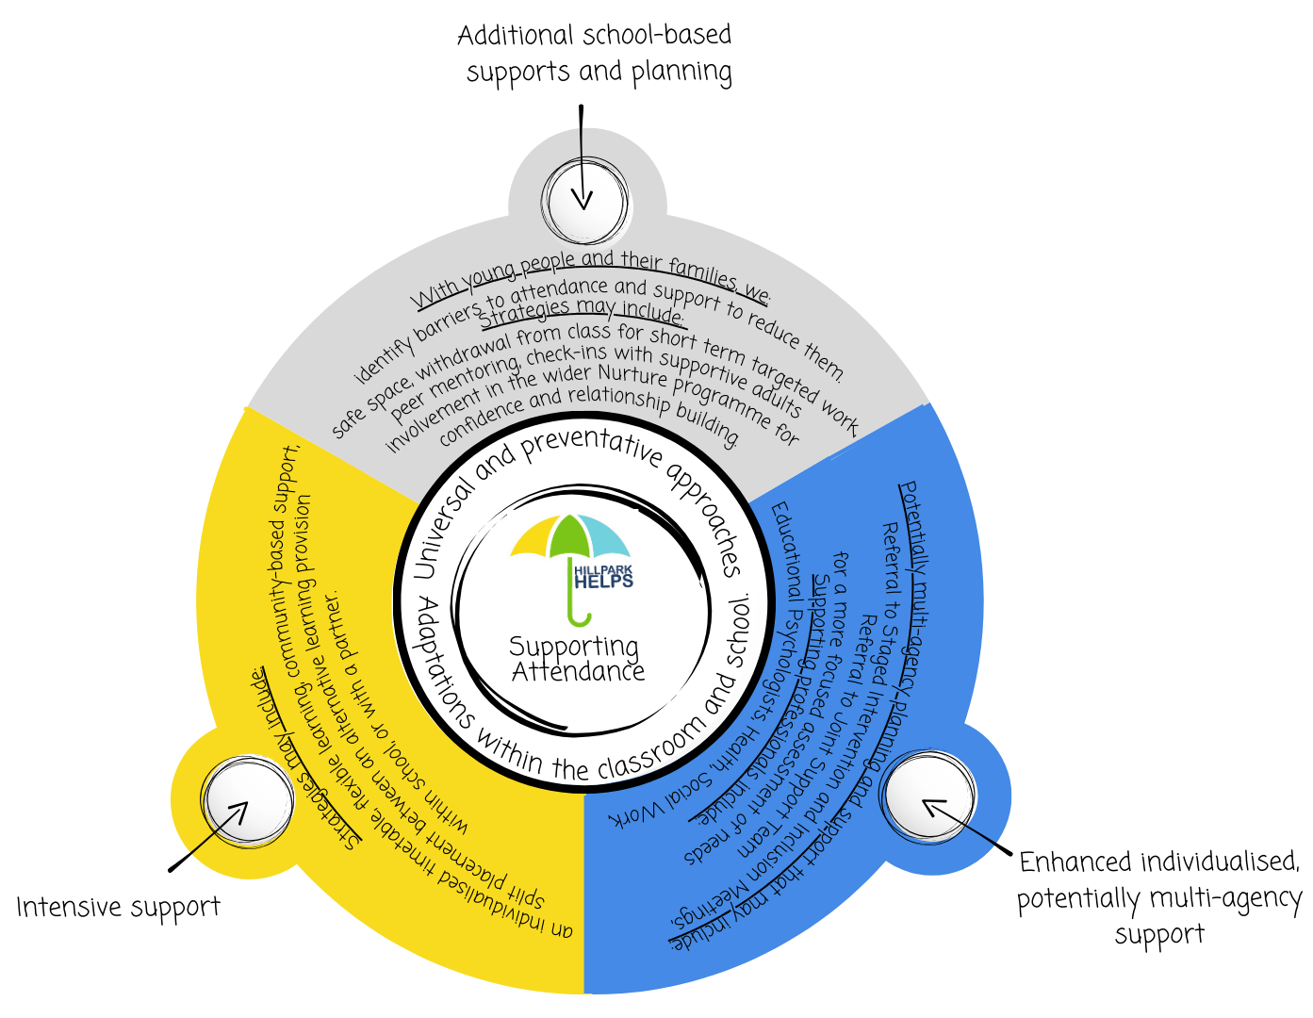
Support interventions fall into four categories: universal and preventative, additional school-based supports and planning, enhanced individualised support, and intensive support. The school may utilise supports from any of these categories depending on the barriers to attendance faced by individual young people. The diagram below outlines each category in more detail:

For more information or help on maximising school attendance:
- Learners - talk to an adult, see school posters, listen in assemblies and in PSE classes
- Parents/carers - contact the school, attend parent evenings/meetings, join family learning sessions, see our information leaflets, school handbook and/or our website
- Staff - ask a colleague/manager, consider further professional learning, see local authority policy/operational guidelines.

