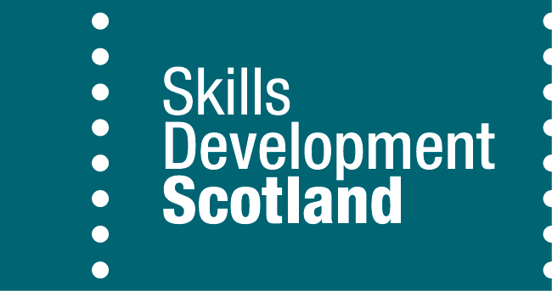

DRAFT

**NEWS RELEASE – 20 December**

**Angus and Glasgow pupils excel in finance challenge**

Carnoustie High & Hillpark Secondary crowned winners thanks to investment know-how

Financial knowledge, quick decision making, and good teamwork have helped Carnoustie High and Hillpark Secondary win a competition challenging pupils to show their investment skills.

The schools were the winners of the Investment Challenge in which S5 and S6 pupils work in teams to grow a virtual investment fund, making decisions on what to buy and sell based on their own research and incoming news stories.

The competition is sponsored by BNP Paribas in partnership with Skills Development Scotland (SDS) and Global Investor Simulations.

Six schools beat 32 others to reach regional finals hosted by BNP Paribas at their offices in Glasgow and Dundee, giving them the chance to pit their investment wits against each other whilst also hearing more about careers in the financial services industry.

Carnoustie High triumphed in the North East region, beating St. Andrew’s High and Balwearie High.

Mark Murison, S6 pupil at Carnoustie, and a member of the winning team, said: “Taking part in the Investment Challenge helps you work as a team, develop your research skills and learn when to take risks. The simulation game has been great – and I really enjoyed the employability workshops and seeing behind the scenes at BNP Paribas’ offices.”

More than 1,100 pupils took part in the competition using the online business simulation Finance Lab, with volunteers from BNP Paribas visiting schools to meet teachers and students and talk about opportunities in the sector.

Hillpark Secondary clinched the title in the West region, beating St. Stephen’s High and Clydeview Academy.

Adam Curreshi, S5 pupil at Hillpark, said: "I really enjoyed the experience and the highly competitive nature of the Investment Challenge competition. I developed my communication and analytical skills and enjoyed the high-risk environment. The experience has given me a valuable insight into working in the financial services sector."

Mark Daisley, Head of Client Delivery (UK, Middle East and Channel Islands), BNP Paribas, said: “We’d like to congratulate Carnoustie High and Hillpark Secondary for such impressive performances, and applaud all schools for the enthusiasm they’ve shown during the competition.

“This competition gives us the opportunity to promote the wide variety of careers the financial services sector has to offer. The enthusiasm of pupils for the competition across the country has been striking and we’ve been delighted to welcome them to BNP Paribas for the finals.”

The competition supports the Developing the Young Workforce strategy and forms part of SDS’s Skills Investment Plan for Scotland’s Financial Services sector, which features themes including attracting new talent.

Laura Wilson, Financial Services Sector Manager at SDS, said: “The competition provides students with an exciting insight into career opportunities in the sector, and promotes the development of key skills, such as communication and problem solving. SDS is here to support industry and schools as they continue to engage in these kinds of initiatives, which help develop young people’s future career pathways.”

“Linking young people with employers is hugely important as they consider the various career pathways available to them, so the support of BNP Paribas is fundamental to the competition being a success.”

**ENDS**

**FOR FURTHER INFORMATION, PLEASE CONTACT:**

Belen Coviella, Communications and Marketing Coordinator

0141 448 6494, 07429 247714 or [belen.coviella@sds.co.uk](mailto:belen.coviella@sds.co.uk)

[www.skillsdevelopmentscotland.co.uk](http://www.skillsdevelopmentscotland.co.uk)

**NOTES TO EDITORS:**

Photo 1: North East region winners: Mark Murison and Finlay Napier from Carnoustie High School, with Alison Duncan and Kirsteen McKelvie from BNP Paribas.

Photo 2: West region winners: Adam Curreshi, Fraser Docherty, Josh Nicol and Callie Dryden with the rest of Hillpark’s pupils, teacher, Lauren Connelly, and Audrey Daniels from BNP Paribas,

For further information, visit the Global Investor website: [www.globalinvestorsims.com/uk/showcase/](http://www.globalinvestorsims.com/uk/showcase/)

A video featuring pupils from Hillpark Secondary in Glasgow taking part in the competition is available here: [www.youtube.com/watch?v=aEXWKMCPLYs](http://www.youtube.com/watch?v=aEXWKMCPLYs)