
Parents’ Guide for Booking Appointments
Go to https://hillpark.parentseveningsystem.co.uk
Booking Opens on 26 October 2022 @19.00 and closes on 7 November 2022 @19.00
Please Note – This evening will take place in person
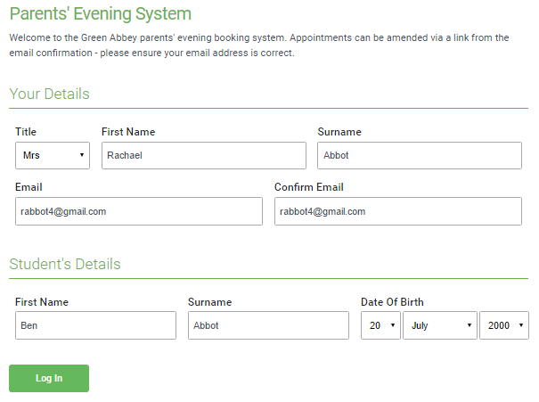 | Step 1: Login  Fill out the details on the page then click the Log In  button. A confirmation of your appointments will be  sent to the email address you provide.
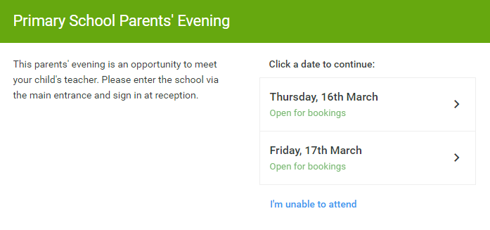 | Step 2: Select Parents’ Evening  Click on the S1 Parents’ Evening.  Unable to make the S1 Parents’ Evening?  Click I'm unable to attend.
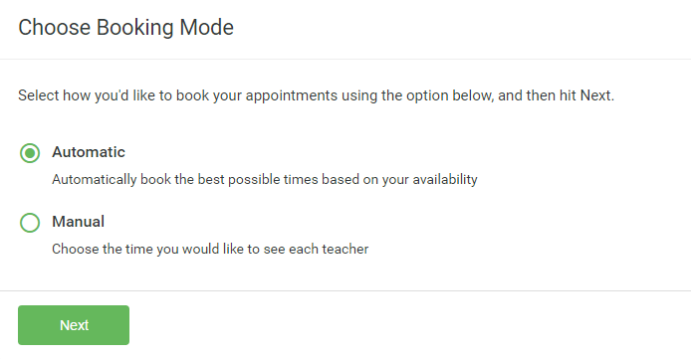 | Step 3: Select Booking Mode  Choose Automatic if you'd like the system to suggest the shortest possible appointment schedule based on the times you're available to attend. This is the easiest way for you to make appointments and will make the best time efficient appointments.  If you'd rather choose the times to book with each teacher, choose Manual. Then press Next.  We recommend choosing the automatic booking mode when browsing on a mobile phone.
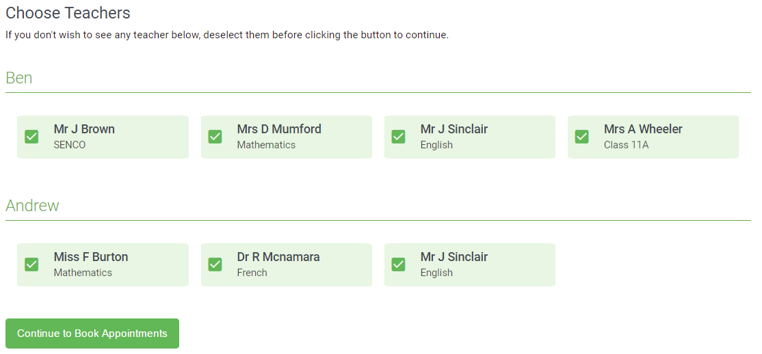 | Step 4: Choose Teachers  If you chose the automatic booking mode, drag the sliders at the top of the screen to indicate the earliest and latest times that you can attend.  Select the teachers you’d like to book appointments with. A green tick indicates they’re selected. To de-select any teacher you do not require to see, click on their name.  To add appointments for another child, press the Add Another Child button at the bottom and then repeat this step.
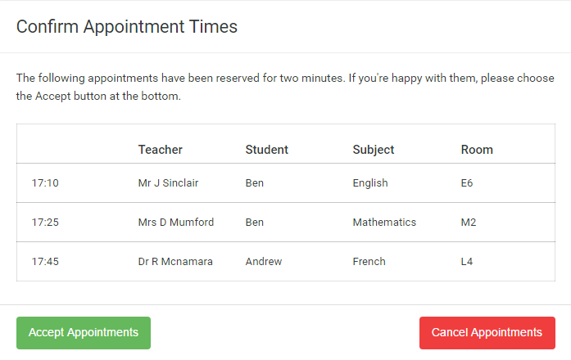 | Step 5a (Automatic): Book Appointments  If you chose the automatic booking mode, you should see provisional appointments which are held for 2 minutes. To keep them, choose Accept at the bottom left.  If it wasn’t possible to book every selected teacher during the times you are able to attend, you can either adjust the teachers you wish to meet with and try again, or switch to manual booking mode (Step 5b).
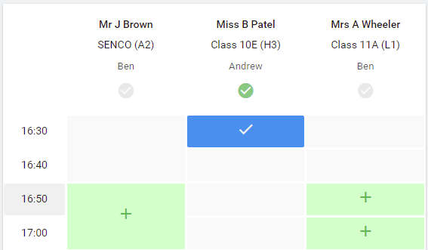 | Step 5b (Manual): Book Appointments  Click any of the green cells to make an appointment. Blue cells signify where you already have an appointment. Grey cells are unavailable.  To change an appointment, delete the original by hovering over the blue box and clicking Delete. Then choose an alternate time.  Once you’re finished booking all appointments, at the top of the page in the alert box, press click here to finish the booking process.
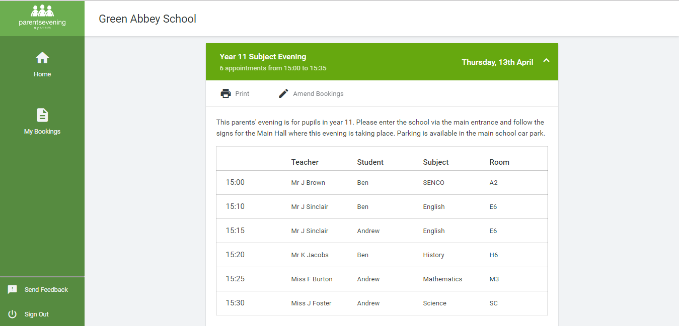 | Step 6: Finished  You’re now on the My Bookings page and all your bookings are below.  An email confirmation has been sent and you can also print appointments from this page by pressing Print.  To change your appointments, click on Amend Bookings.  Please contact the school office on 0141 582 0110 if you need any support with this.

