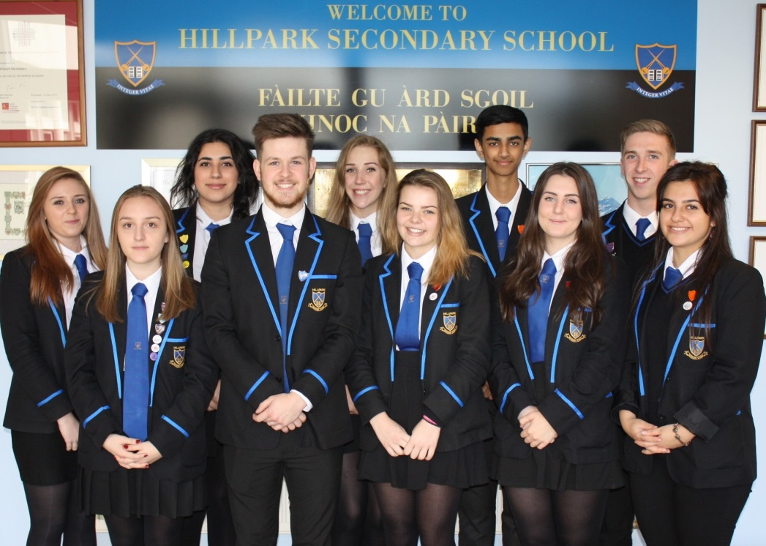
The summary report is provided for parents/careers and partners to outline our achievements this session and our priorities for next session. Throughout this session we have taken forward our priorities as detailed in our school improvement plan. Through our processes of self-evaluation, we have identified how we can improve outcomes for our children and young people.

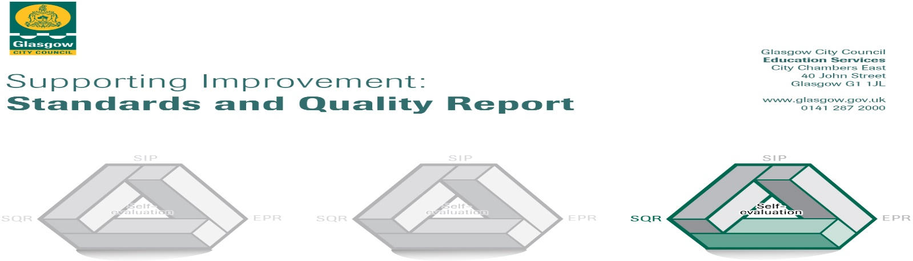

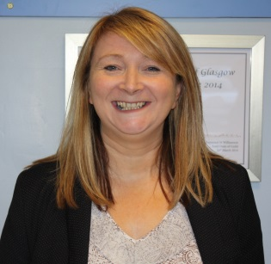
I am delighted to be able to present another impressive Standards and Quality Report for Hillpark Secondary School. The report includes our many achievements, our improving attainment in key areas and the amazing wider life of the school. As Head Teacher I continue to be incredibly proud of all staff and pupils.

Head Teacher

Geri Collins

OUR SCHOOL

Hillpark Secondary is a non-denominational school and is part of the Hillpark Learning Community. The current roll is 1100. The school enjoys close working links with its 6 associated primaries: Ashpark Primary School, Cleeves Primary School, Darnley Primary School, Gowanbank Primary School, Merrylee Primary School, and Tinto Primary School.

The Learning Community maintains strong links with our Pre-5 partners: Burnbrae Children’s Centre, Eastwood Nursery, Jimmy Dunnachie Learning Centre and Shaw Mohr Nursery.

The school itself is an attractive, well equipped building which boasts excellent facilities including its own swimming pool, fitness suite, games hall, playing fields a 4G all-weather pitch, eight fully equipped ICT labs, a well resourced library , drama studio and assembly hall with state of the art ICT equipment.

A significant feature of the school is the Language and Communication Unit. The unit has 33 pupils within the Autistic Spectrum. These pupils are integrated either partially or fully into mainstream classes.

OUR PARENT COUNCIL

The school has an active Parent Council which represents the views of parents to the Head Teacher and the Authority. The Parent Council meets once per month and is comprised of parent and staff members.

The Parent Council gives excellent support to the school and offers its views on a wide variety of issues such as reporting, quality assurance and consultation with parents.

OUR PUPIL VOICE

At Hillpark we take the pupil voice incredibly seriously with all significant events evaluated and feedback sought. Every trip or excursion out of school has been reviewed with a focus on the impact of young people. Every young person this session has been involved in a wider life activity either through school shows, presentations, school trips or educational events. Almost all young people have found these experiences very enjoyable having a positive impact on their educational experience.

OUR STAFF

The Senior Management Team consists of the Head Teacher, Formal Depute and three Depute Head Teachers. Curricular areas are managed by four Faculty Heads and eight Principal Teachers (Curriculum). There are five Principal Teachers of Pastoral Care, one Principal Teacher Support for Learning and one Principal Teacher Language and Communication Unit.
The total staff of the school consists of 74.4 FTE teaching staff, four clerical, seven Pupil Support Assistants, three technicians, three janitorial staff and an AFA.

VISION VALUES AIMS

Our Vision, Values and Aims have recently been evaluated and as a school community we have focused on the key themes, attitudes and beliefs that make Hillpark a forward thinking and caring secondary school. Our key themes are: Achieving, Supportive, Positive, Included, Respectful and Equal. Each word conveys a powerful message and together makes the acronym ASPIRE.

Our achievements and improvements this year.
We would like to highlight the following improvements/achievements:

Attendance

Our attendance continues to remain above 90%. This is despite the challenges over the past 2 years.

Given the school closures due to the Global Pandemic, we cannot accurately calculate attendance for session 2019/20 - 2021/22.

Normal analysis of attendance will resume in session 2022/23.

Exclusions

We continue to work hard to reduce exclusions.

The number of days lost to exclusions over the past three years continues to fall:

2017/18 (83) 2018/19 (72) 2019/20 (50) 2020/21 (40) 2021/22 (38)

The number of incidents over the past three years has also fallen:

2017/18 (54) 2018/19 (50) 2019/20 (37) 2020/21 (37) 2021/22 (33)

We continue to meet the needs of our pupils more effectively by providing enhanced behaviour management, counselling and conflict resolution. We also provide support via our Pupil Support Centre where support is provided on a 1-1 basis with specialist staff. Most staff are trained in Assertive Discipline and employ these strategies in classrooms. Staff are very proactive in developing strategies within their classrooms to manage pupil behaviour appropriately and in classrooms there is a purposeful and engaging learning environment. We have introduced a de-escalation room in order to calm situations down during the school day and to support inclusion.

We will also utilize more fully the skills and knowledge of our LCR staff to develop further the skills of staff in meeting the needs of our ASN pupils in mainstream.

Leaver Destinations

The pandemic has impacted on all of us and our leaver destinations have been affected. Despite the challenges almost all of our leavers move into a positive destination and the percentage who move into Higher and Further education continues to improve. Our pupils are very well supported by our Skills Development Advisor whose work has had a positive impact on the outcomes for our pupils.
A significant number of pupils in S5/6 benefit from the Top-Up Programme. This has had a positive impact on pupils as it supports them in the transition phase to University and enhances their chances of being accepted into their chosen course. It has also impacted positively on raising pupil expectation by widening access to Higher and Further Education. The school will continue to engage positively with the Top-Up Programme in future years.

2016/17 (90.6%) 2017/18 (92.48%) 2018/19 (91.8%) 2019/20 (93%) 2020/21 (94.94%)

Wider Achievement

Although through the pandemic we have not been able to ensure wider achievement for young people in the normal way, we look forward to a new session in 2022/23 to continue.

The school has worked hard to develop the range of Wider Achievement Awards and experiences within the school.
- In S1 and S2, a large number of young people received a Crest Award for activities undertaken in Science.
- In S3 Modern Languages, almost all young people achieved a “Skills for Life and Work Award”.
- A significant number of pupils in S6 achieved a Saltire Award for a range of leadership activities which they had undertaken. Many worked as buddies and some offered in class support to our younger pupils.
- A group of pupils in S6 worked with Strathclyde University on the Prof. Smith Telecommunications award.
- A group of S2 pupils achieved a Silver Crest Award for their achievement in the Go4Set
Awards.
- Our S2 Group undertook a range of enterprise activities which developed their leadership and interpersonal skills.
- Our S1 Challenge Group undertook a healthy eating project and undertook a sponsored walk in addition to their Crest award work.

- In PE there were a wide range of Wider Achievement Awards. Last session almost all young people gained Wider Achievement or internal award in PE in the following areas:

- Track Cycling Champions.
- S3 pupils achieved the Heartstart Award.
- Pupils have become Sports Ambassadors.
- Pupils gained levels 1 or 2 in Sports/Dance leadership.
- All Sports/Dance Leaders/Ambassadors took part in the Positive Coaching
- Scotland Award.
- 95% of S6 pupils undertook the Emergency First Aid at Work Award.

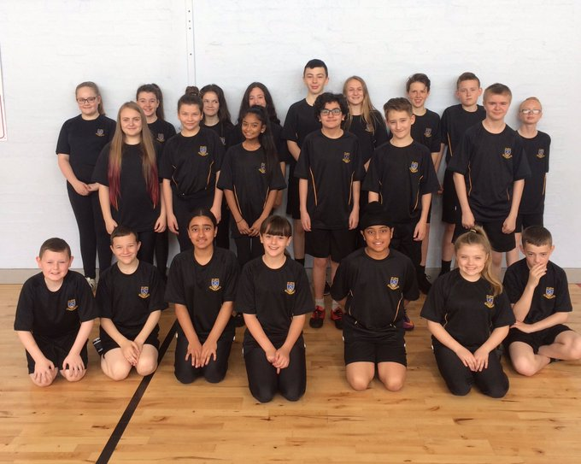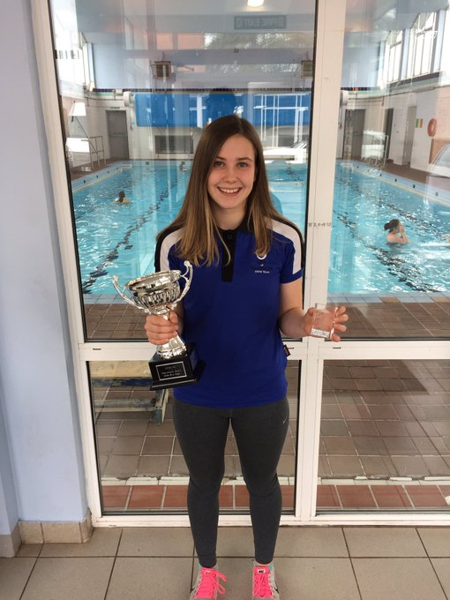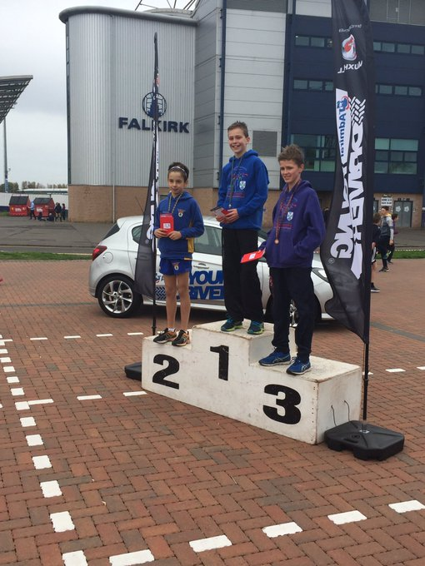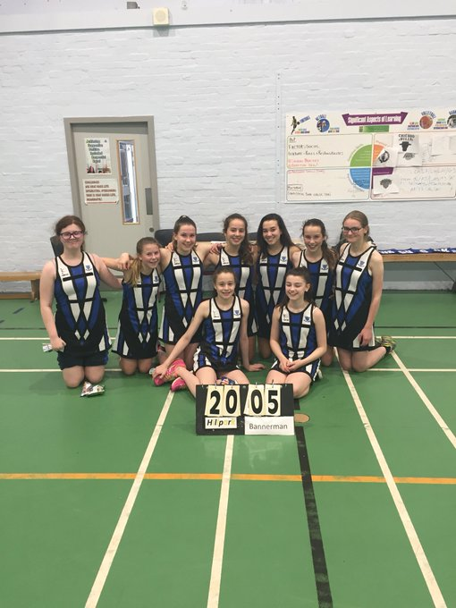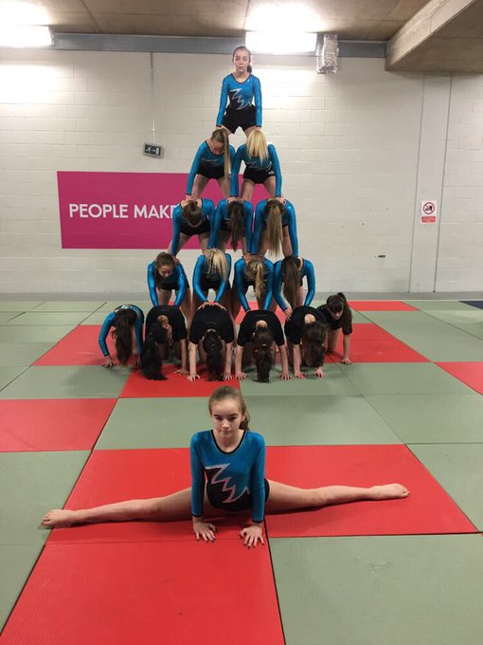

- In addition to these awards, many pupils took part in our charity fund raising events and donated significantly to a range of charities.
- The school maintained our Fair Trade status and our Young Co-op members were extremely proactive throughout the year.
- Our Craft Club raised a substantial amount of money for our partner school in Malawi. We support the school in a variety of ways through our Craft Club and Fairtrade group to provide meals for pupils.
- We committed time and effort to supporting our local food bank who were delighted with the substantial contribution which our school made to our local community.

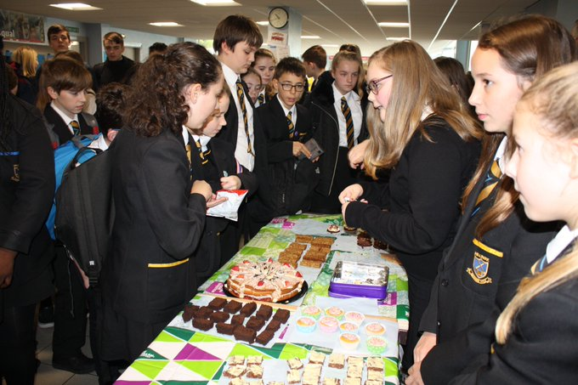
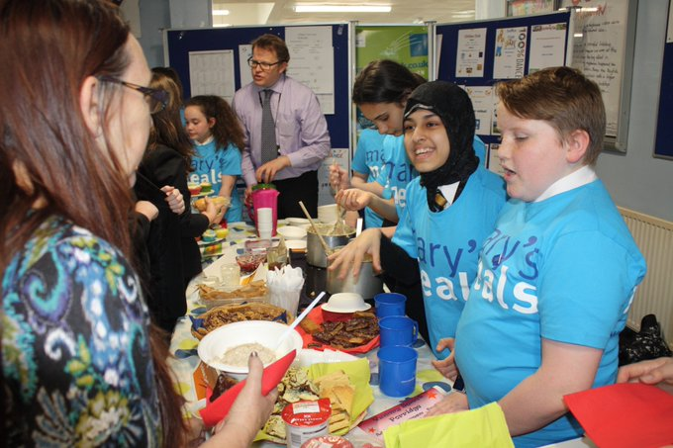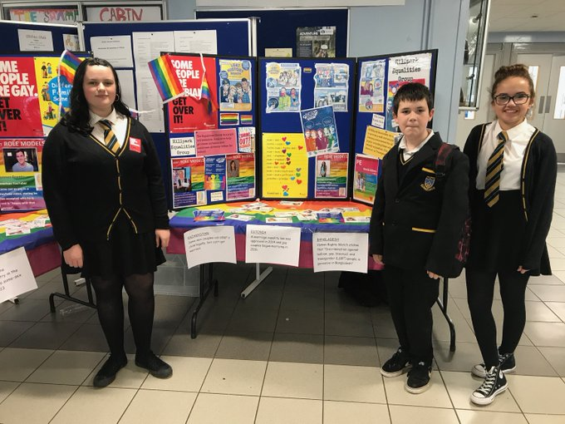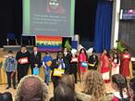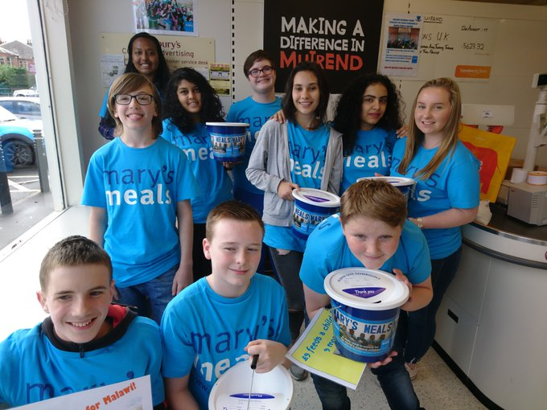
Attainment

I am delighted to share with you the incredible improvements in attainment within S4 and S5. Despite the obvious challenges we have continues to improve in almost every measurable benchmark. We will continue to ensure targeted intervention and support takes place particularly for young people disadvantaged by their environment. We have used the Pupil Equity Fund to ensure that support has reached our learners most in need. We have appointed 5 temporary Raising Attainment PEF PTs to focus on key areas including:

  - Ethos and Inclusion
  - Engagement
  - Developing the young workforce
  - Broad general education
  - The senior phase

Further support in the form of Counselling and our Campus Officer has also contributed to the increased attainment.

S4 Results Analysis

Pupils in S4 sat 7 National exams. This was a reduction from 8 Standard Grades in previous years. We were delighted at the increase in our S4 results, particularly as pupils are sitting one SQA exam fewer than in previous years.

Level 5 (National 5)

There has been a 5 year positive pattern of attainment

2018 2019 2020 2021 2022

27.2% 27.7% 30.5% 31.3% 31.2%

This is a dramatic improvement due to the determination of
Staff and pupils and despite the challenges of the pandemic.
This is the first time we have ever achieved more than 30%.

Level 4 (National 4)

There has been a 5 year positive pattern of attainment

2018 2019 2020 2021 2022

76.9% 71.6% 85.6% 81.6% 86.3%

.
Looking at a 5 year trend, this year’s dip is a reflection on
the challenges faced given the pandemic. Quite simply, if
the pupils are in attendance, they will achieve at Hillpark.

15 young people in S4 did not achieve at least 5 National 3 awards. This was due to the fact that they: left school, did not attend, attended EVIP or suffered from mental health.

Level 3 (National 3)

There has been an increase over 2 years

2018 2019 2020 2021 2022

98.6% 95.9% 98.2% 92.2% 92.7%

S5 Results analysis

5+ level 5 (National 5)

This area was one of our main focuses last year. All our efforts paid off.

2018 2019 2020 2021 2022

41.2% 41.5% 51.4% 47.9% 39.3%

This another reflection of borderline pupils in S5
trying to achieve after 2 years of interrupted teaching.

5+ level 6 (Higher)

There has been a 3 year positive pattern of attainment.

2018 2019 2020 2021 2022

7.8% 9.52% 12.2% 17.4% 14%

This is a positive result after 2 years of interrupted teaching. Excluding the covid years this is a significant
Improvement.

3+ level 6 (Higher)

There has been a three year positive pattern of attainment.

2018 2019 2020 2021 2022

19.6% 20.4% 31.1% 29.9% 27%

This is a positive result after 2 years of interrupted teaching. This is a dramatic improvement from 2019-
The last time the young people sat a formal exam.

1+ level 6 (Higher)

There has been a 3 year positive pattern of attainment.

2018 2019 2020 2021 2022

48.4% 55.1% 59.5% 53.9% 48.3%

This another reflection of borderline pupils in S5 trying to achieve after 2 years of interrupted teaching.

Here is what we plan to improve next year.
- Measure the impact of staff training leading to improved outcomes for young people.
- Build on existing growth mindset practice across the school community.
- Further develop the Teaching and Learning leadership groups increasing opportunities for sharing new pedagogical practice.
- Increased opportunities for aspiring leaders to develop skills and/or apply theory from previous training to their everyday practice.
- Effective Parent and Pupil Voice procedures within every dept. with measurable outcomes.
- Increased opportunities for all staff to build on collaborations within our LIG.
- All departments to support young people to recognise and articulate their own achievements through learning progress, learning conversations and enhanced profiles.
- Collaborative work within the Local Improvement Group will support improvement within key priorities.
- Departments and whole school must continue to embed skills for Life, Learning and Work when planning the curriculum.
- Differentiation is a priority when meeting learner needs with every department.
- Attainment levels in literacy and numeracy are a central feature of department’s priorities for improvement and raising attainment.
- New tracking data to be analysed to inform appropriate interventions for individuals and for groups of young people.
- Attainment for all seniors continues to increase across all curricular areas.

How can you find out more information about our school?
Please contact us directly if you require further information or if you wish to comment on the report.

The contact e-mail address is:Headteacher@Hillpark-sec.gledgow.sch.uk

Our telephone number is:0141 582 0110

Our school address is: 36 Cairngorm Rd, Glasgow G43 2XA

Further information is available in: newsletters, the school website, and the school handbook.

