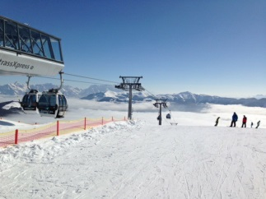
Interested in going on a School Ski Trip?
Prior to Covid-19 Hillpark Secondary organised a ski trip every year for about 40 years. We are looking to start this back up in 2023 with the difference that it is likely to be every two years from now on.
Another big change is that the trip will take place in February so we are guaranteed better snow! Dates will be around the Feb weekend so pupils only miss 2 days of school (Saturday 11-18th Feb). Travelling by bus as flying adds about £300-400 on to the cost!
If pupils are unable to ski, they will attend lessons (small weekly fee) at Bearsden to get to a basic standard so that they can get the best experience possible on the trip.
At this stage I am trying to gauge interest to see what the numbers will be like. The price will include all travel, half board hotel accommodation, lunch on the slope, hired skis/boots/poles/helmet, ski pass and ski instruction. Prices are based on full trip of 40 pupils so may vary if a smaller group. There is some fund-raising from previous trips that may be used to help with the price.
Please complete the slip below and return to Miss Guild if you are interested. This does not in any way commit you to the trip.

Pupil Name _____________________________________________
Registration Class___________ Can you ski? _________________________
Two options/prices I have been quoted for. Please circle which you would prefer, or both if no preference.
Andorra £819pp Austria (Oberlungau) £919pp

