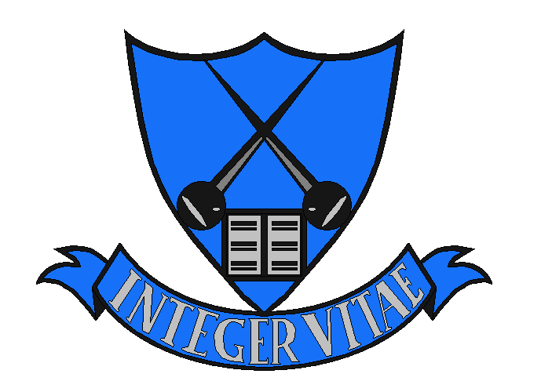
HILLPARK SECONDARY

Promoting a Positive Ethos
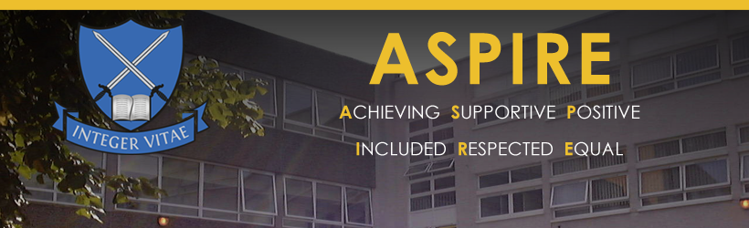
Policy 2022

At Hillpark we are committed to maintaining a caring ethos where pupils feel safe, healthy and supported.
We encourage our pupils to take responsibility for their learning, behaviour and achievement and to contribute to our learning community in which ever way they can.
We promote an ethos of inclusion and equality and work hard to achieve the very best for all pupils. We celebrate the diversity which exists within the school and recognise and celebrate the cultures and religions of all pupils and staff.

This policy supports Pupils, Parents and Staff to make sure that a Positive Ethos allows pupils to learn and achieve their best.

What is the aim of this document?
This document aims to demonstrate how Hillpark will develop a positive ethos and culture which promotes positive relationships and behaviour. We believe that promoting a positive learning environment is everyone’s responsibility within a school.
This document will serve as an agreement and a toolkit for all staff supporting the learning progression of all young people within Hillpark. Each department will have their own position paper outlining departmental expectations, strategies and sanctions.
The Learning culture within every school begins the moment young people enter our school building. It then continues as the young people travel to each classroom and is cemented during each lesson. Positive relationships and nurturing principles are key to securing positive learning environments along with pupil equity to ensure that we are Getting It Right For Every Child.
Within Hillpark, our ASPIRE values underpin everything we do and our monthly Recognition of Achievement programme celebrates all pupils who excel by Achieving, being Supportive, being Positive, ensuring others are Included, being Respectful and ensuring all are Equal.
This document will support pupils, parents and staff within Hillpark Secondary to create the ethos that is inclusive and allows all young people to learn in a safe and happy environment.

What is our Ethos?
At Hillpark we foster an ethos of nurture, inclusion and positivity and believe that young people have the right to be educated in a safe, welcoming environment. Although the subject within lessons will vary across the school we expect the ethos or learning climate to be consistent. To support this pupils and teachers are expected to follow the steps below:
- Teachers are welcoming and pupils respond politely.
- Pupils and teachers build positive relationships.
- Teachers set the tone of the lesson – all pupils take responsibility for their learning.
- Pupils understand teacher expectations and teachers know their pupils.
- Pupils arrive at class with a positive attitude and eager to learn with teachers ready to teach.
- Pupils arrive with appropriate resources (charged Ipad etc ), but teachers will provide resources if needed.
- Teachers recognise achievement and praise appropriately – pupils respond politely to praise.
- Teachers will motivate, encourage and have high expectations – pupils must make every effort to respond.
- Pupils will try their best and teachers will show that they care about their learning.
- All staff and all pupils are kind to each other showing respect to the belongings of others.
- Mutual respect is shown even if there is a teacher / pupil disagreement.
- Learning conversations take place regularly to support growth.
- Individual teacher / pupil discussions are not shared with the whole class
- Pupils are respectful in their views and teachers listen to and value the view of young people.
- Pupils and teachers use appropriate and respectful language
- Full school uniform expected – outer wear can be worn if temperature is low due to enhanced ventilation
- Phones are out of sight during class time.
- Pupils will respect the one-way system and respond politely when reminded to do so.

Strategies
Every subject area is different and every child is unique therefore strategies and techniques to meet the learning needs of young people can vary from lesson to lesson. To best serve the individual within each subject, each subject area will have their own departmental policy outlining their preferred strategies for promoting a positive ethos and learning environment.
Classroom strategies could include:
- There is a consistent approach to Teaching and Learning
- Meeting and greeting your pupils as they enter your classroom
- Learning intentions/ success criteria discussed / shared.
- Clear rules and teacher expectations are understood by all.
- Classroom, resources and tasks are organised.
- Clear routines during resource distribution and pack up.
- Teacher has referred to ASN database to ensure the appropriate use of support strategies.
- Differentiated teaching to meet the needs of every individual i.e. scaffolding / extension work.
- Teachers embrace support from LCR, ASL and Pastoral Care as appropriate.
- Make lessons active / engaging.
- Make the pace of the lesson specific to pupil/class.
- Praise pupils as much as appropriate.
- Use departmental reward schemes/initiatives to promote positive behaviour.
- Provide Regular feedback through individual learning conversations, using Growth Mind set language.
- Change learning style to suit class / pupil.
- Use ICT where appropriate to engage pupils.
- Provide choice for pupils where possible.
- Use MTV and SIPE strategies to further engage all pupils.
- Remove as many barriers to learning as you can.

Sanctions
Sometimes despite the use of positive strategies, sanctions are required to ensure that all young people within a class are able to learn without disruption. As with strategies, effective sanctions can vary from department to department. To best serve the individual within each subject, each subject area will have their own departmental policy outlining their preferred sanctions for promoting a positive ethos and learning environment. These sanctions will begin within the classroom and then may progress to departmental levels.

Possible classroom sanctions are as follows :
- Classroom target sheet – agreed targets between teacher and pupil.
- Solution focussed discussions – clearly explain decisions to pupils
- Issue warnings to pupils – some departments use 3 warnings before next steps.
- Issue a time out
- Removal of opportunity to take part in the activity
- Classwork missed to be completed at home
- Departmental reflection sheet.
- Time off chosen activity – written instead of practical
- Discussion with Faculty Head to resolve any difficulties or try different strategies.
- Where appropriate a 3- way restorative meeting.
Possible departmental sanctions are as follows :

- Inform Departmental Head about challenging classes/hotspots to enable support to be put in place
- Head of Dept to proactively visit hotspots to support departmental behaviour
- If a pupil remains non co-operative and highly disruptive, send to Head of Department, always phone ahead first
- Interview pupils who are causing concern
- De-merits – can be used departmentally with weekly / monthly reports
- Departmental detention
- Departmental conduct cards – Head of Dept to meet pupils regularly
- Remove challenging pupils from classes where appropriate
- Organise for SMT to visit challenging classes when it isn’t possible for department head to visit due to teaching commitment.
- Liaise with PC to support individual
- Referral to Year Head if situation does not improve - At this point a referral must be sent to the year head from the PT / FH.

Supporting Young people who display extremely challenging behaviour
Planned strategies or sanctions won’t always work is a young person is distressed or anxious and often individual anxieties can lead to challenging behaviour. At Hillpark our approach to dealing with challenging behaviour begins with us reframing our understanding of behaviour. All behaviour is communication and can often be an indication of stress. Staff are expected to be proactive when planning for individual learners by using the ASN database and can receive advice and guidance from:
- Pastoral Care
- Additional Support for Learning Department
- The Language and Communication Department
We recognise that when behaviour is escalating and a pupil is becoming distressed and anxious, our focus must be to de-escalate the situation and to relieve the stress of the individual. Staff can achieve this through:
- Avoiding raising their voice as this tends to escalate the situation
- Avoiding a power struggle or becoming counter aggressive
- Allowing the pupil some time to calm down if possible
- Remain a safe distance to avoid further conflict
- Use active listening techniques
- Use phrases such as “I can see that you are upset” rather than “I understand….
The senior management team will support staff and pupils should the situation remain challenging.

Our Learning Culture at Hillpark

