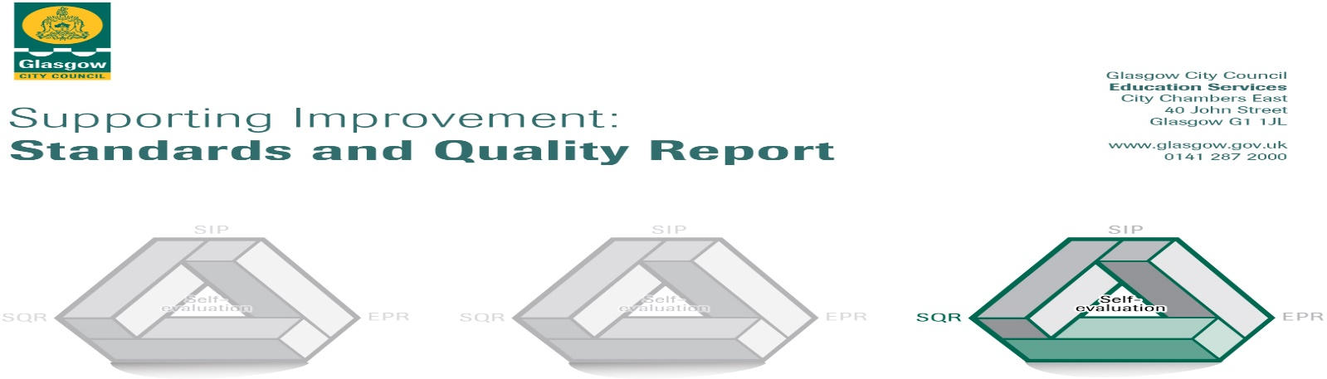

The summary report is provided for parents/careers and partners to outline our achievements this session and our priorities for next session. Throughout this session we have taken forward our priorities as detailed in our school improvement plan. Through our processes of self-evaluation, we have identified how we can improve outcomes for our children and young people.

Our achievements and improvements this year.
Teachers developing Literacy and Numeracy through Outdoor Learning

Increased family learning opportunities

Awards: Silver Sport Scotland Award, Apple coach

Here is what we plan to improve next year.
Literacy - writing / reading into writing
Pedagogy focus on differentiation
Anti-Racism Charter
The Promise
Nurture

How can you find out more information about our school?
Please contact us directly if you require further information or if you wish to comment on the report.

The contact e-mail address is: heateacher@hillington-pri.glasgow.sch.uk

Our telephone number is: 0141 882 2144

Our school address is: 227 Hartlaw Crescent, Hillington GLASGOW G52 2JL

Further information is available in: newsletters, the school website, and the school handbook

