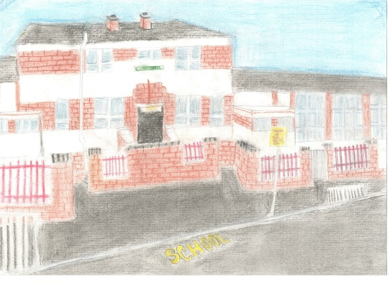
Hillington Primary
2023 Pre-Entrant Information
We are delighted that you will be joining us at Hillington Primary School in August 2023. Over the next few months there will be a variety of transition key dates and events for families.
School staff will be liaising closely with Nursery staff over the next few months to ensure a positive transition from nursery to primary.
To prepare for joining us at Hillington Primary we have made a video of our school for families that can be viewed on our YouTube channel
https://www.youtube.com/watch?v=UBFInyYsYD0
Induction Days
- Induction Day 1 – Friday 5th May 2023 at 9.30am
Induction Day 1 is for parents/carers only. On Induction Day 1 we will share important information with you about our school including our school vision and values, start dates, school timings and school uniform.
- Induction Day 2 – Monday 19th June 2023 at 1.30pm
Induction Day 2 is for you and your child. Children will get the opportunity to visit their new class and participate in some fun learning activities with their peers. We will share with adult’s information about our school curriculum and other important details about starting school in August 2023.
Keeping You Informed
You can keep up to date with things that are happening in school and in your child’s class through our school website.
https://blogs.glowscotland.org.uk/gc/hillingtonprimary/
You can also follow our school on Twitter.
@HillingtonPS

Contact Information
Please do get in touch with us if you have any questions or queries.
Mrs Weir (Acting Depute Head Teacher)
0141 882 2144

We are looking forward to meeting the families joining our school community in August 2023.

