Hillington Primary
Starting School August 2022
First Day at School – Wednesday 17th August 2022
On their first day of school children come in to school at 9.30am and leave school at 2.30pm. Children will enter the school into the infant playground through the back gate at the right hand side. On the first day only, parents may come in to the school playground from 9.15am and take photographs of their own children. The teachers will take the children out the back gate at 2.30pm. Parents should wait at the bottom of the stairs at the school gate.
Second Day at School – Thursday 18th August 2021
The children will start at the normal time of 8.55am. They will finish at 3pm. Parents should not enter the school playground. The children will be taken to the gate by their teacher at 3pm.
School Timings
School Times – From 18th August 2022 onwards
• School Start Time – 08.55am (Playground supervised from 8.45am)
Pupils will enter playground through the back gate at the right-hand side.
• School Finish Time – 3pm
Children will exit school out of the front gate (front gate left - disabled access ramp)
Break Times
• Morning Break – 10.25am (15 minutes)
• Lunch Time – 12.10pm-1pm

School Office Opening Times
• Mon – Thur 8.30am – 4.15pm
• Fri – 8.30am – 3.15pm
Telephone lines open 8.30am to 3.15pm Monday to Friday.
Reminder
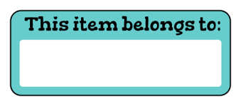
Please remember to label all of your child’s belongings. For example uniform, lunch box, jacket, gym shoes, hats and scarves
Keeping You Informed
You can keep up to date with things that are happening in school and in your child’s class through our school website.
https://blogs.glowscotland.org.uk/gc/hillingtonprimary/
You can also follow our school on Twitter.
@HillingtonPS

