Groupcall Xpressions App
View your child’s information on your mobile phone!
An exciting new service is now available for parents to ensure communication between the school and yourselves is easier and more effective. Groupcall Xpressions is a new service created by the award-winning school communication company Groupcall Limited.

The app is completely free of charge to you and can be installed on your mobile phone or tablet. It currently supports both Apple iOS and Android devices (with Windows mobile to follow) and you’ll be able to see information for your children.

If you have children in different schools and those schools also use Groupcall Xpressions, you will be able to view information on multiple children within the same app.

What do I need to do now?
Please ensure we have your correct mobile number and email address on our school database to ensure you can use the new app as soon as it is available. A form is attached which you can complete to update your details. You are required to make sure you keep these details up to date in future, in order to maintain access to the service.

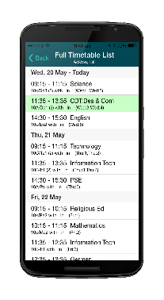
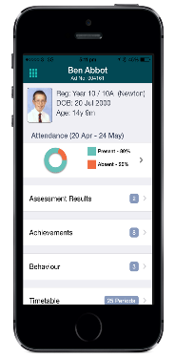
What happens next?
Groupcall has now set up the system in your child’s school. Once you ensure the school has your current email address and mobile number, you can then download the app by accessing http://parents.groupcall.com/

Once downloaded, you may receive information on some of the following:

• Emergency school closures
• Pupil absence notifications
• Covid updates
• Meetings and after school activities
• Parent evenings
• School events and newsletters
• Pupil reports – issue dates
• Expected time of arrival when pupils are returning from school trips
• General updates

